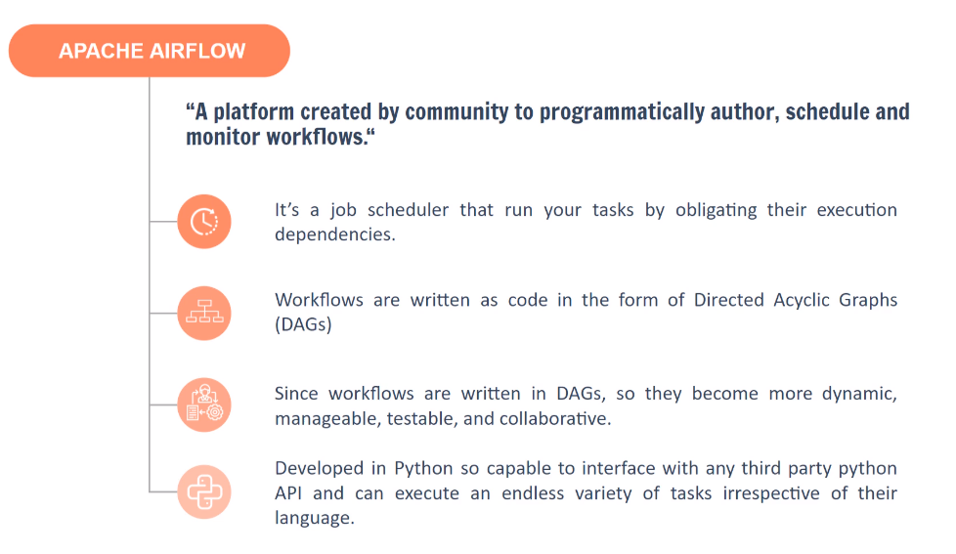

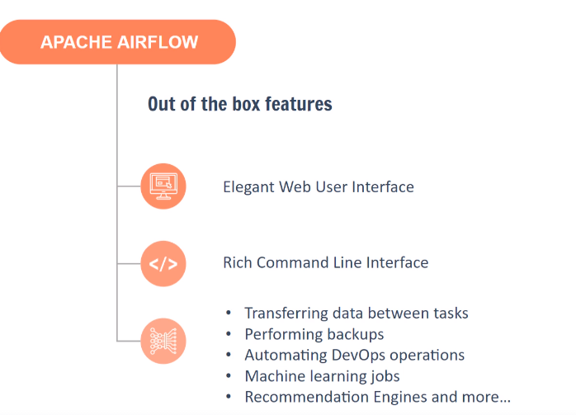

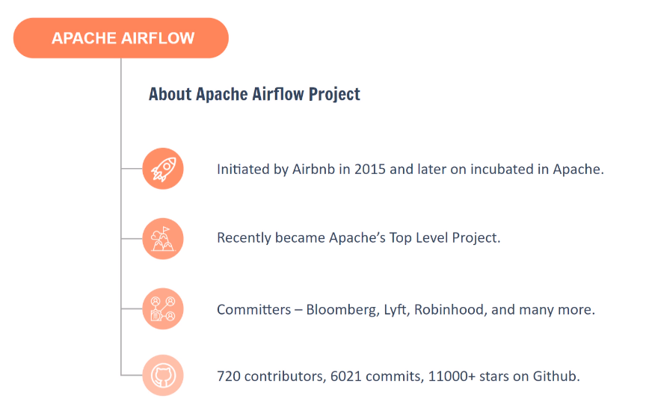

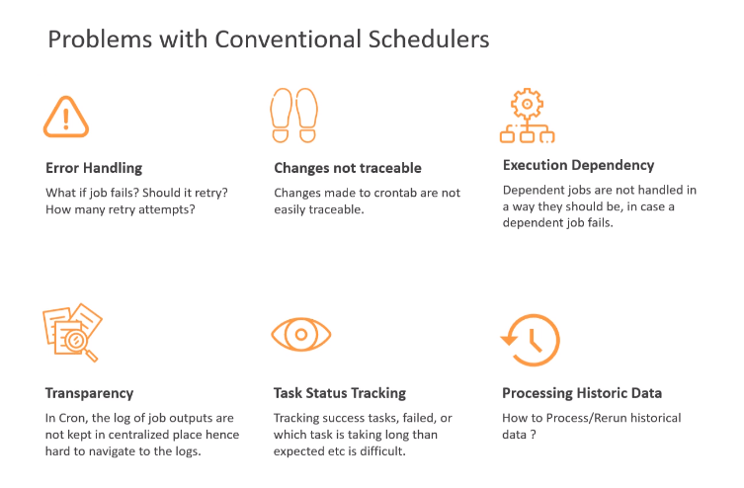

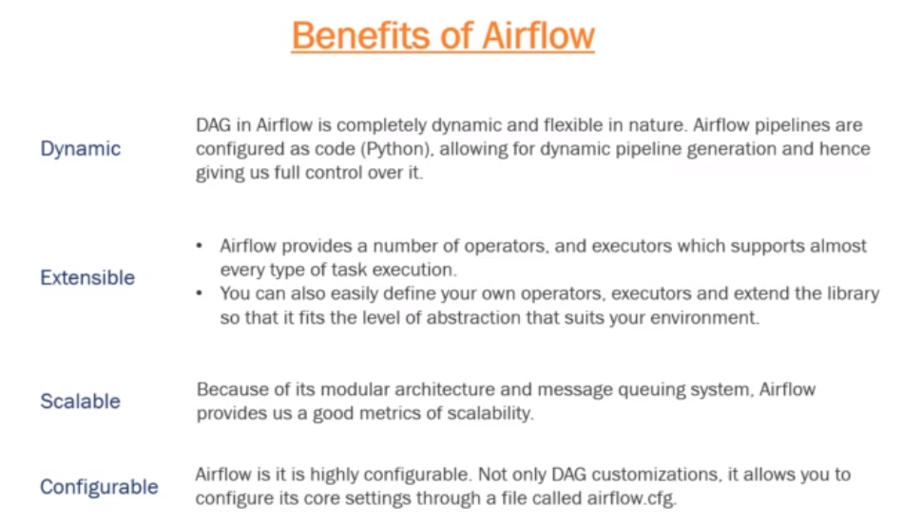

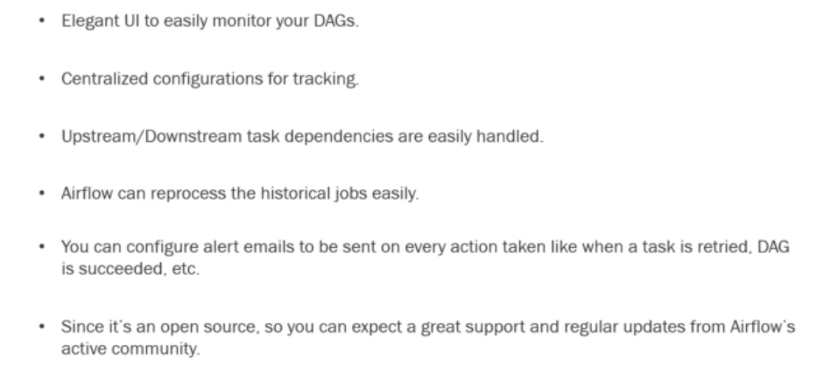

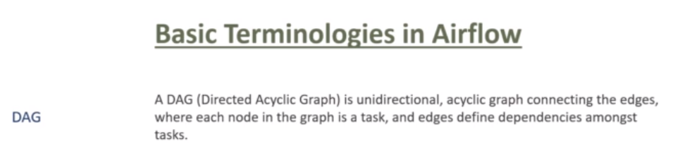

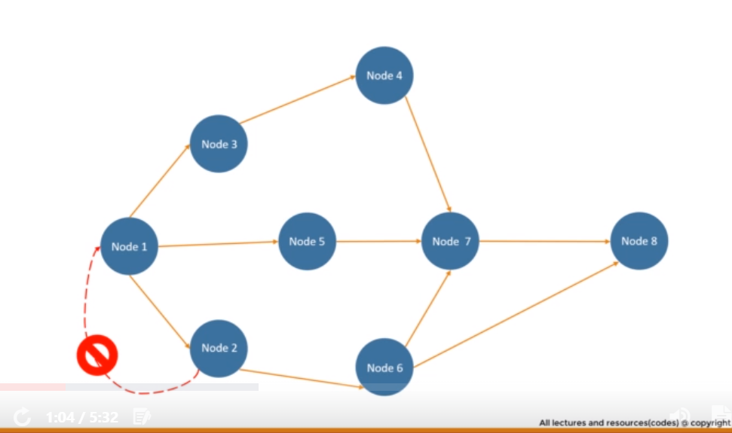

There shouldn’t be any cycle in the graph.

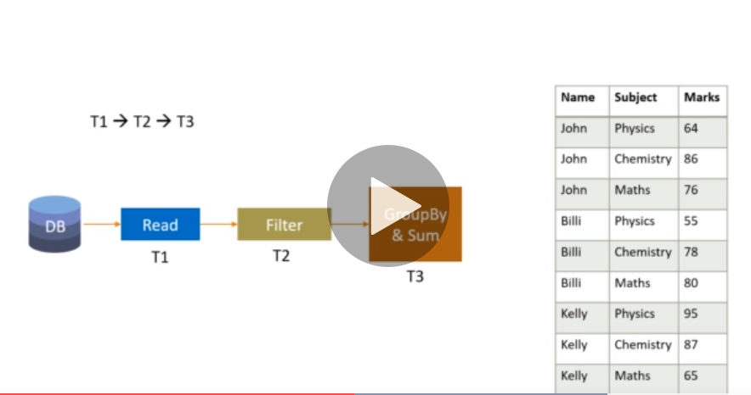

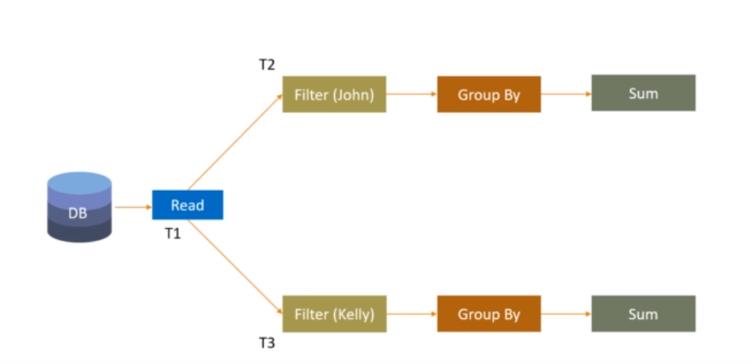

We can perform the operations parallelly.

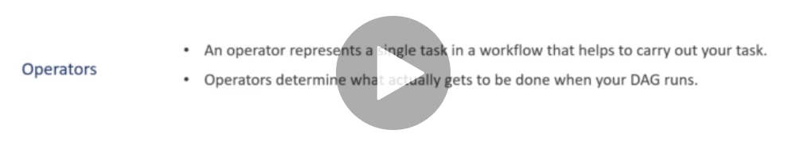

Operator is a task that can handle only one particular work.

When an operator is running, it is called as task.

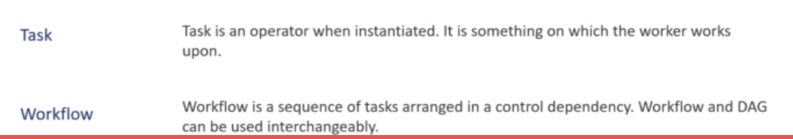

Workflow and DAG is the same thing.

**Architecture of Airflow**

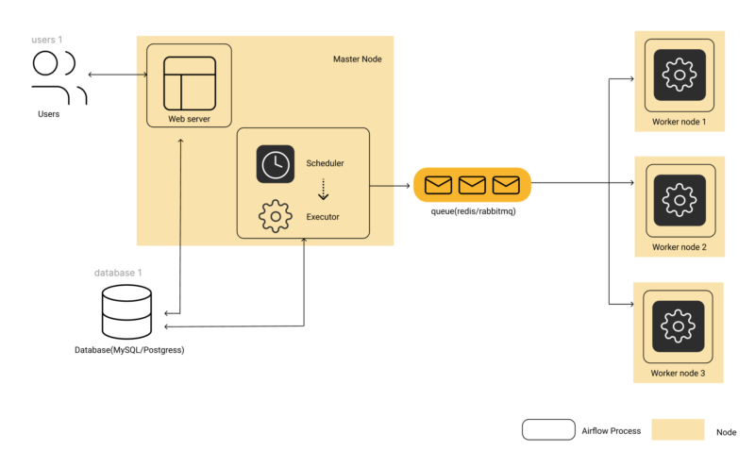**Airflow Architecture diagram for Celery Executor based Configuration**

**Scheduler job is to trigger the task at the right time but the executor actually carry out the task.**

Before we start using [**Apache Airflow**](https://www.qubole.com/the-ultimate-guide-to-apache-airflow/) to build and manage pipelines, it is important to understand how Airflow works. Understanding the components and *modular architecture* of Airflow allows you to understand how its various components interact with each other and seamlessly orchestrate data pipelines.

Apache Airflow Architecture Components:

1. **Web Server:** This is the UI of Airflow, that can be used to get an overview of the overall health of different Directed Acyclic Graphs (DAG) and also help in visualizing different components and states of each DAG. The Web Server also provides the ability to manage users, roles and different configurations for the Airflow setup.
2. **Scheduler:** This is the most important part of Airflow, which orchestrates various DAGs and their tasks, taking care of their interdependencies, limiting the number of runs of each DAG so that one DAG doesn’t overwhelm the entire system and makes it easy for users to schedule and run DAGs on Airflow.
3. **Executor:** While the Scheduler orchestrates the tasks, the executors are the components that actually execute tasks. There are various types of executors that come with Airflow, such as SequentialExecutor, LocalExecutor, CeleryExecutor and the KubernetesExecutor. People usually select the executor that suits their use case best. We will cover the details later in this blog.
4. **Metadata Database:** Airflow supports a variety of databases for its metadata store. This database stores metadata about DAGs, their runs, and other Airflow configurations like users, roles, and connections. The Web Server shows the DAGs’ states and its runs from the database. The Scheduler also updates this information in this metadata database.

Let’s cover each of these components in detail.

Apache Airflow Web Server:

*Airflow’ Web Server* comes with a well equipped built-in user interface that provides control over each pipeline, including the ability to visualize various aspects of them. The most important capabilities of Web Server are:

* Monitoring DAGs: The Airflow Web Server homepage provides a brief overview of the statues of the DAGs and their recent runs.

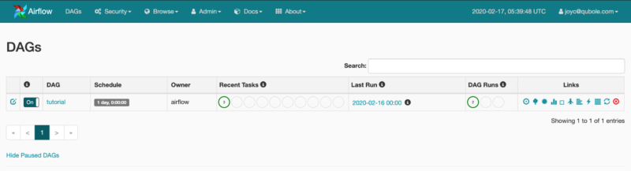**Airflow Web Server HomePage Showing a List of DAGs and statuses of their most recent runs**

* Visualizing DAGs: The UI also has a section for visualizing the DAG flow, a tree view to represent all the recent runs and the status of each task for these runs. One can also view other things like the DAG code, time taken by each task for each run, logs and more to help debug DAG runs.

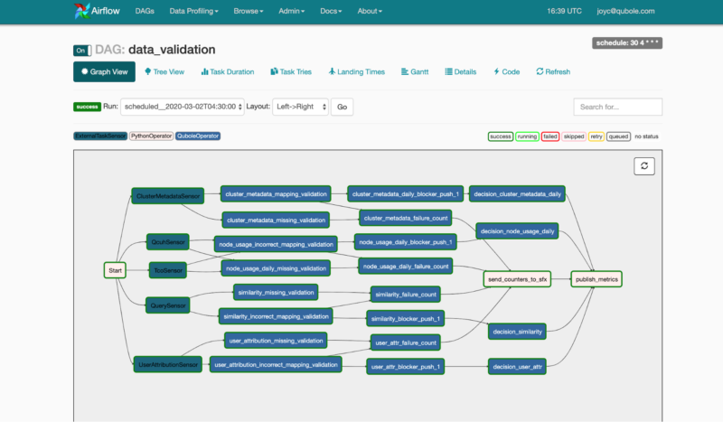**Airflow UI showing graphical representation of a DAG**

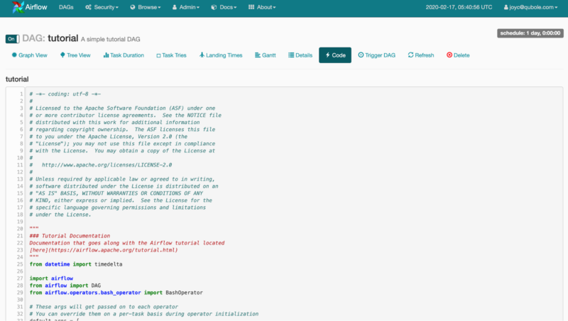**Viewing DAG Code from Airflow UI**

* API Endpoints: Airflow Web Server also provides a set of [**REST APIs**](https://airflow.apache.org/docs/stable/api.html) that can be used to perform various tasks like triggering DAGs, tasks, or getting status of each task instance.
* Configuration Management: The Web Server UI also provides options to manage various configs like variables, connections and view the Airflow default configuration on the UI itself.
* User Management: Airflow Web Server also comes with an option to enable Role-Based Access Controls (RBAC). One just needs to set `webserver.rbac` to **True** in order to enable this interface. It provides the ability to manage user permissions at a very granular level. We can even restrict if someone can trigger/view a DAG.

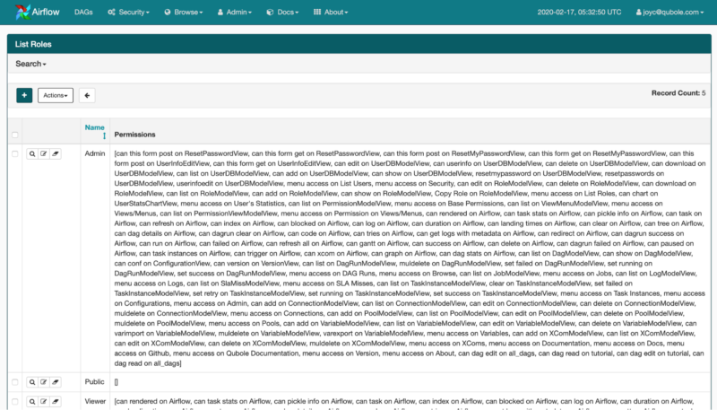**Managing Roles on the Airflow Web Server UI**

Apache Airflow Scheduler:

The scheduler is at the core of Airflow and manages anything and everything related to DAG runs, tasks, task runs, parsing and storing DAGs while also taking care of other aspects like worker pool management, SLAs and many more.

The scheduler is a multi-threaded python process that keeps on checking and parsing all the code present in the Airflow DAGs folder. Based on configuration, each DAG gets a number of processes or pools on which it can run.

**Note:** The Scheduler parses all the DAG files every few minutes which can be set by the setting Scheduler parse interval. **This means all the top level code (code written outside methods / classes / operators in the global scope) in a DAG file will run when the Scheduler parses it. This slows down the Scheduler DAG parsing, resulting in increased usage of memory and CPU.** To avoid this, and pass all operations to the Operator ( like Python Operator, passing methods and creating classes instead of writing code in global scope wherever possible) unless absolutely necessary.

The Scheduler then decides which DAG should run on which pool and based on the Executor configuration it delegates the actual task run to the Executor. It then keeps a watch on which tasks are running and which tasks are up for execution or retries. It also updates all state transitions in the metadata database.

Over the years Airflow’s Scheduler has matured a lot, improving stability and error handling. In the past there was a need to restart the Scheduler process every few hours or sometimes it even went into a zombie state where the process was actually running but not processing anything. These issues have been fixed over the years and since version 1.10.0, the Scheduler is a very stable process that can run for days or months without crashing or the need to restart it manually.

Apache Airflow Executor:

Executor in **Apache Airflow** is the actual entity that runs the tasks. There are various types of [**Executors in Airflow**](https://www.qubole.com/tech-blog/how-to-install-apache-airflow-to-run-different-executors/) and any one of them can be selected using the configuration file based on requirements for parallel processing. Let’s dive into some commonly used executors in Airflow:

* **SequentialExecutor** will only run one task instance at a time. This type of Executor is suited only for debugging or testing a DAG locally before pushing to test the environment. It is also the only executor that can be used with SQLite since SQLite doesn’t support multiple connections.
* **LocalExecutor** runs tasks by spawning processes in a controlled fashion in different modes. Ideally the number of tasks a LocalExecutor is unlimited if we specify the parallelism parameter to be 0. But, the number of tasks then are limited by the configuration of the machine being used to run the tasks and the amount of memory and CPU they have available. Arguably, SequentialExecutor could be thought of as a LocalExecutor with limited parallelism of just 1 worker, i.e. self.parallelism = 1. This option could lead to the unification of the executor implementations, running locally, into just one LocalExecutor with multiple modes. Again, this type of Executor is suitable only for running small workloads on a single machine, for higher parallelism we need to be able to distribute tasks to multiple worker processes running on different machines.
* **CeleryExecutor** is based on [**python celery**](https://www.celeryproject.org/) which is widely used to process asynchronous tasks. Celery is an asynchronous task queue/job queue based on distributed message passing. For CeleryExecutor, one needs to set up a queue (Redis, RabbitMQ or any other task broker supported by Celery) on which all the celery workers running keep on polling for any new tasks to run. In the case of CeleryExecutor, the Scheduler adds all tasks to the task queue that we configure. From the queue, the celery worker picks up the task and runs it. After the execution is complete, the worker reports the status of the task in the database. The Scheduler knows from the database when a task has completed, and then runs the next set of tasks or process alerts based on what is configured in the DAG.

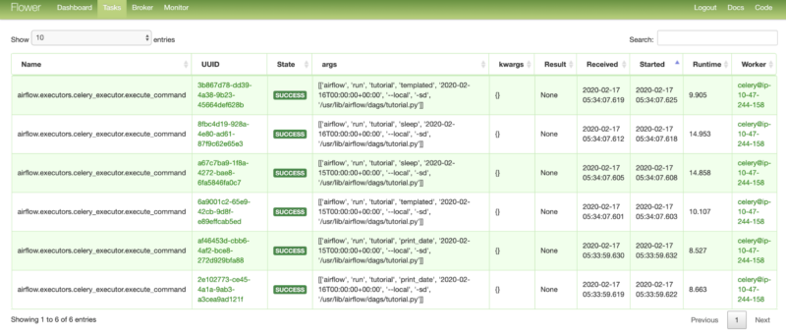**Flower (The UI for Celery) showing a list of recent task runs**

* **KubernetesExecutor** provides a way to run Airflow tasks on Kubernetes, Kubernetes launch a new pod for each task. While Kubernetes takes care of the pod lifecycle (as Celery took care of task processing) and the Scheduler keeps on polling for task status from Kubernetes. Kubernetes provides a [**native way**](https://kubernetes.io/docs/tasks/job/fine-parallel-processing-work-queue/) to run tasks in a queue. Airflow takes advantage of this mechanism and delegates the actual task processing to Kubernetes. With KubernetesExecutor, each task runs in a new pod within the Kubernetes cluster, which helps isolate the environment for all the tasks. This also improves dependency management using Docker Images, and up- or downscales workers as needed—even all the way down to zero worker processes.

Apache Airflow Metadata Database:

Airflow uses [**SQLAlchemy**](https://www.sqlalchemy.org/) and Object Relational Mapping (ORM) written in Python to connect to the metadata database. This means that any database supported by SQLALchemy can be used to store all the Airflow metadata. The metadata database stores configurations, such as variables and connections. It also stores user information, roles, and policies. Finally, the Scheduler parses all the DAGs and stores relevant metadata such as schedule intervals, statistics from each run, and their tasks.

After giving you an [**overview of Airflow**](https://www.qubole.com/blog/apache-airflow-tutorial-etl-elt-workflow-orchestration-made-easy/), in this article, we have covered Apache Airflow’s modular architecture in detail. The next blog will focus on installing and running [**Apache Airflow**](https://www.qubole.com/developers/apache-airflow-on-qubole/) locally so that we can easily test our DAGs

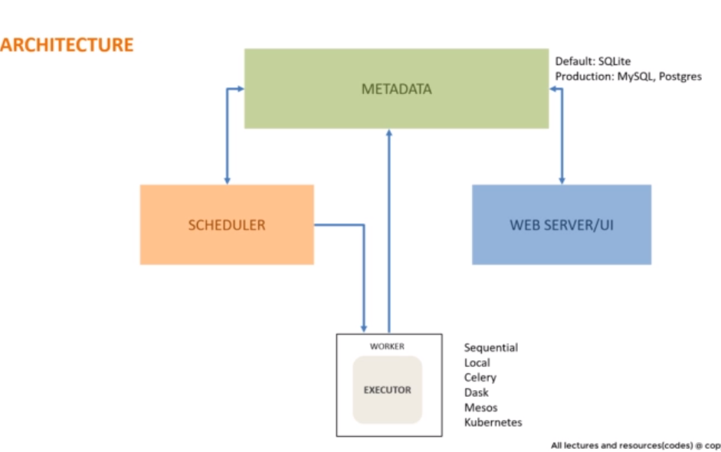

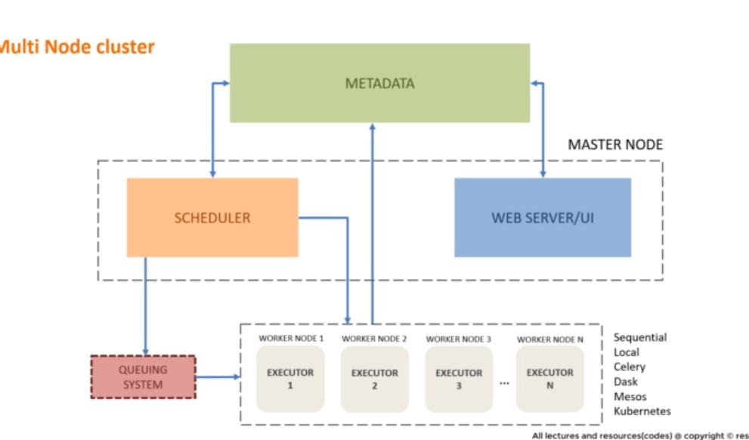

### **Task Instances**

A task instance represents a specific run of a task and is characterized as the combination of a DAG, a task, and a point in time. Task instances also have an indicative state, which could be “running”, “success”, “failed”, “skipped”, “up for retry”, etc.

**When we need to execute a task, a task instance is instantiated.**

### **Task Lifecycle**

A task goes through various stages from start to completion. In the Airflow UI (graph and tree views), these stages are displayed by a color representing each stage:



The complete lifecycle of the task looks like this:

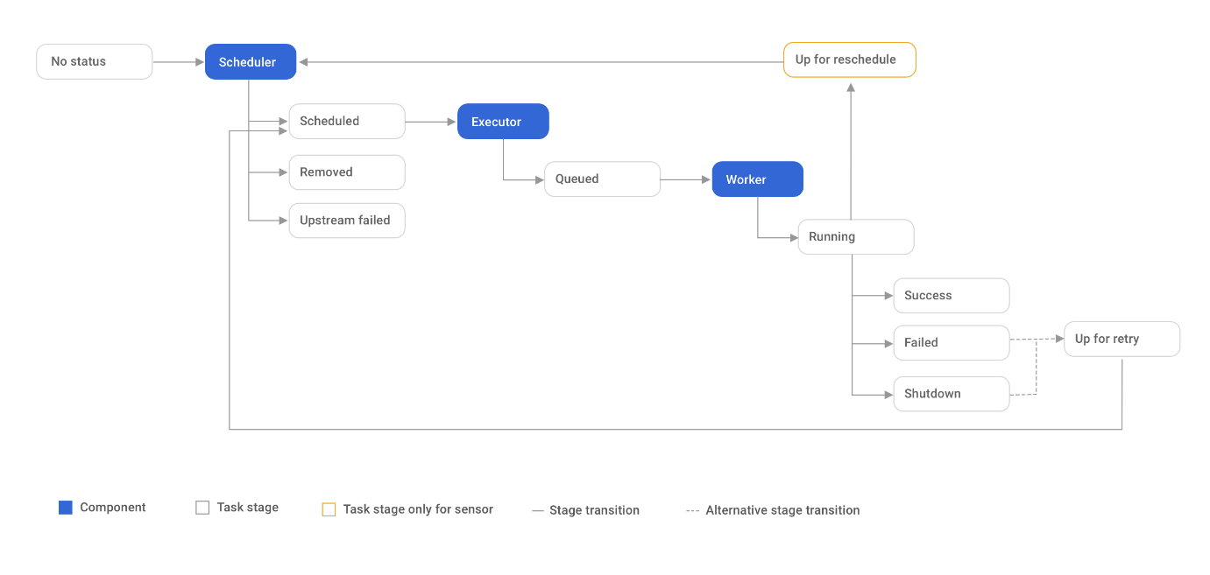

The happy flow consists of the following stages:

1. No status (scheduler created empty task instance)
2. Scheduled (scheduler determined task instance needs to run)
3. Queued (scheduler sent task to executor to run on the queue)
4. Running (worker picked up a task and is now running it)
5. Success (task completed)

There is also visual difference between scheduled and manually triggered DAGs/tasks.

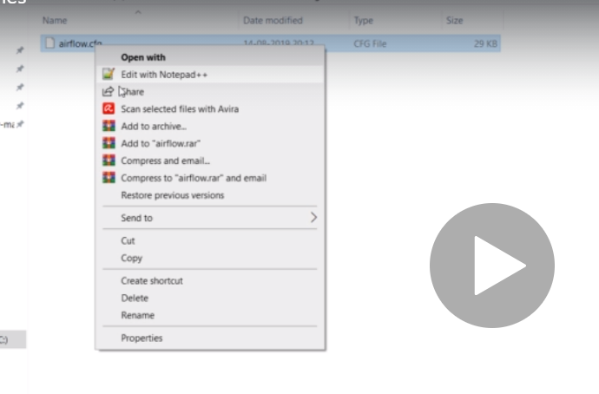

Airflow.cfg is the file where it has all the default settings.

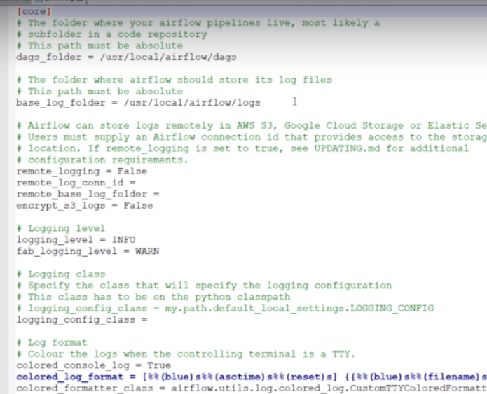

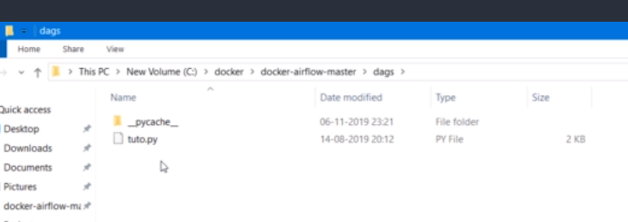

Dag folder will have all the DAG definition files written by the airflow application.

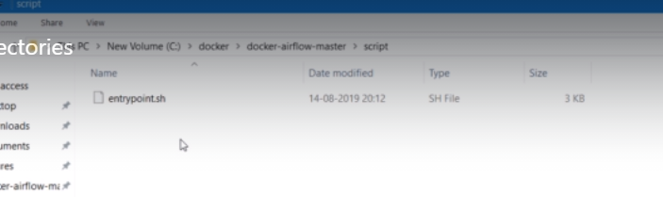

This is a shell script to start airflow UI, Schduler and all other components in the linux based systems.

It also sets the environmental variable of airflow.



The Airflow UI makes it easy to monitor and troubleshoot your data pipelines

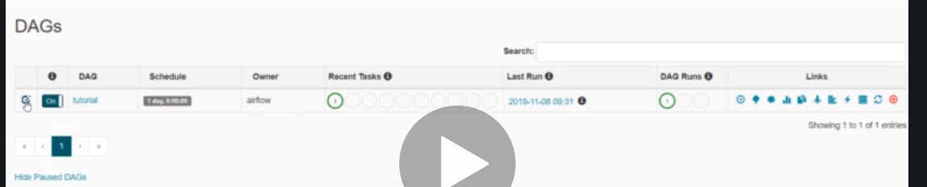

The edit button will show us the information as shown below.

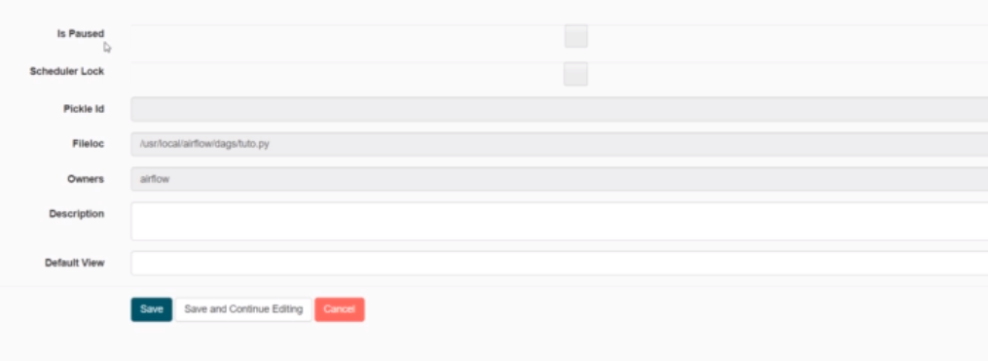

Fileloc:- the DAG file location

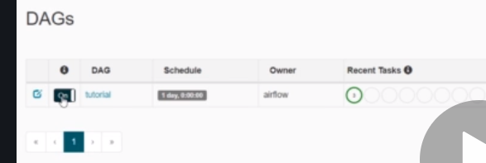

The toggle switch tells us whether our DAG is enabled or disabled.

Then clicking on the DAG id will take us to the different view of the DAG.

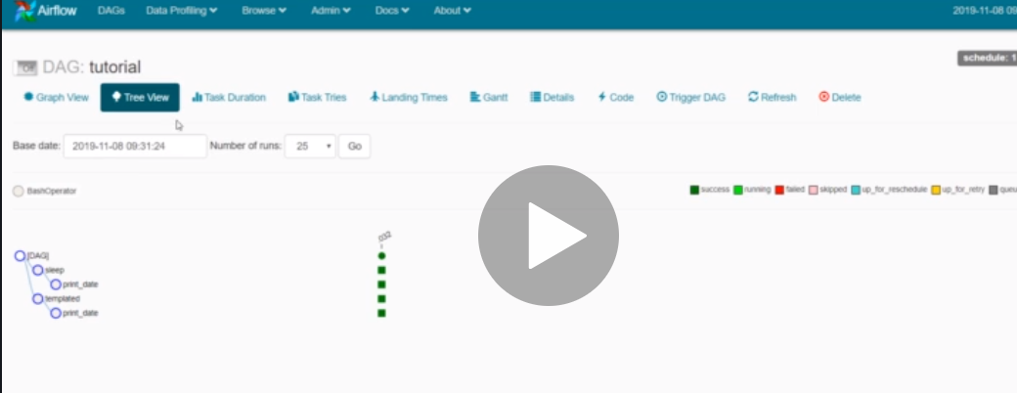

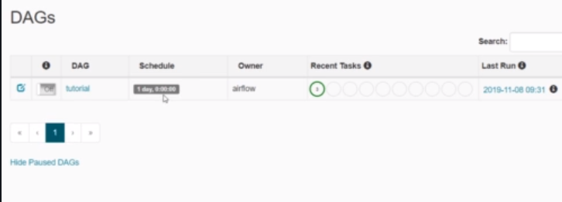

Schedule is the interval after which our DAG will be triggered.

If we click on schedule, it will take us all the historical runs.

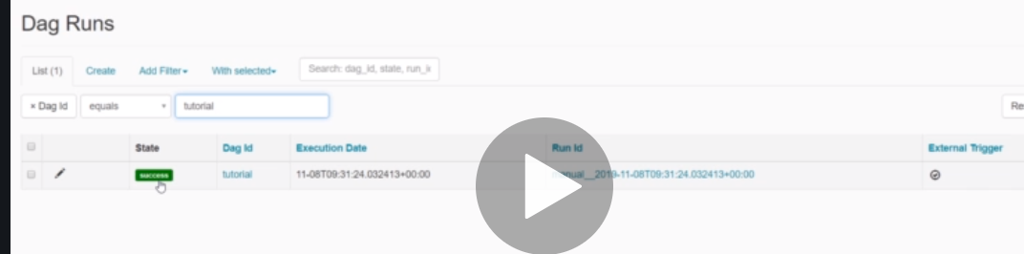

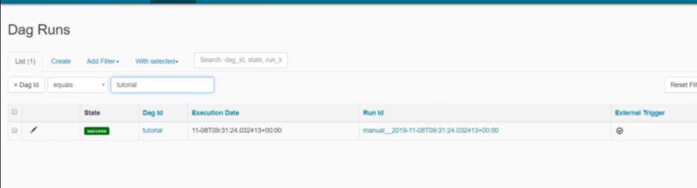

If the Run ID is starts with manual, it means that we have manually triggered it. If it starts with Scheduled, it means it has triggered as per the scheduled.

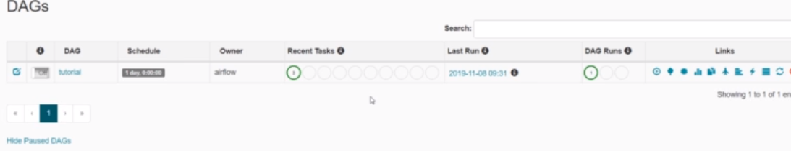

Recent tasks shows us the status of the different tasks in the DAG.

Recent tasks shows us the summary of the task present in the latest DAG. If the DAG is running, then it will show us its live task status.

If it is not running , then it will us the task summary from the most recent DAG run.

Eeah color represents different task status.

Green:- success.

DAG runs shows us the status of the entire DAG, whether it is running, or success or failure

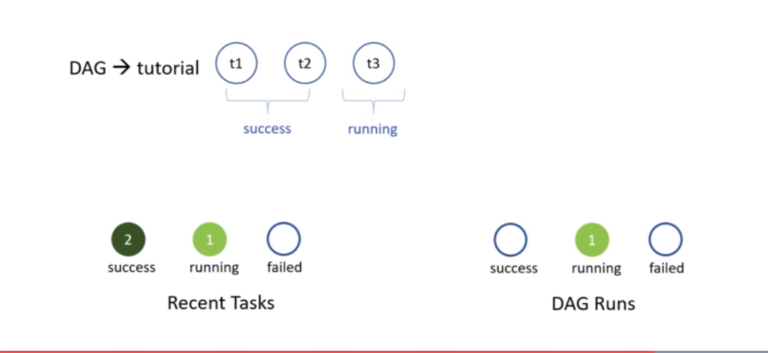

Here 2 means two tasks has been successfully completed and one is running,.

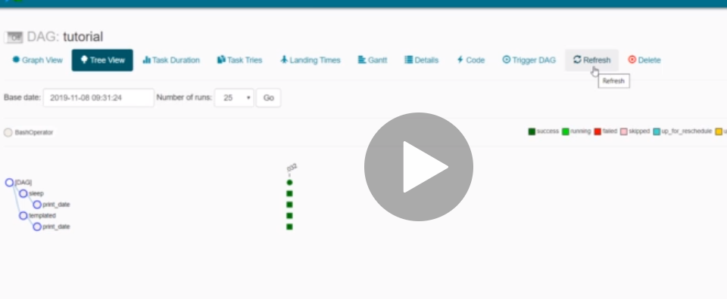

If we made some changes in the DAG definition file, then it will take some time to reflect in the UI. If you want to promptly show it in the UI, you need to click on the refresh button.

Delete will delete the selected DAG and all the data associated with it except the logs.

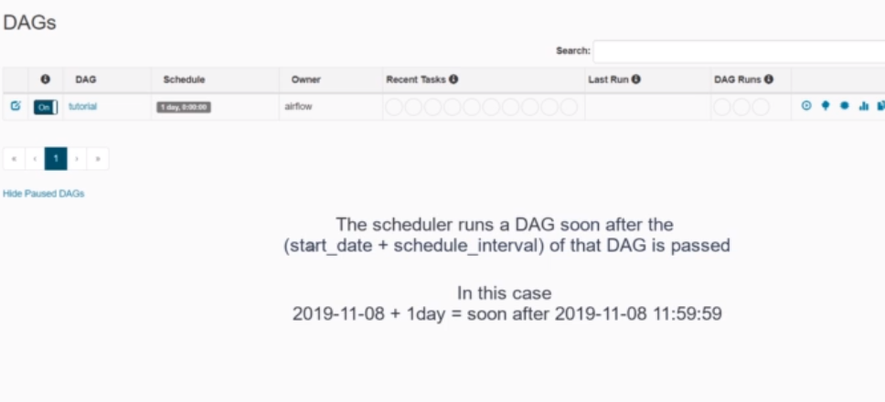

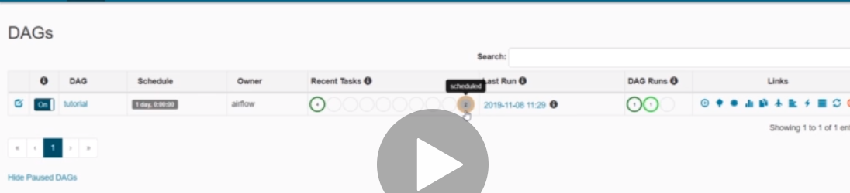

If we run the DAG again, then it will show the cumulative information in DAG Runs and Recent tasks.

Here we can see 1 success and 1 is running in DAG Runs.

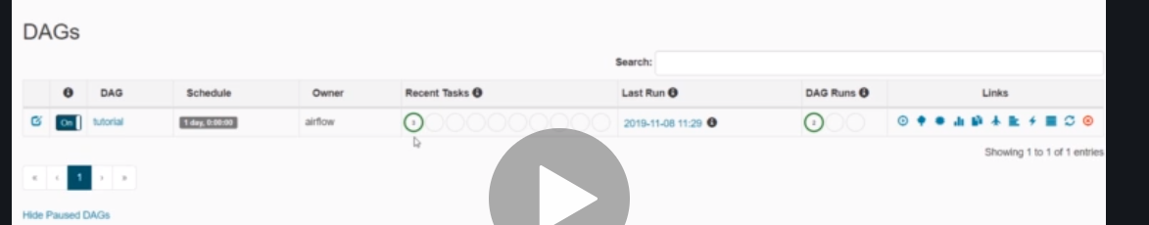

After the success, the Recent task will show the data about the most recents tasks. So that’s why it is showing 3 now instead of 6.

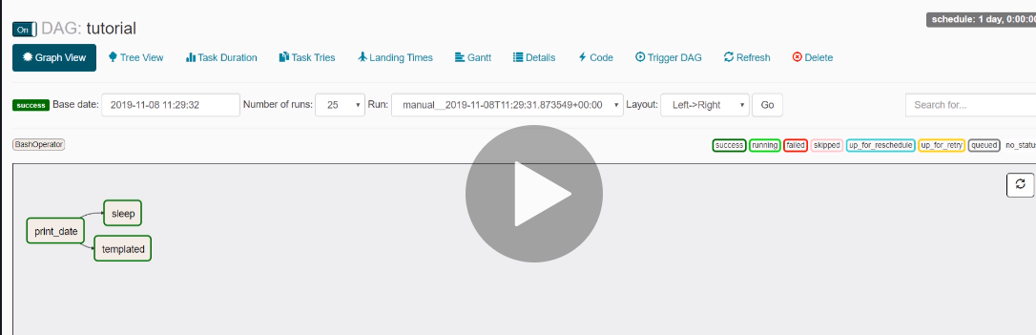

Graph View show the DAG at each task level.

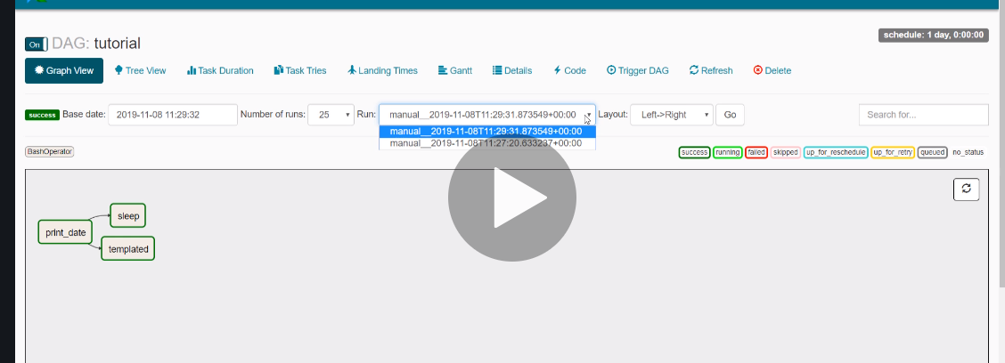

We can also filter out the records based on our needs.

You can click on any task and get the details about the task.

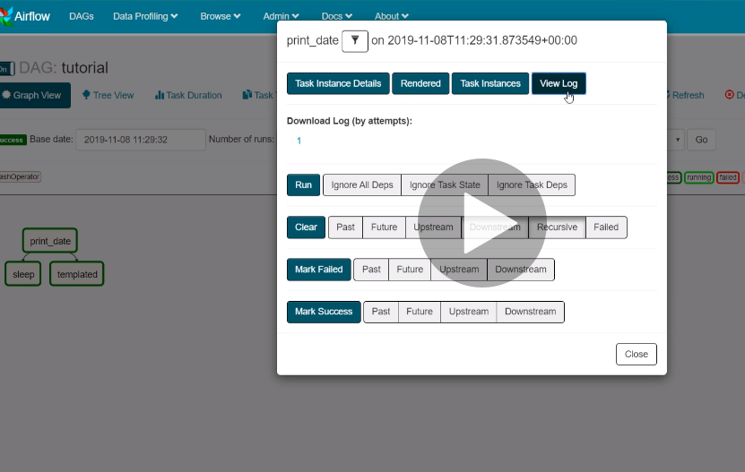

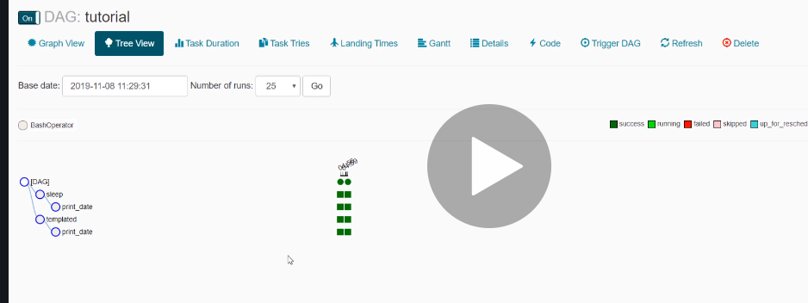

In tree view, we can see the details of multiple DAG runs.

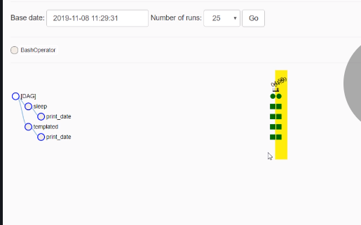

First columns shows the DAG of first DAG run and second column show the status of second DAG run.

Circle represents the DAG itself and the rectangle shows about the task.

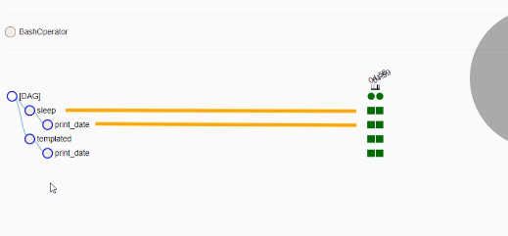

We can see which box reprensts which tasks.

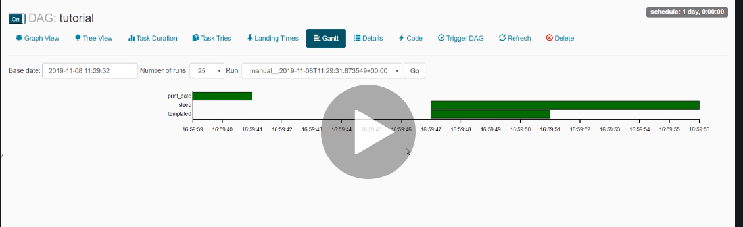

Gantt view breaks down the timeline of each task and show us the view as shown above.

If our pipeline is taking too much of time and we need to figure out which task is taking more time, then we need to see this graph.

Here we can see a gap between the task, This is the time the scheduler takes to switch from one task to another.

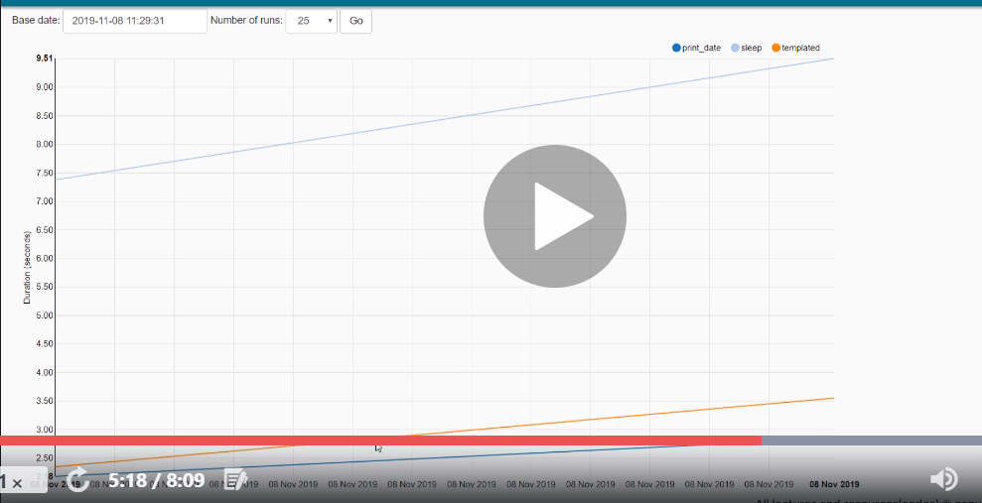

Task duration tells about duration of different task over the past runs.

The left hand side we can see that it is the execution time and x-axis is the time when we have executed the task.

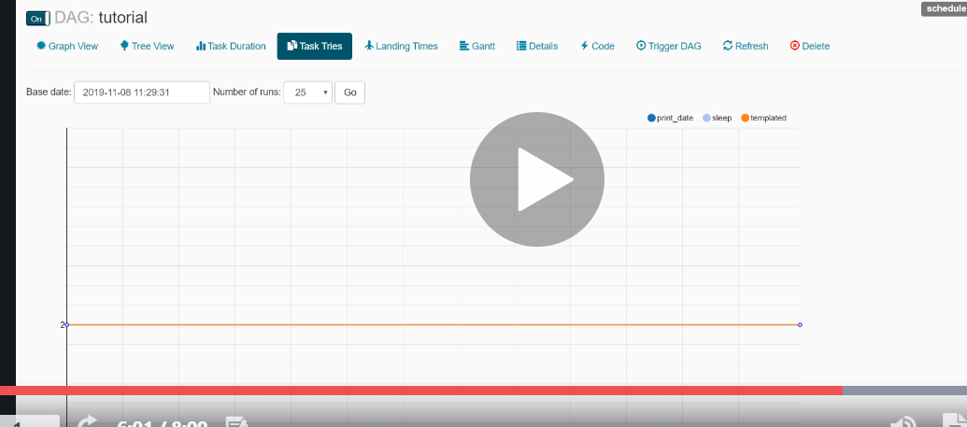

Task Tries is the number of retries for a particular task in case it is failing.

It will show two because of a glitz in airflow. One for successful attempt and one for the untried task.

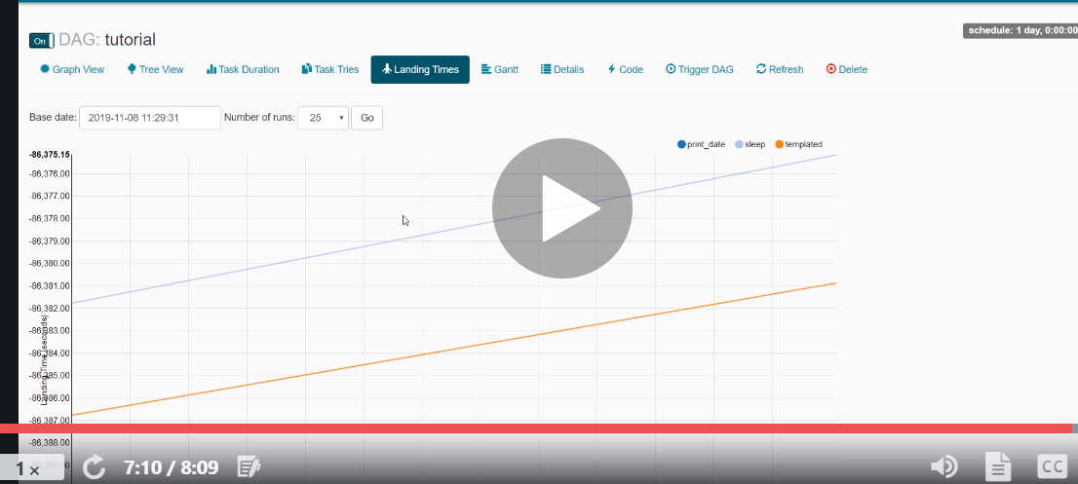

It will show the execution time of a DAG for the past runs.

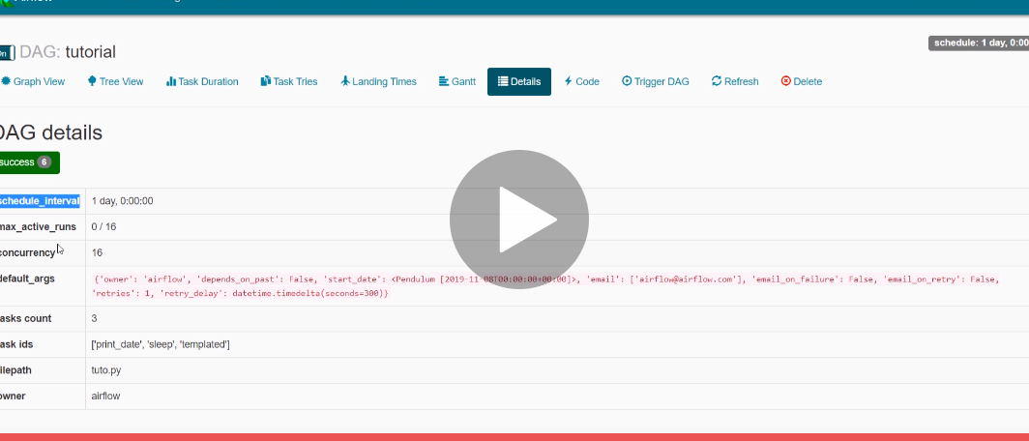

Details will show the details about the DAG.

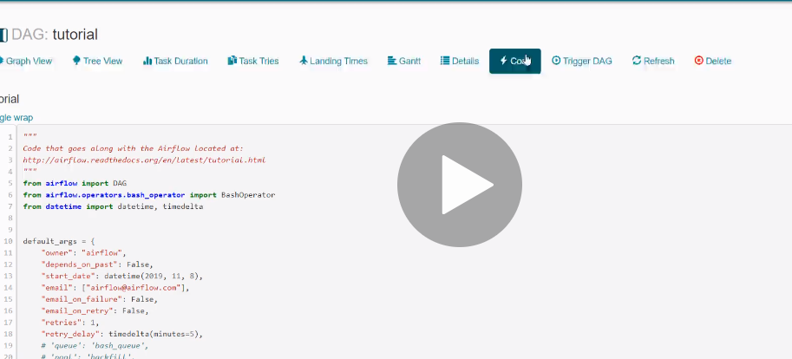

Code section shows the code of the entire DAG.

DAG Defination file:-

People sometimes think of the DAG definition file as a place where they can do some actual data processing - that is not the case at all! The script’s purpose is to define a DAG object. It needs to evaluate quickly (seconds, not minutes) since the scheduler will execute it periodically to reflect the changes if any.

One thing to wrap your head around (it may not be very intuitive for everyone at first) is that this Airflow Python script is really just a configuration file specifying the DAG’s structure as code. The actual tasks defined here will run in a different context from the context of this script. Different tasks run on different workers at different points in time, which means that this script cannot be used to cross communicate between tasks. Note that for this purpose we have a more advanced feature called XCom.

## Importing Modules

An Airflow pipeline is just a Python script that happens to define an Airflow DAG object. Let’s start by importing the libraries we will need.

*# The DAG object; we'll need this to instantiate a DAG*

**from** **airflow** **import** DAG

*# Operators; we need this to operate!*

**from** **airflow.operators.bash_operator** **import** BashOperator

## Default Arguments

We’re about to create a DAG and some tasks, and we have the choice to explicitly pass a set of arguments to each task’s constructor (which would become redundant), or (better!) we can define a dictionary of default parameters that we can use when creating tasks.

**from** **datetime** **import** datetime, timedelta

default_args = {

'owner': 'airflow',

'depends_on_past': **False**,

'start_date': datetime(2015, 6, 1),

'email': ['airflow@example.com'],

'email_on_failure': **False**,

'email_on_retry': **False**,

'retries': 1,

'retry_delay': timedelta(minutes=5),

*# 'queue': 'bash_queue',*

*# 'pool': 'backfill',*

*# 'priority_weight': 10,*

*# 'end_date': datetime(2016, 1, 1),*

}

For more information about the BaseOperator’s parameters and what they do, refer to the [**airflow.models.BaseOperator**](https://airflow.apache.org/docs/apache-airflow/1.10.1/code.html#airflow.models.BaseOperator) documentation.

Also, note that you could easily define different sets of arguments that would serve different purposes. An example of that would be to have different settings between a production and development environment.

## Instantiate a DAG

We’ll need a DAG object to nest our tasks into. Here we pass a string that defines the dag_id, which serves as a unique identifier for your DAG. We also pass the default argument dictionary that we just defined and define a schedule_interval of 1 day for the DAG.

dag = DAG(

'tutorial', default_args=default_args, schedule_interval=timedelta(days=1))

## Tasks

Tasks are generated when instantiating operator objects. An object instantiated from an operator is called a constructor. The first argument task_id acts as a unique identifier for the task.

t1 = BashOperator(

task_id='print_date',

bash_command='date',

dag=dag)

t2 = BashOperator(

task_id='sleep',

bash_command='sleep 5',

retries=3,

dag=dag)

Notice how we pass a mix of operator specific arguments (bash_command) and an argument common to all operators (retries) inherited from BaseOperator to the operator’s constructor. This is simpler than passing every argument for every constructor call. Also, notice that in the second task we override the retries parameter with 3.

The precedence rules for a task are as follows:

1. Explicitly passed arguments
2. Values that exist in the default_args dictionary
3. The operator’s default value, if one exists

A task must include or inherit the arguments task_id and owner, otherwise Airflow will raise an exception.

## Templating with Jinja( Used for dynamically passing arguments)

## Referece link must read:- [Macros reference — Airflow Documentation (apache.org)](https://airflow.apache.org/docs/apache-airflow/stable/macros-ref)

Airflow leverages the power of [Jinja Templating](http://jinja.pocoo.org/docs/dev/) and provides the pipeline author with a set of built-in parameters and macros. Airflow also provides hooks for the pipeline author to define their own parameters, macros and templates.

This tutorial barely scratches the surface of what you can do with templating in Airflow, but the goal of this section is to let you know this feature exists, get you familiar with double curly brackets, and point to the most common template variable: {{ ds }} (today’s “date stamp”).

templated_command = """

{*% f*or i in range(5) %}

echo "{{ ds }}"

echo "{{ macros.ds_add(ds, 7) }}"

echo "{{ params.my_param }}"

{*% e*ndfor %}

"""

t3 = BashOperator(

task_id='templated',

bash_command=templated_command,

params={'my_param': 'Parameter I passed in'},

dag=dag)

Notice that the templated_command contains code logic in {% %} blocks, references parameters like {{ ds }}, calls a function as in {{ macros.ds_add(ds, 7)}}, and references a user-defined parameter in {{ params.my_param }}.

Files can also be passed to the bash_command argument, like bash_command='templated_command.sh', where the file location is relative to the directory containing the pipeline file (tutorial.py in this case). This may be desirable for many reasons, like separating your script’s logic and pipeline code, allowing for proper code highlighting in files composed in different languages, and general flexibility in structuring pipelines. It is also possible to define your template_searchpath as pointing to any folder locations in the DAG constructor call.

## Setting up Dependencies

We have tasks t1, t2 and t3 that do not depend on each other. Here’s a few ways you can define dependencies between them:

t1.set_downstream(t2)

*# This means that t2 will depend on t1*

*# running successfully to run.*

*# It is equivalent to:*

t2.set_upstream(t1)

*# The bit shift operator can also be*

*# used to chain operations:*

t1 >> t2

*# And the upstream dependency with the*

*# bit shift operator:*

t2 << t1

*# Chaining multiple dependencies becomes*

*# concise with the bit shift operator:*

t1 >> t2 >> t3

*# A list of tasks can also be set as*

*# dependencies. These operations*

*# all have the same effect:*

t1.set_downstream([t2, t3])

t1 >> [t2, t3]

[t2, t3] << t1

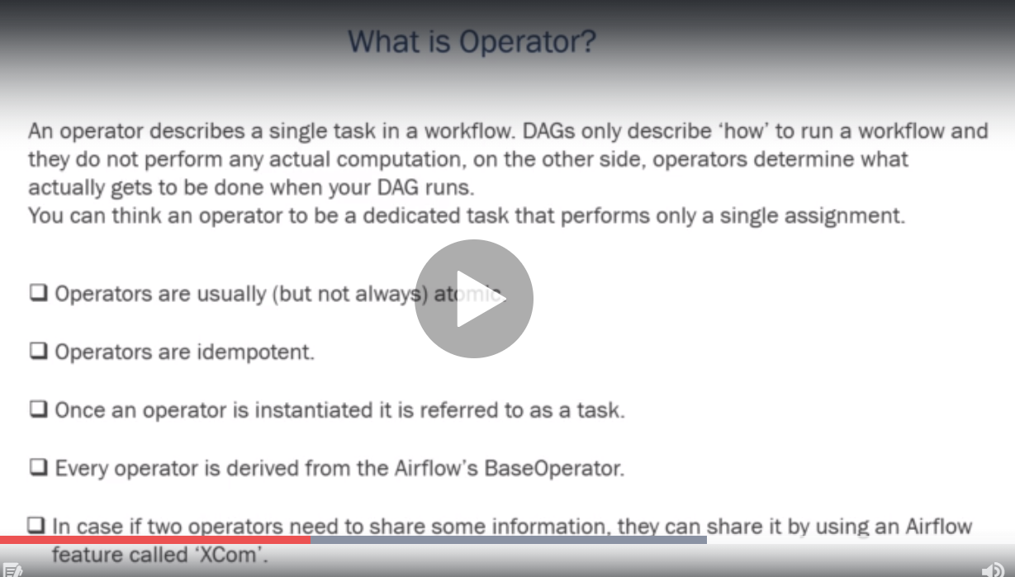

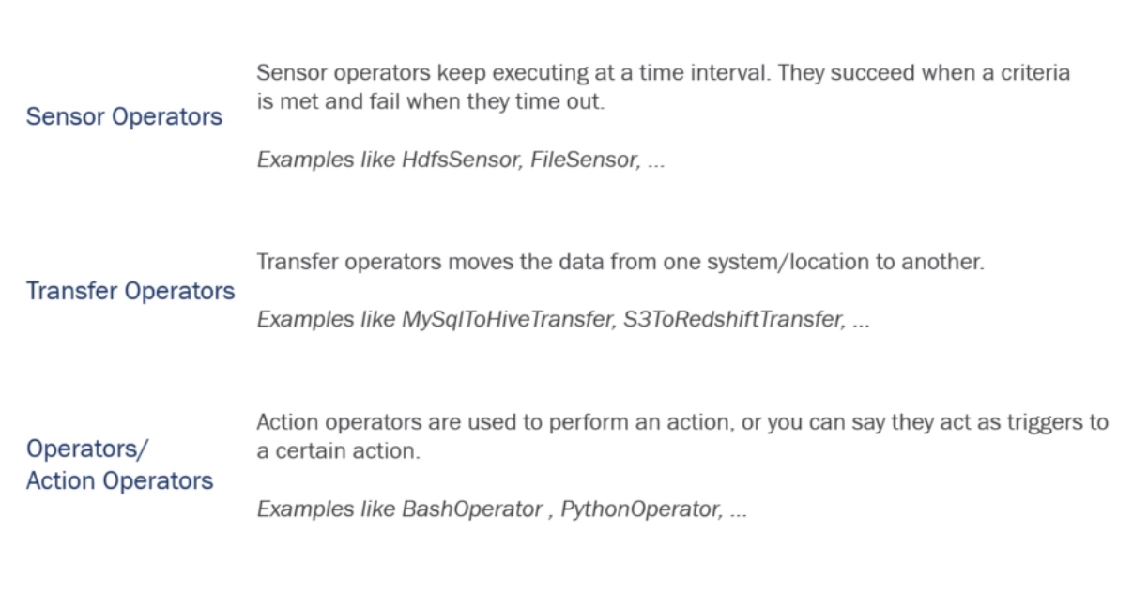

Project:-

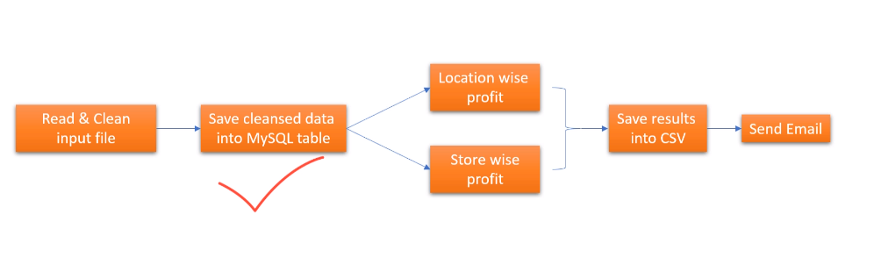

In Order to create a mysql connection:

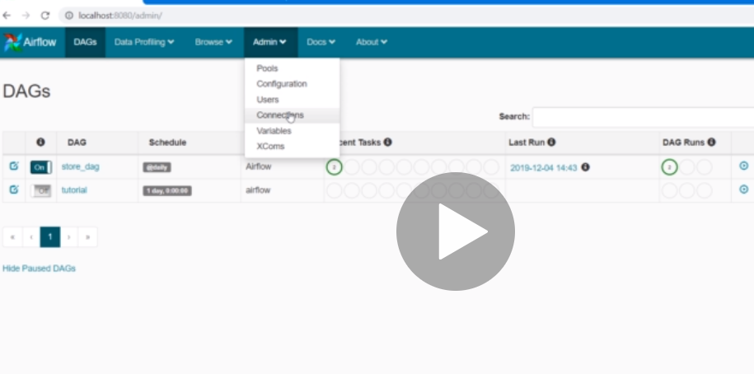

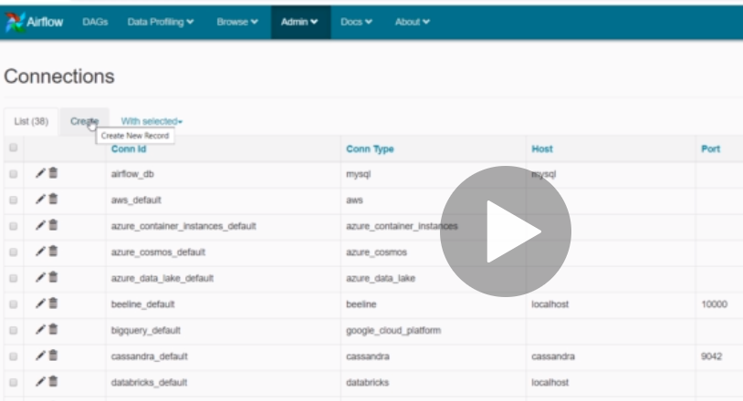

Click on Create.

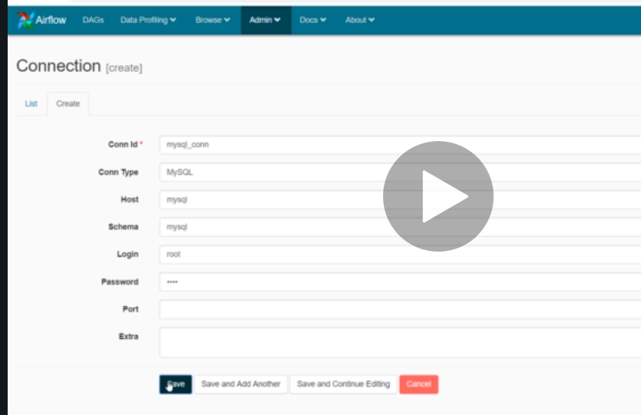

Give all the details and create a connection. Once the connection is created, provide this connection ID in the DAG file.

Airflow CLI:-

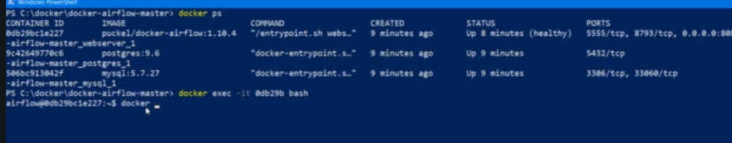

Go inside the airflow docker container to start executing the airflow CLI commands.

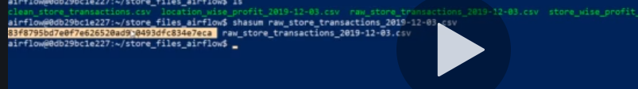

Shasum value to check if the file is present or not.

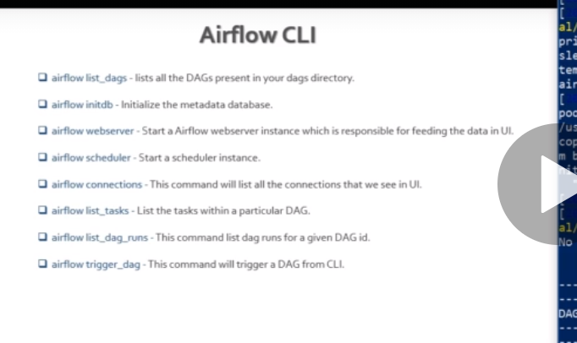

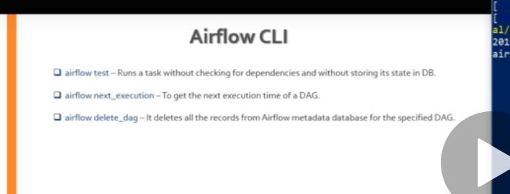

Additional Commands-

[Command Line Interface and Environment Variables Reference — Airflow Documentation (apache.org)](https://airflow.apache.org/docs/apache-airflow/stable/cli-and-env-variables-ref.html)

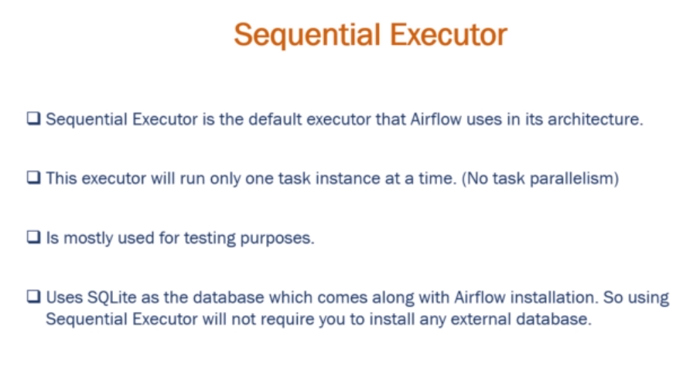

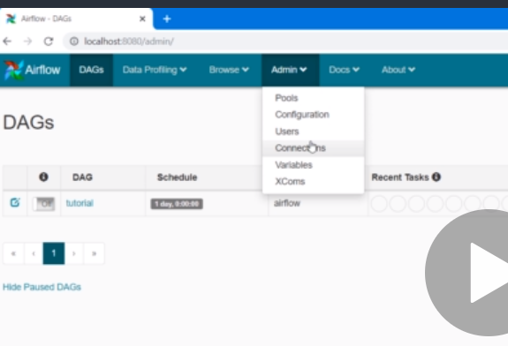

In airflow.cfg, this is mentioned as default executor. This is being overwritten by the docker-compose file of the DAG.

We can check the same in the action tab of UI.

Here we can go to running configuration and see the executor value set for this instance.

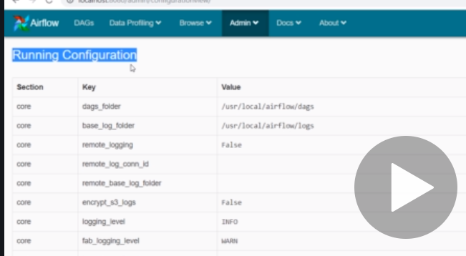

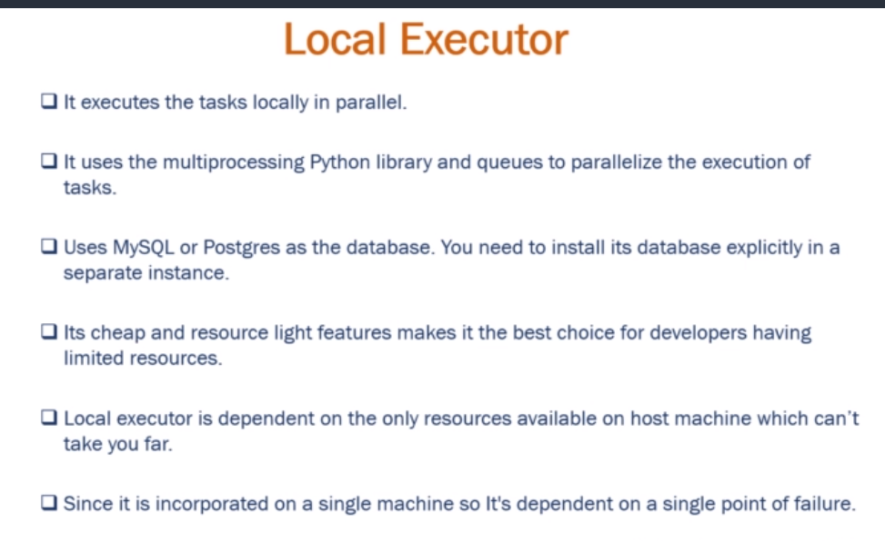

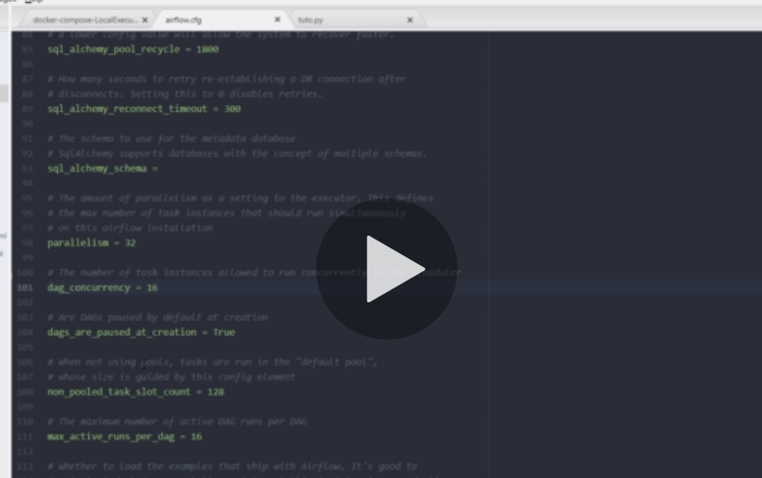

We can limit the parallelism by limiting the dag_concurrency parameter in airflow.cfg file.

Parallelism is the parameter where we can schedule number of parallel task across all DAGs.

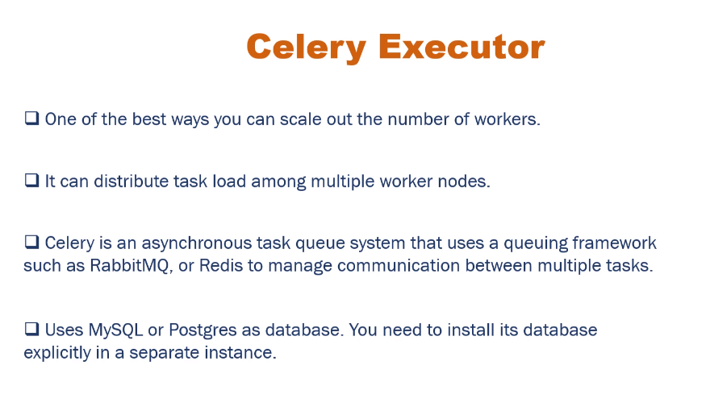

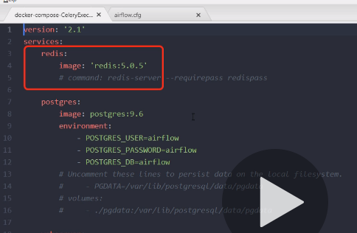

We have to use messaging queue service.

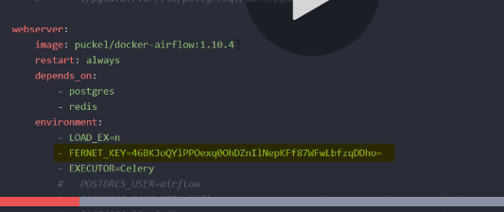

Fernet_key to encypt the password.

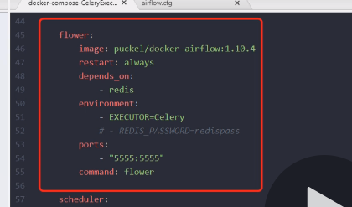

ou can also run [Celery Flower](https://flower.readthedocs.io/en/latest/), a web UI built on top of Celery, to monitor your workers. You can use the shortcut command to start a Flower web server:

airflow celery flower

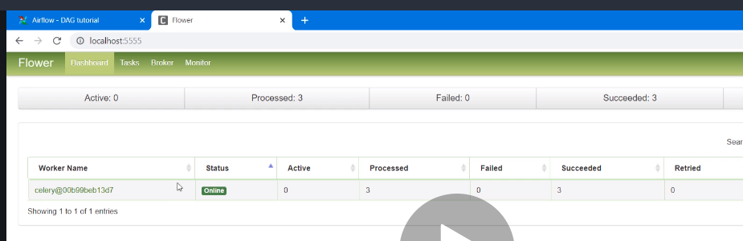

We can see fower UI

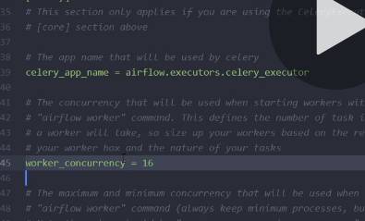

Worker_concurrency means how many tasks one worker can process.

# **Airflow XCOM**

It is used to share data between tasks.

## Use case

As usual, to better explain why you need a functionality, it’s always good to start with a use case. The Airflow XCom is not an easy concept, so let me illustrate why it might be useful for you. Let’s imagine you have the following data pipeline:

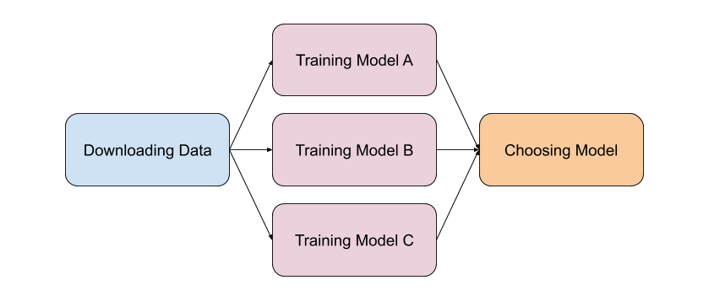

In a nutshell, this data pipeline trains different machine learning models based on a dataset and the last task selects the model having the highest accuracy. The question is,

**How can we get the accuracy of each model in the task Choosing Model to choose the best one?**

One solution could be to store the accuracies in a database and fetch them back in the task Choosing Model with a SQL request. That’s perfectly viable. But, it’s there any native easier mechanism in Airflow allowing you to do that?

Yes! XComs!

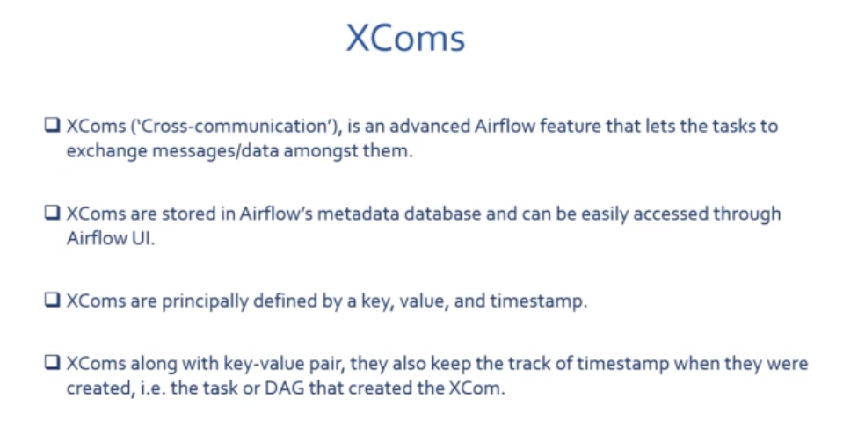



## What is an Airflow XCom ?

XCom stands for “cross-communication” and allows to exchange messages or **small** amount of data between tasks. You can think of an XCom as a little object with the following fields:

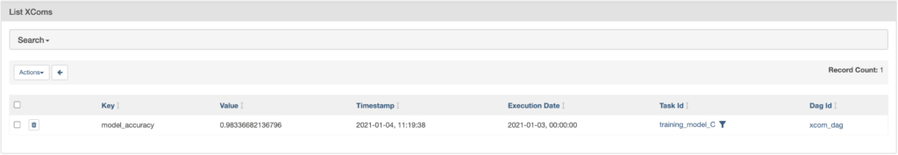

hat is**stored IN the metadata database** of Airflow. From left to right,

* The **key** is the identifier of your XCom. No need to be unique and is used to get back the xcom from a given task.
* The **value** is … the value of your XCom. What you want to share. Keep in mind that **your value must be serializable in JSON or pickable**. Notice that serializing with pickle is disabled by default to avoid RCE exploits/security issues. If you want to learn more about the differences between JSON/Pickle click here.
* The **timestamp** is the data at which the XCom was created.
* The **execution date**! This is important! That execution date corresponds to the execution date of the DagRun having generated the XCom. That’s how Airflow avoid fetching an XCom coming from another DAGRun. You don’t know what I’m talking about? Check my video about how scheduling works in Airflow.
* The**task id** of the task where the XCom was created.
* The **dag id** of the dag where the XCom was created.

To access your XComs in Airflow, go to Admin -> XComs.

Great! Now you know what a XCom is, let’s create your first Airflow XCom

Time to practice! To let you follow the tutorial, here is the data pipeline we use:

|  |  |
| --- | --- |
| 1  2  3  4  5  6  7  8  9  10  11  12  13  14  15  16  17  18  19  20  21  22  23  24  25  26  27  28  29  30  31  32  33  34  35  36  37  38 | from airflow import DAG  from airflow.operators.bash import BashOperator  from airflow.operators.python import PythonOperator  from random import uniform  from datetime import datetime  default_args = {  'start_date': datetime(2020, 1, 1)  }  def _training_model():  accuracy = uniform(0.1, 10.0)  print(f'model\'s accuracy: {accuracy}')  def _choose_best_model():  print('choose best model')  with DAG('xcom_dag', schedule_interval='@daily', default_args=default_args, catchup=False) as dag:  downloading_data = BashOperator(  task_id='downloading_data',  bash_command='sleep 3'  )  training_model_task = [  PythonOperator(  task_id=f'training_model_{task}',  python_callable=_training_model  ) for task in ['A', 'B', 'C']]  choose_model = PythonOperator(  task_id='choose_model',  python_callable=_choose_best_model  )  downloading_data >> training_model_task >> choose_model |

Add this code into a file xcom_dag.py in dags/ and you should obtain the following DAG:

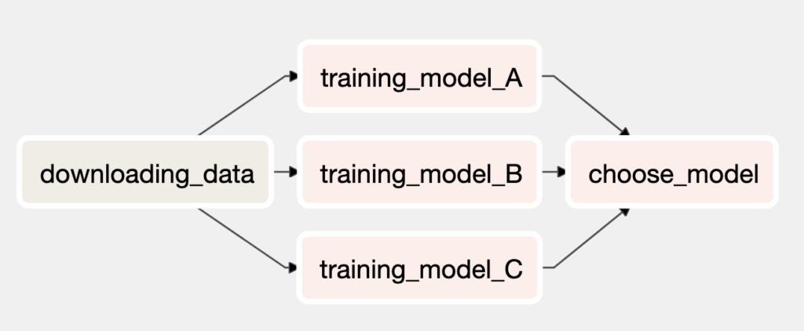

The data pipeline is pretty simple. We have 5 tasks. downloading_data is a BashOperator executing the bash command which waits for 3 seconds. Then, we have 3 tasks, training_model_[A,B,C] dynamically generated in a list comprehension. Each task implements the PythonOperator to execute the function _training_model. That functions generates randomly an accuracy for each models A, B, C. Finally, we want to choose the best model based on the generated accuracies in the task choose_model.

Our goal is to create one XCom for each model and fetch back the XComs from the task choose_model to choose the best.

How? 2 steps:

1. Create an XCom for each training_model task
2. Pull the XComs from choose_model

Let’s do it!

## How to push an Airflow XCom

In this Airflow XCom example, we are going to discover how to push an XCom containing the accuracy of each model A, B and C.

There are multiple ways of creating a XCom but let’s begin the most basic one. Whenever you want to create a XCom from a task, the easiest way to do it is by **returning** a value. In the case of the PythonOperator, use the **return keyword along with the value** in the python callable function in order to create automatically a XCom.

|  |  |
| --- | --- |
| 1  2  3  4 | def _training_model(ti):  accuracy = uniform(0.1, 10.0)  print(f'model\'s accuracy: {accuracy}')  **return accuracy** |

By adding **return accuracy**, if you execute the DAG, you will obtain the following XComs:

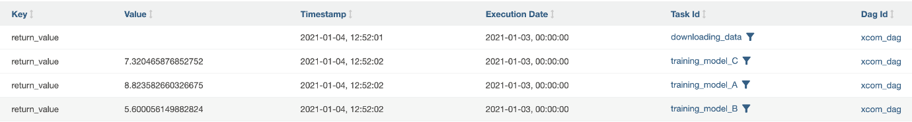

Well done! With just one line of code, you’ve already pushed your first XCom!

What’s important here is the key, **return_value**. By default, when a XCom is automatically created by returning a value, Airflow assigns the key **return_value**. In addition, you can see that each XCom was well created from different tasks ( based on the task ids ) but got something weird here. We don’t return any value from the task downloading_data but we an associated XCom.

Where does it come from?

### **The do_xcom_push argument**

By default, **all operators returning a value, create a XCom**. **There is one argument that ALL OPERATORS SHARE** ( BashOperator, PythonOperator etc. ) **which is** **do_xcom_push** set to True. Let’s change that argument for the BashOperator to False.

|  |  |
| --- | --- |
| 1  2  3  4  5 | downloading_data = BashOperator(  task_id='downloading_data',  bash_command='sleep 3',  **do_xcom_push=False**  ) |

Turn off the toggle of the DAG. Clear the task instances (In Browse -> Task Instances). Delete all DAGRuns (Browse -> DagRuns) as well as the XComs (Browse -> XComs). Now, if you turn on the toggle of your data pipeline again, you obtain the following XComs:

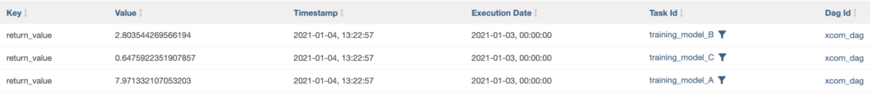

As you can see, this time, we don’t get the extra XCom that was generated by downloading_data. As an exercise, try to avoid generating XComs from the PythonOperator with the same argument. At the end, you should have no XComs at all.

### **Pushing a XCom with xcom_push**

The simplest way to create a XCom is by returning a value from an operator. We know that, and we know that we can change that behaviour with do_xcom_push. By the way, keep in mind that all operators do not return XComs. Therefore. it depends of the implementation of the operator you use.

Ok, is there another way to create a XCom? A way that allows more flexibility? Yes there is! With the method xcom_push. Let’s use it!

First thing first, the method **xcom_push is only accessible from a task instance object**. With the PythonOperator we can access it by passing the parameter **ti** to the python callable function. In Airflow 1.10.x, we had to set the argument provide_context but in Airflow 2.0, that’s not the case anymore. Now, you just have to specify the keyword argument as a parameter for the python callable function.

|  |  |
| --- | --- |
| 1  2  3  4 | def _training_model(**ti**):  accuracy = uniform(0.1, 10.0)  print(f'model\'s accuracy: {accuracy}')  return accuracy |

Notice the argument ti. Once we can access the task instance object, we can call xcom_push.

xcom_push expects two parameters:

1. A key to identify the XCom
2. A value to the XCom that is serializable in JSON or picklable, stored in the metadata database of Airflow.

At the end, to push the accuracy with xcom_push you do,

|  |  |
| --- | --- |
| 1  2  3  4 | def _training_model(ti):  accuracy = uniform(0.1, 10.0)  print(f'model\'s accuracy: {accuracy}')  **ti.xcom_push(key='model_accuracy', value=accuracy)** |

If you trigger the DAG again, you obtain 3 XComs. However, they all have the same key, model_accuracy as specified in xcom_push and not return_value as before. By the way, when you execute twice your DAG on the **same execution date,** the XComs created during the first DAGRun are overwritten by the ones created in the second DAGRun.

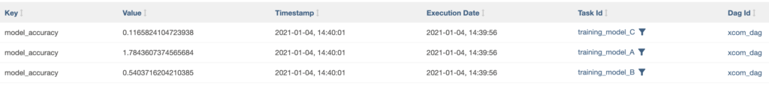

That’s it! That’s all you need to know about xcom_push.

### **The useless argument**

Actually, there is one additional parameter I didn’t talk about which is execution_date. By specifying a date in the future, that XCom won’t be visible until the corresponding DAGRun is triggered. To be honnest, I never found any solid use case for this.

### **Pulling a XCom with xcom_pull**

Alright, now we know how to push an XCom from a task, what about pulling it from another task? We are trying to exchange data between tasks, are we? Let’s go!

In order to pull a XCom from a task, you have to use the xcom_pull method. Like xcom_push, this method is available through a task instance object. xcom_pull expects 2 arguments:

1. **task_ids**, only XComs from tasks matching ids will be pulled
2. **key**, only XComs with matching key will be returned

Two things to keep in mind here. First, it looks like we can specify multiple task ids, therefore we can pull XComs from multiple tasks at once. Second, we have to give a key to pull the right XComs. Let’s pull our first XCom.

|  |  |
| --- | --- |
| 1  2  3 | def _choose_best_model(ti):  fetched_accuracy = ti.xcom_pull(key='model_accuracy', task_ids=['training_model_A'])  print(f'choose best model: {fetched_accuracy}') |

In the code above, we pull the XCom with the key model_accuracy that was created from the task training_model_A. Trigger your DAG, click on the task choose_model and log. You obtain the output:

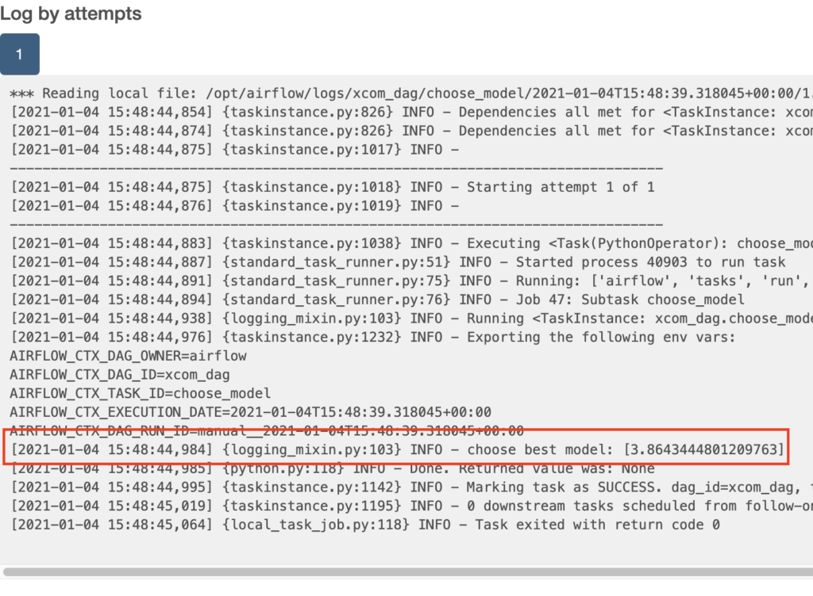

We have successfully pulled the accuracy stored in a XCom that was created by the task training_model_A from the task choosing_model! ( Notice that the value will be different for you).

### **Pulling XComs from multiple tasks**

We know how to push and pull a XCom between two tasks. At this point, we are able to share data between tasks in Airflow! Great! But that’s not all. Indeed, we are able to pull only one XCom from choose_model, whereas we want to pull all XComs from training_model_A, B and C to choose which one is the best.

How can we do this?

Simple! You just need to specify the task ids in xcom_pull.

|  |  |
| --- | --- |
| 1  2  3 | def _choose_best_model(ti):  fetched_accuracies = ti.xcom_pull(key='model_accuracy', task_ids=['training_model_A', 'training_model_B', 'training_model_C'])  print(f'choose best model: {fetched_accuracies}') |

If you trigger you DAG, you obtain the 3 different accuracies and now you are able to choose which model is performing the best.

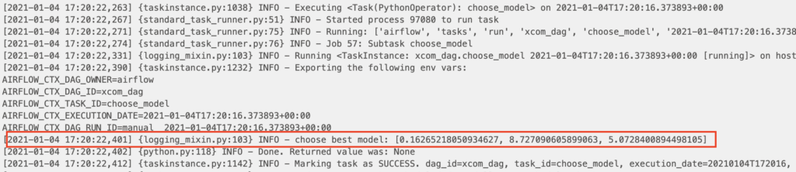

Congratulations! Now you are able to exchange data between tasks in your data pipelines!

### **The bashoperator with XComs**

I know, I know. So far, in the Airflow XCom example, we’ve seen how to share data between tasks using the PythonOperator, which is the most popular operator in Airflow. Great, but. There is another very popular operator which is, the BashOperator. I can’t count the number of times I received the questions, “Hey Marc, how the bashoperator xcom_pull and xcom_push method work? how can we share data with the BashOperator, I don’t have access to the task instance object!” Well, let’s answer those questions!

### **The bashoperator xcom_push**

You already know that by default, an XCom is pushed when you use the BashOperator. We’ve seen that with the task downloading_data. This controlled by the parameter do_xcom_push which is common to all operators. Nonetheless, there was one issue. The XCom was empty. So, how can we create an XCom having a value with the BashOperator?

By using templating! Wait, what? You don’t know what templating is? Well, check my other tutorial [right there](https://marclamberti.com/blog/templates-macros-apache-airflow/) before moving on. THIS IS SUPER IMPORTANT!

Now you know, what templating is, let’s move on! Here is what you should do to push a XCom from the BashOperator:

|  |  |
| --- | --- |
| 1  2  3  4  5 | downloading_data = BashOperator(  task_id='downloading_data',  bash_command='echo "Hello, I am a value!"',  do_xcom_push=True  ) |

And you obtain



Keep in mind that, **only the last line written to stdout by your command, will be pushed as a XCom**. By the way, you don’t have to specify do_xcom_push here, as it is set to True by default.

Pushing a XCom with the BashOperator done, what about pulling a XCOM?

### **The bashoperator xcom_pull**

Pulling a XCom from the BashOperator is a little bit more complex. This time, as you can’t execute a python function to access the task instance object, you are going to use the Jinja Template Engine. Indeed, since the argument bash_command is templated, you can render values at runtime in it. Let’s leverage this to pull a XCom.

|  |  |
| --- | --- |
| 1  2  3  4  5 | fetching_data = BashOperator(  task_id='fetching_data',  bash_command="echo 'XCom fetched: {{ ti.xcom_pull(task_ids=[\'downloading_data\']) }}'",  do_xcom_push=False  ) |

Here, the magic happens with the two pairs of curly brackets {{}}. That’s how we indicate to the Jinja Template Engine that a value here should be evaluated at runtime and in that case, xcom_pull will be replaced by the XCom pushed by the task downloading_data. Notice that I didn’t specify a key here. Why? Because the key of the XCom retuned by downloading_data is return_value. This is the default behaviour. Same for xcom_pull. By default, the key of the XCom pulled is return_value. That’s why, I didn’t specify it here.

Add this task just after downloading_data and set the dependency accordingly (downloading_data >> fetching_data) and you should obtain:

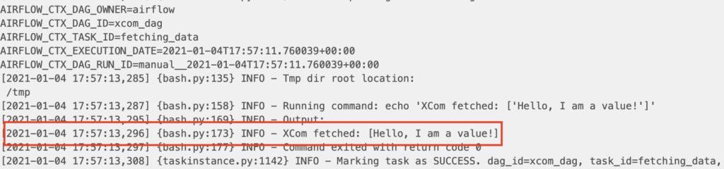

Keep in mind that you might not be able to do that with all operators. At the end, you have to understand how your operator works, to know if you can use XComs with it and if so, how. For that, the code/documentation is your friend 😍

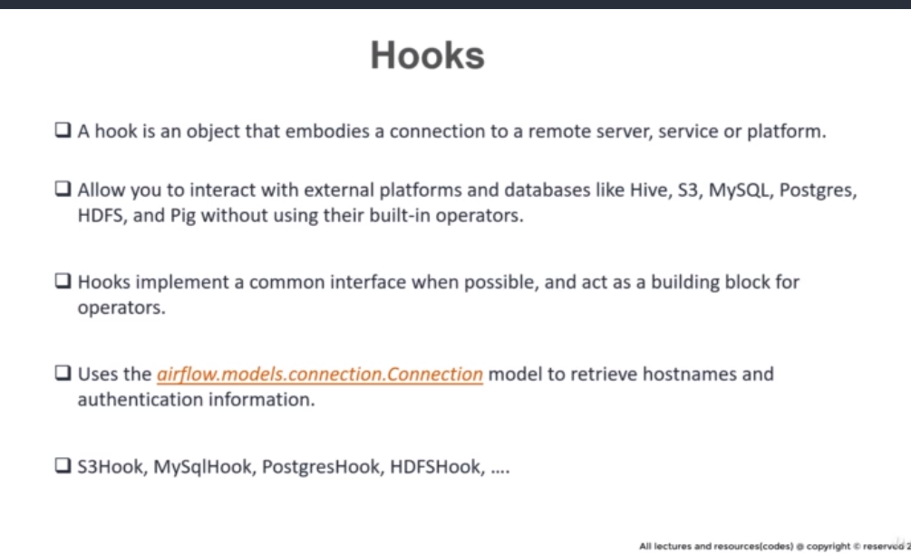

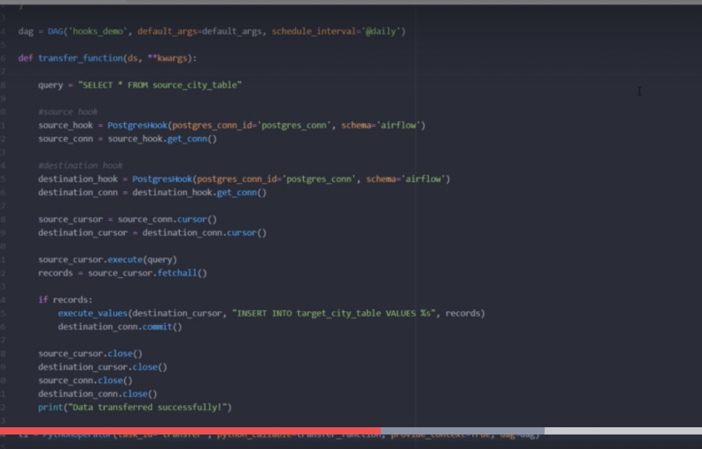

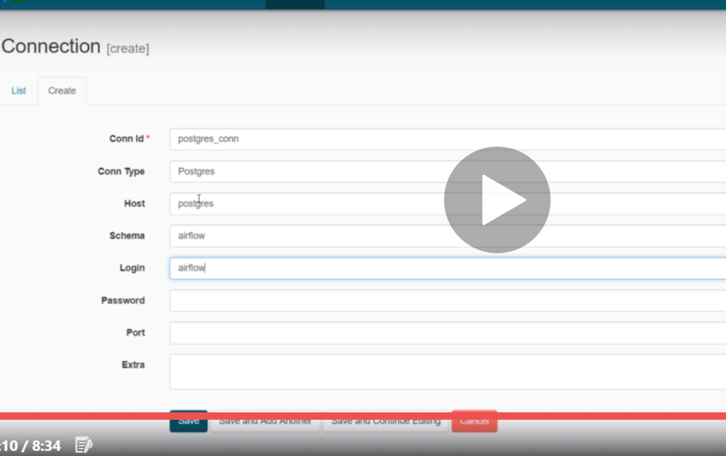

# ***Use of  Pools***

Finally, pools are a way of limiting the number of concurrent instances of a specific type of task. This is great if you have a lot of workers in parallel, but you don’t want to overwhelm a source or destination.

For example, with the default airflow config settings, and a DAG with 50 tasks to pull data from a REST API, when the DAG starts, you would get 16 workers hitting the API at once and you may get some throttling errors back from your API. You can create a pool and give it a limit of 5. Then assign all of the tasks to that pool. Even though you have plenty of free workers, only 5 will run at one time.

You can create a pool directly in the Admin section of the Airflow web UI

You can create a pool directly in the Admin section of the Airflow web UI

# ***Screen Shot 2020-05-09 at 4.28.52 PM***

# ***Implementation Approach***

We wanted an approach for the best utilisation of resources which means if we start enforcing pools, let’s say Client A &  B with limits 30 & 20 respectively and default pool size is 128 for non-pooled clients, then following should be possible.

* Non-Pooled tasks are 50, Client A has 30 & Client B has 20 tasks to run – All tasks will start running
* Non-Pooled tasks are 150, Client A has 35 & Client B has 25 tasks to run – 30 tasks of Client A & 20 tasks of B and 128 non-pooled will start running.
* Non-Pooled tasks are 150 & Client B has 5 tasks to run –  5 tasks of B and 128 non-pooled will start running.

Another problem we have is existing DAGs which are not pooled. So we can implement client level pools only on new clusters we will provision. But E2E can always be put under a pool(let say, e2e_pool of size 5).So with this we can say default_pool size is 50 and e2e_pool is 5, so in this scenario, our E2E won’t be waiting for the slot as long as we have 5 e2e.

# ***Provision of Pools through DAG***

run_bash_job = BashOperator(

task_id='test_task_1', bash_command='echo 1 && sleep 1400m', retries=3,

retry_delay=timedelta(seconds=300), **pool='test-client'**, dag=dag)

run_spark_job = SparkOperator(

json={"name":"HelloWorld","sparkConf":{},"envVars":{},"className":"HelloWorld",

"jar":"https://xyz.com/artifactory/hello.jar",

"args":["/usr/local/spark/README.md"],"driverMemory":1024,"driverCores":1,"executorMemory":1024,"executorCores":2,"numExecutors":1},

retries=1,retry_delay=timedelta(seconds=5),task_id='Spark_0_TrainingJob',**pool='test'**,dag=dag)

run_bash_job.set_upstream(run_compute_job)

The pool parameter can be used in conjunction with priority_weight to define priorities in the queue, and which tasks get executed first as slots open up in the pool. The default priority_weight is 1, and can be bumped to any number. When sorting the queue to evaluate which task should be executed next, we use the priority_weight, summed up with all of the priority_weight values from tasks downstream from this task. You can use this to bump a specific important task and the whole path to that task gets prioritised accordingly.

Tasks will be scheduled as usual while the slots fill up. Once capacity is reached, runnable tasks get queued and their state will show as such in the UI. As slots free up, queued tasks start running based on the priority_weight (of the task and its descendants).

Note that if tasks are not given a pool, they are assigned to a default pool default_pool. default_pool is initialised with 128 slots and can changed through the UI or CLI (though it cannot be removed).

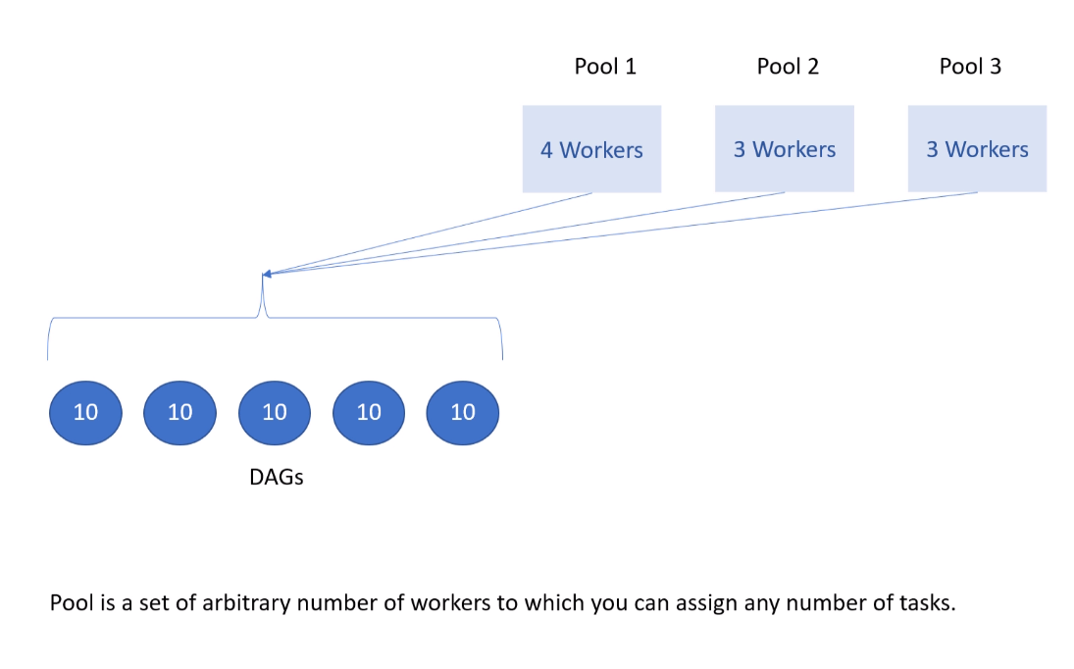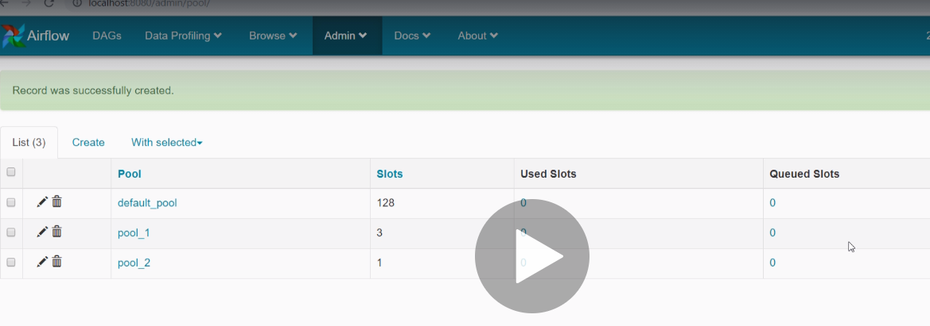

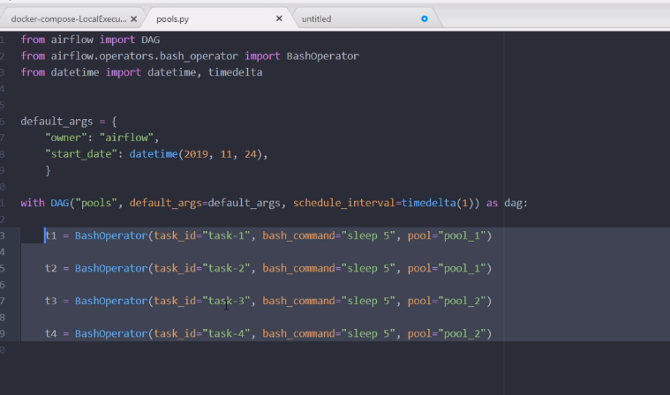

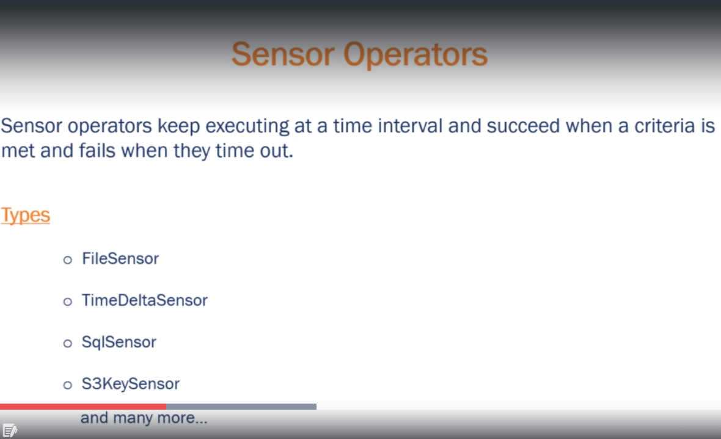

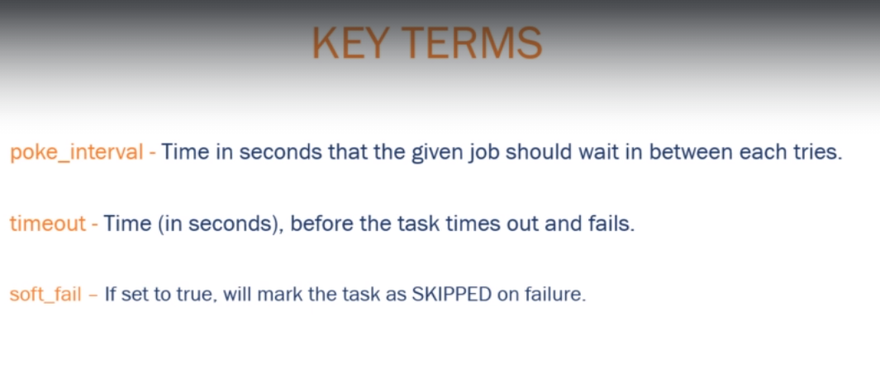

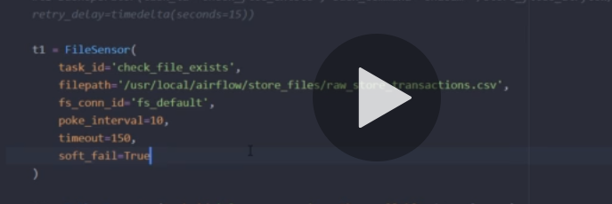

Delete the file from the source location and you will get the below error message.

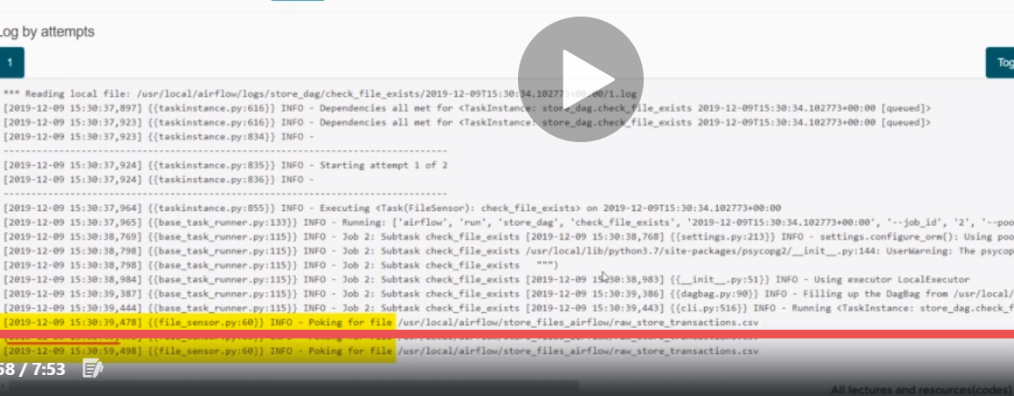



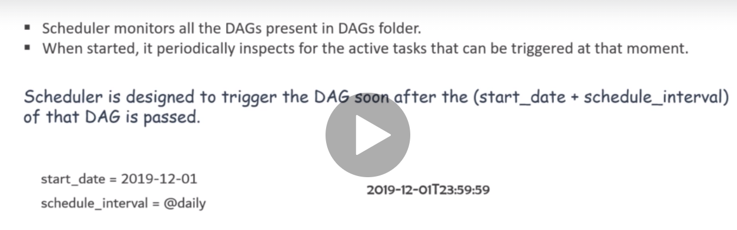

Airflow allows missed DAG Runs to be scheduled again so that the pipelines catchup on the schedules that were missed for some reason. It also allows rerunning of DAGs in back date manually & backfill those runs. Backfill & Catch up are confusing at first glance. In this blog we will understand the concepts. But before we start on these we need to refresh about “start_date” and “execution_date”.

## Start Date & Execution Date

***start_date****—*date at which DAG will start being scheduled

***schedule_interval****—*the interval of time from the minimum start_date at which we want our DAG to be triggered.



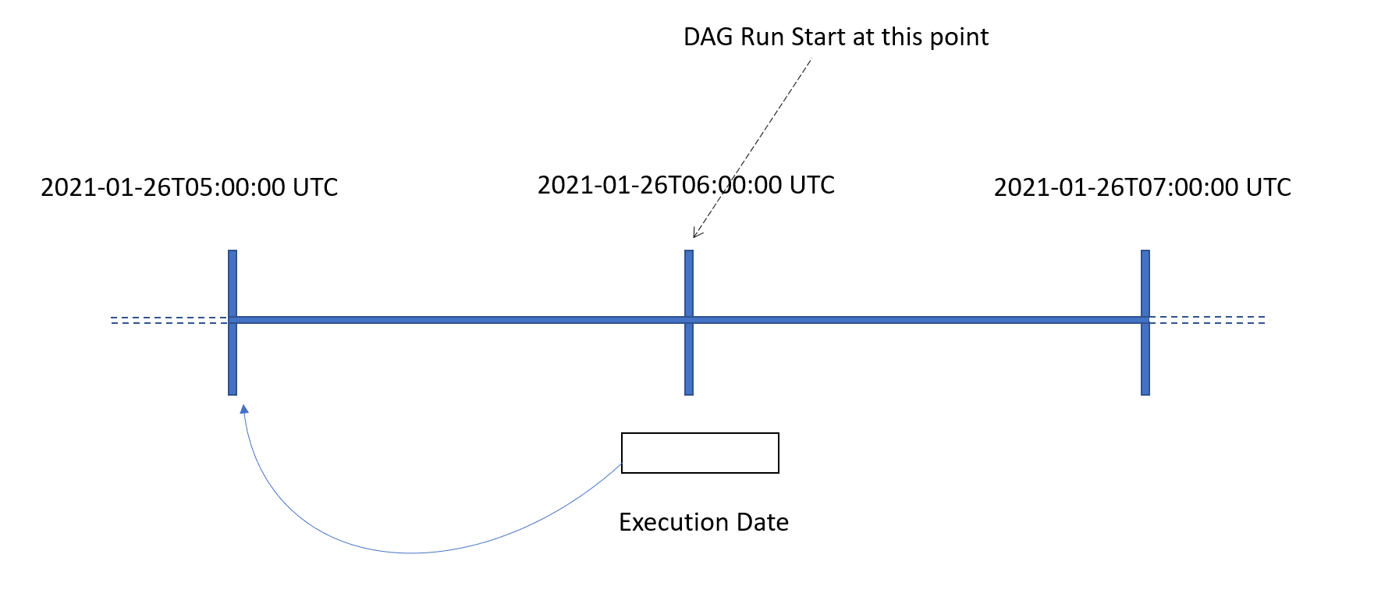

A DAG with start date at 2021–01–26T05:00:00 UTC and schedule interval of 1 hr, get actually executed at 2021–01–26T06:00:00 for data coming from 2021–01–26T05:00:00.

Trigger Point → start_date + { schedule_interval } → till the end.



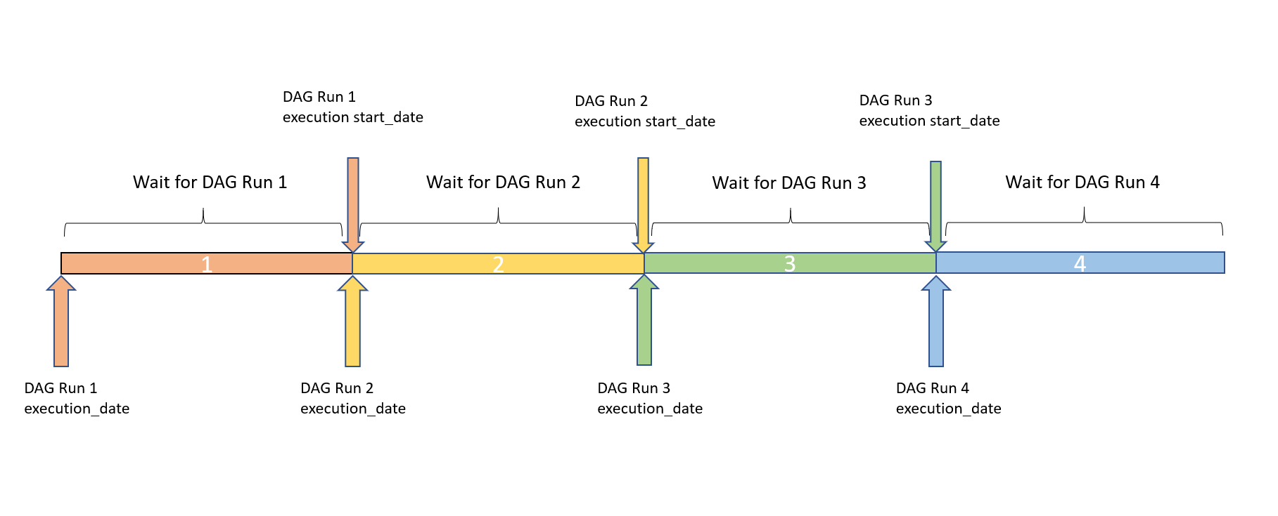

Execution date is the beginning Of the period for which data needs to be processed from.

## Catchup



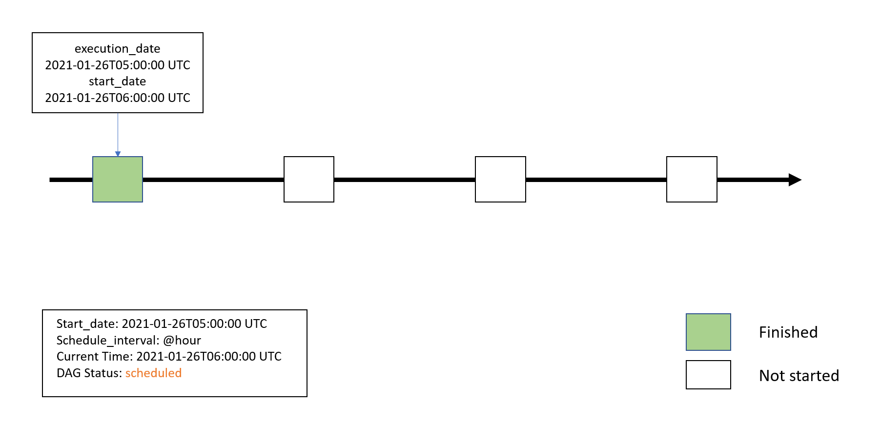

In the above image we are initial config where everything is fine and our DAG Run happened at 6. Then we paused the DAG.



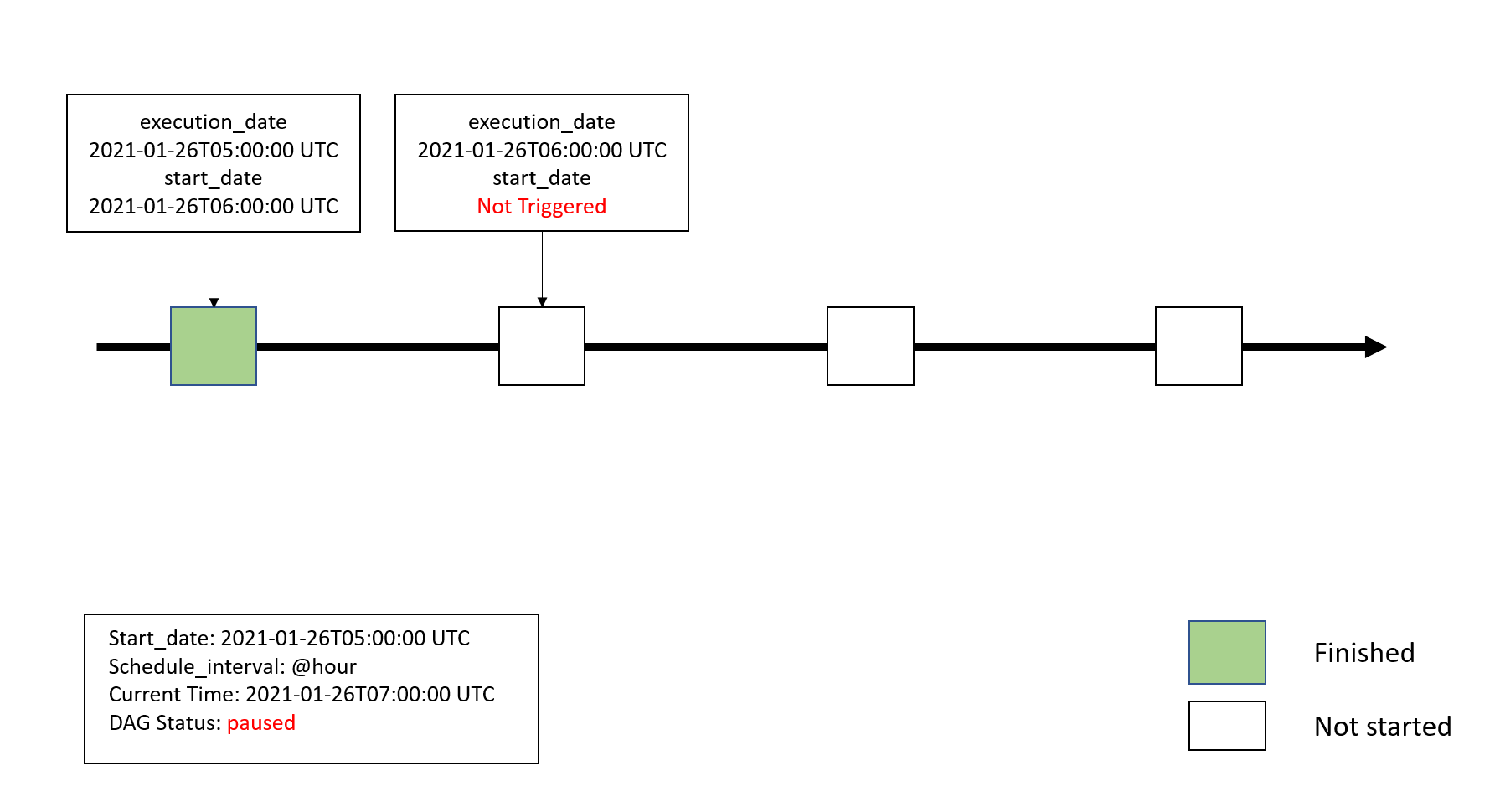

Here we see that since at the next schedule DAG run was paused hence start_date for the schedule is not available.



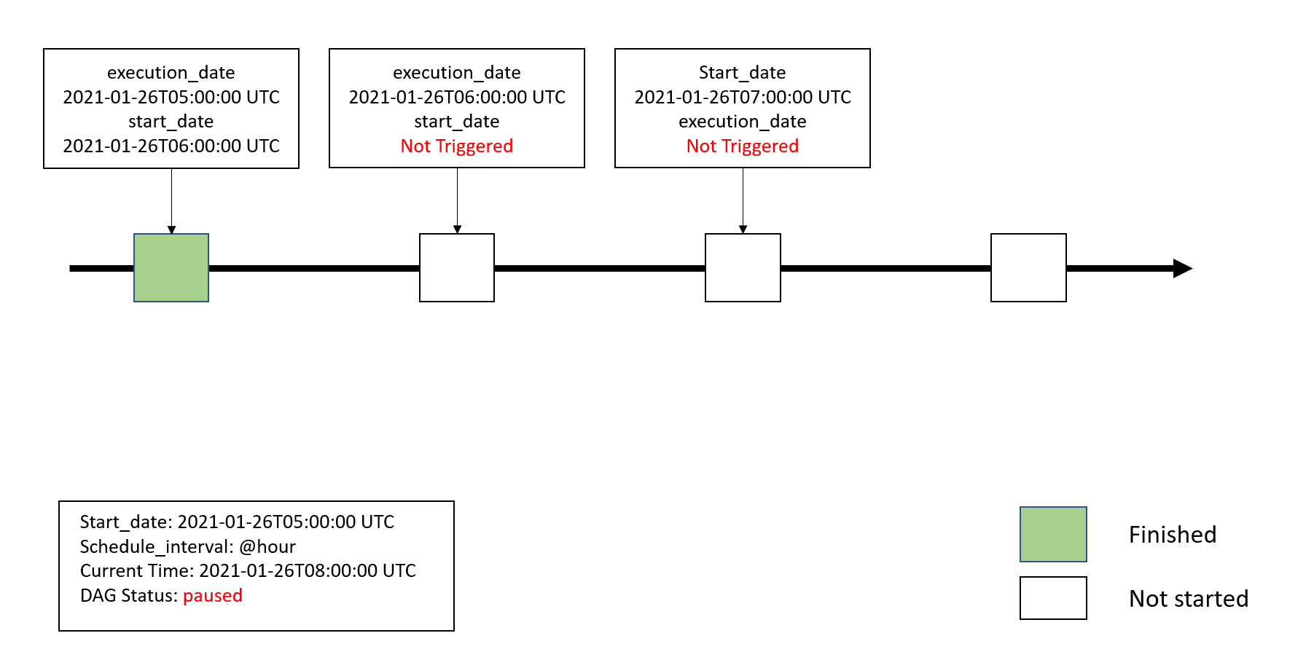

At the next schedule the same happened (DAG run was not triggered). Now we enable or schedule the DAG run from console



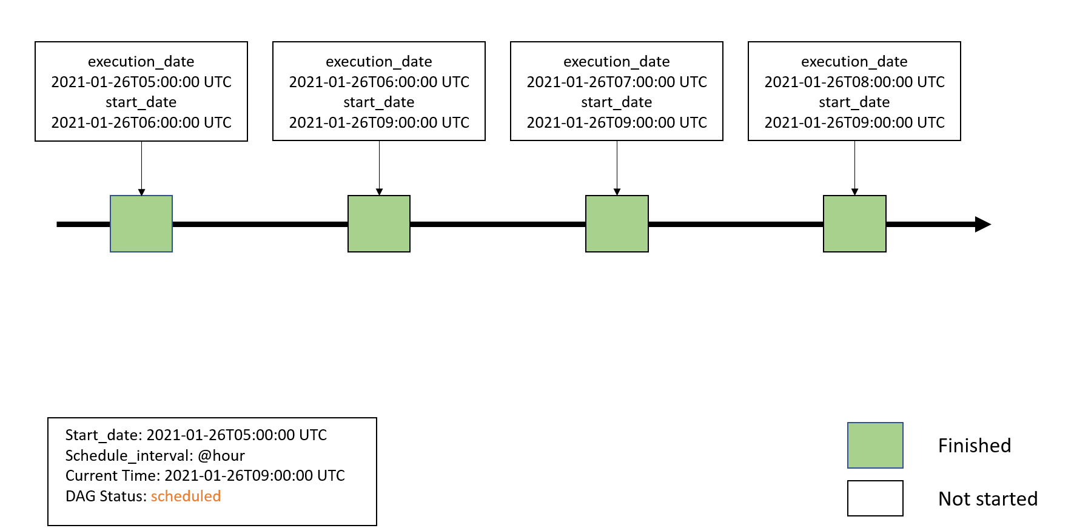

In the above diagram we see at the next schedule previously missed DAG Runs were triggered. Notice start_date is the next schedule (9). While the Execution dates are the actual ones, if you notice, start_date are same for the last three DAG runs. This denotes backfill. So first DAG run for execution date of 6 happened then for 7 and then for 8.

## Backfill

If for some reason we want to re run DAGs on certain schedules manually we can use the following CLI command to do so.

airflow backfill -s <START_DATE> -e <END_DATE> --rerun_failed_tasks -B <DAG_NAME>

This will execute all DAG runs that were scheduled between START_DATE & END_DATE **irrespective of the value of the catchup parameter**in airflow.cfg.

Note here -B means we want DAG Runs to happen in backwards. Latest date first then the older dates.

airflow backfill -m -s <START_DATE> -e <END_DATE> <DAG_NAME>

The above command will mark all task “success” for the given interval.

Note: With above CLI commands for backfill DAG run will have the backfill_ prefix in its ID.

Hope this was helpful!!

# **Airflow – Branching**

## Introduction

Branching is a useful concept when creating workflows. Simply speaking it is a way to implement if-then-else logic in airflow. For example, there may be a requirement to execute a certain task(s) only when a particular condition is met. This is achieved via airflow branching. If the condition is true, certain task(s) are executed and if the condition is false, different task(s) are executed.

Branching is achieved by implementing an Airflow operator called the **BranchPythonOperator**. To keep it simple – it is essentially, an API which implements a task. This task then calls a simple method written in python – whose only job is to implement an if-then-else logic and return to airflow the name of the next task to execute.

## Branching

Let’s take an example. We want to check if the value of a variable is greater than 10. If the value is greater than or equal 15 then task “greater than 15” should be executed and if the value is less than or task “less than 15” should be executed.

### **Step 1 – Create a variable**

Create a variable **v_val** with a value of **15**

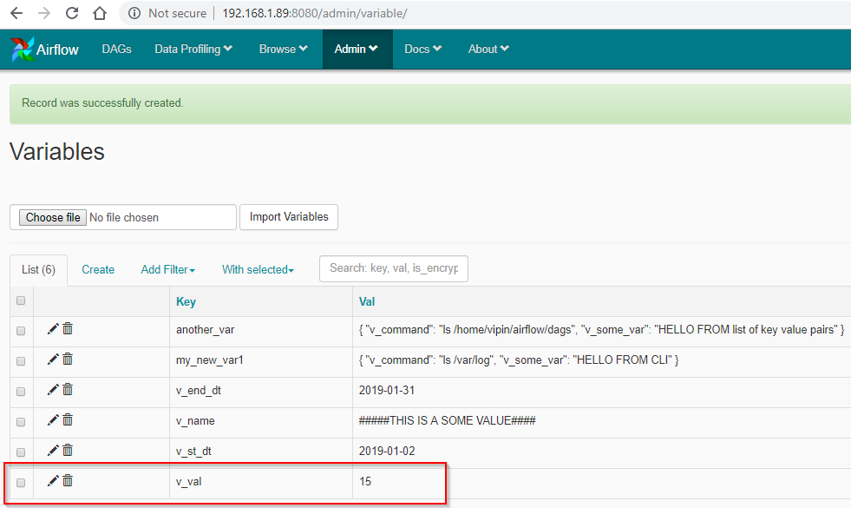

### **Step 2 – Create the DAG**

Let’s create a python file named – hello_branching.py

# Filename: hello_branching.py  
from airflow import DAG  
from airflow.operators.bash_operator import BashOperator  
from airflow.operators.python_operator import PythonOperator, BranchPythonOperator  
from datetime import datetime, timedelta  
from airflow.models import Variable  
  
# Step 1 - define the default parameters for the DAG  
default_args = {  
  'owner': 'airflow',  
  'depends_on_past': False,  
  'start_date': datetime(2019, 7, 20),  
  'email': ['vipin.chadha@gmail.com'],  
  'email_on_failure': False,  
  'email_on_retry': False,  
  'retries': 1,  
  'retry_delay': timedelta(minutes=5),  
  
}  
  
p_val=Variable.get('v_val') #Variable passed to registered method  
  
# Step 2 - Create a DAG object  
dag = DAG(  'hello_branching',  
        schedule_interval='0 0 * * *' ,  
        default_args=default_args  
    )  
  
# Step 3 - Define the method to check the condition for branching  
def my_check_condition(**kwargs):  
  if int(p_val)&gt;=15 :  
    return 'greater_Than_equal_to_15'  
  else:  
    return 'less_Than_15'  
  
# Step 4 - Create a Branching task to Register the method in step 3 to the branching API  
checkTask = BranchPythonOperator(  
  task_id='check_task',  
  python_callable=my_check_condition, #Registered method  
  provide_context=True,  
  dag=dag  
)  
  
# Step 5 - Create tasks  
greaterThan15 = BashOperator(  
  task_id= 'greater_Than_equal_to_15',  
  bash_command="echo value is greater than or equal to 15",  
  dag=dag  
)  
  
lessThan15 = BashOperator(  
  task_id= 'less_Than_15',  
  bash_command="echo value is less than 15",  
  dag=dag  
)  
  
# Step 6 - Define the sequence of tasks.  
greaterThan15.set_upstream(checkTask)  
lessThan15.set_upstream(checkTask)

Let’s analyse the code step by step

* **Step 1** – Define all the default variables and the p_val variable we want to run the checks in our function
* **Step 2** – Creates a DAG object
* **Step 3** – Defines the check method
* **Step 4** – Create a task for branching and register the call back function in it.
* **Step 5** – Create the remaining tasks
* **Step 6** – Set the ordering of the tasks

### **Step 3 – Execute the DAG**

When the code is executed with the **variable v_val set to 15**. It runs with the following dag

[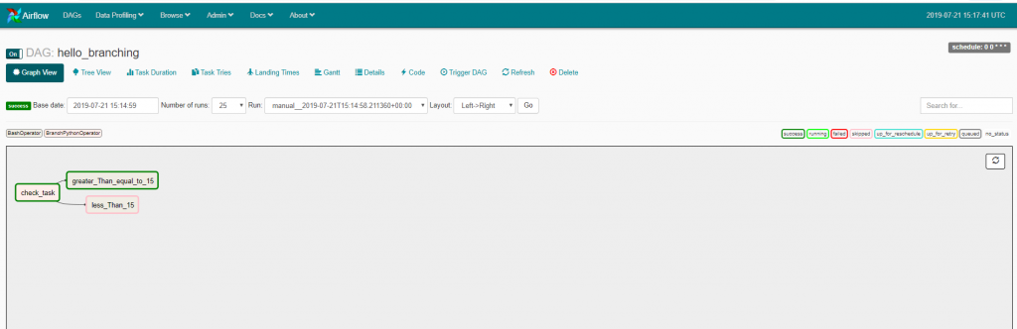](https://www.cloudwalker.io/wp-content/uploads/2019/07/image-24.png)

The output log of check_task is shown below with the relevant part highlighted. Click on the image to enlarge

[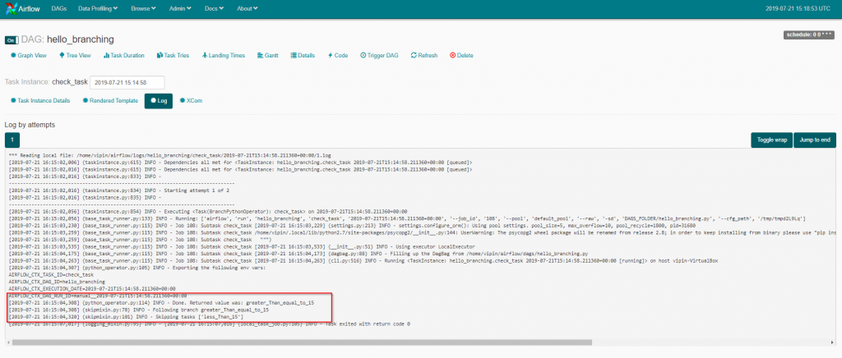](https://www.cloudwalker.io/wp-content/uploads/2019/07/image-25.png)

If the value of the**v_val is set to 10**(which is less than 15). The output is shown below

[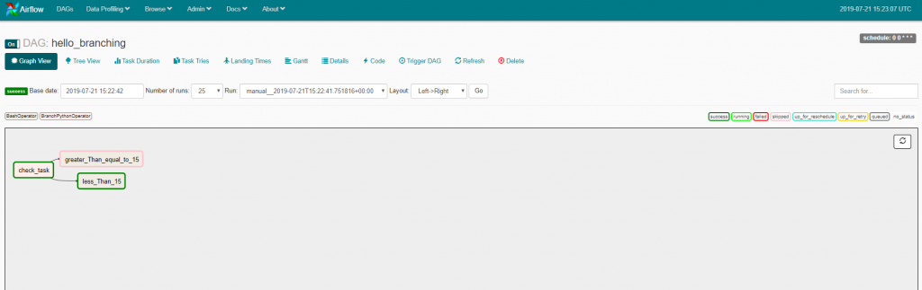](https://www.cloudwalker.io/wp-content/uploads/2019/07/image-26.png)

The output log of check_task is shown below with the relevant part highlighted. Click on the image to enlarge

[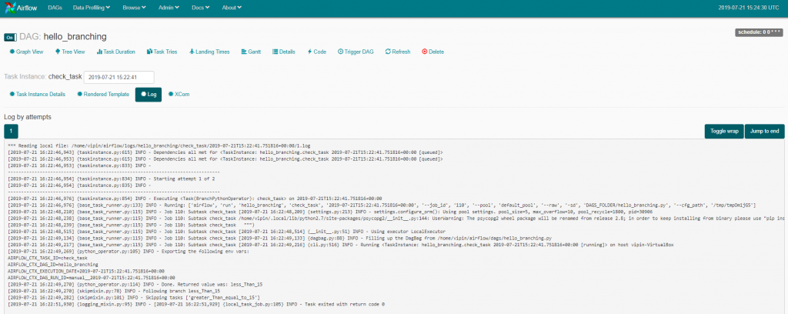](https://www.cloudwalker.io/wp-content/uploads/2019/07/image-27.png)

## Summary

There can be various ways the check condition can be implemented – including reading databases or file systems and so on. Once the callback function is ready it is then only a case of registering as a Task.

# **Airflow Branch joins**

## Introduction

In many use cases, there is a requirement of having different branches(see [blog entry](https://www.cloudwalker.io/2019/07/22/airflow-branching/)) in a workflow. However, these branches can also join together and execute a common task. Something similar to the pic below

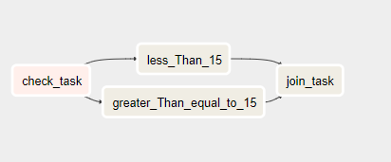

There is no special operator which is used but only the way we assign & set upstream and downstream relationships between the tasks. An example of this is shown below.

## Branch Join DAG

The **hello_joins** example extends a DAG from the [previous blog](https://www.cloudwalker.io/2018/06/06/apache-airflow-first-dag/) entry. An additional task is added to the dag which has been quite imaginatively named **join_task**.

# Filename: hello_join.py  
from airflow import DAG  
from airflow.operators.bash_operator import BashOperator  
from airflow.operators.python_operator import PythonOperator, BranchPythonOperator  
from datetime import datetime, timedelta  
from airflow.models import Variable  
from airflow.utils.trigger_rule import TriggerRule  
  
# Step 1 - define the default parameters for the DAG  
default_args = {  
  'owner': 'airflow',  
  'depends_on_past': False,  
  'start_date': datetime(2019, 7, 20),  
  'email': ['vipin.chadha@gmail.com'],  
  'email_on_failure': False,  
  'email_on_retry': False,  
  'retries': 1,  
  'retry_delay': timedelta(minutes=5),  
  
}  
  
p_val=Variable.get('v_val') #Variable passed to registered method  
  
# Step 2 - Create a DAG object  
dag = DAG(  'hello_joins',  
        schedule_interval='0 0 * * *' ,  
        default_args=default_args  
    )  
  
# Step 3 - Define the method to check the condition for branching  
def my_check_condition(**kwargs):  
  if int(p_val)&gt;=15 :  
    return 'greater_Than_equal_to_15'  
  else:  
    return 'less_Than_15'  
  
# Step 4 - Create a Branching task to Register the method in step 3 to the branching API  
checkTask = BranchPythonOperator(  
  task_id='check_task',  
  python_callable=my_check_condition, #Registered method  
  provide_context=True,  
  dag=dag  
)  
  
# Step 5 - Create tasks  
greaterThan15 = BashOperator(  
  task_id= 'greater_Than_equal_to_15',  
  bash_command="echo value is greater than or equal to 15",  
  dag=dag  
)  
  
lessThan15 = BashOperator(  
  task_id= 'less_Than_15',  
  bash_command="echo value is less than 15",  
  dag=dag  
)  
  
joinTask = BashOperator(  
  task_id= 'join_task',  
  bash_command="echo This is a join",  
  trigger_rule=TriggerRule.ONE_SUCCESS,  
  dag=dag  
)  
  
# Step 6 - Define the sequence of tasks.  
lessThan15.set_upstream(checkTask)  
greaterThan15.set_upstream(checkTask)  
joinTask.set_upstream([lessThan15, greaterThan15])

## Understand DAG

Let’s look at the changes introduced in the DAG.

* **Step 5**– A new task called join_task was added. Observe the **TriggerRule**which has been added. It is set to **ONE_SUCCESS**which means that if any one of the preceding tasks has been successful **join_task** should be executed.
* **Step 6 –** Adds the dependency to the **join_task** – as to when it should be executed.

## Execute DAG

Let’s execute hello_joins DAG and see the output

[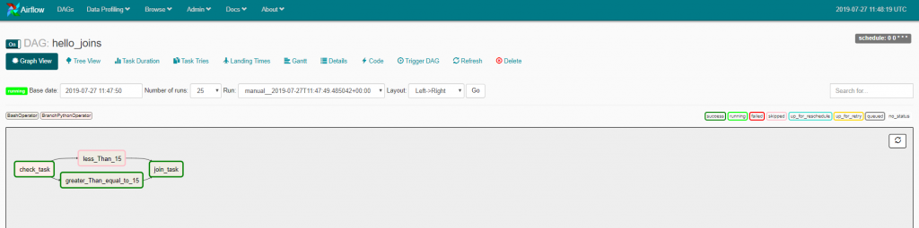](https://www.cloudwalker.io/wp-content/uploads/2019/07/image-29.png)

Observe how the branch **less_Than_15**was skipped and the common task – **join_task** is executed after the execution of **greater_Than_equal_to_15** task. Let’s change the value of the variable v_val to 10 and see the execution of DAG

[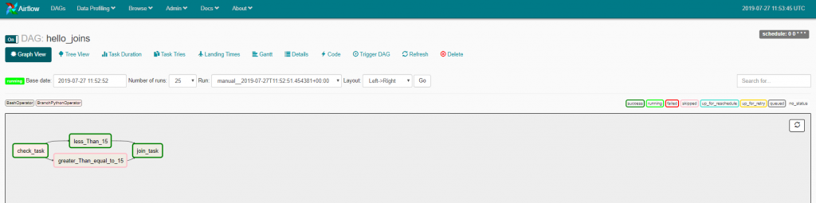](https://www.cloudwalker.io/wp-content/uploads/2019/07/image-30.png)

This time the branch **less_Than_15** is executed and after that the common task – **join_task** is executed again.

# **Airflow – Variables**

In the last entry on airflow(which was many moons ago!) we had created a simple DAG and executed it. It was simple to get us started. However, it did not allow us any flexibility. We could not change the behaviour of the DAG. In the real world scenarios, we may need to change the behaviour of our workflow based on certain parameters. This is accomplished by **Airflow Variables**

Airflow Variables are simple key-value pairs which are stored in the database which holds the airflow metadata. These variables can be created & managed via the airflow UI or airflow CLI.

Airflow WebUI -> Admin -> Variables

[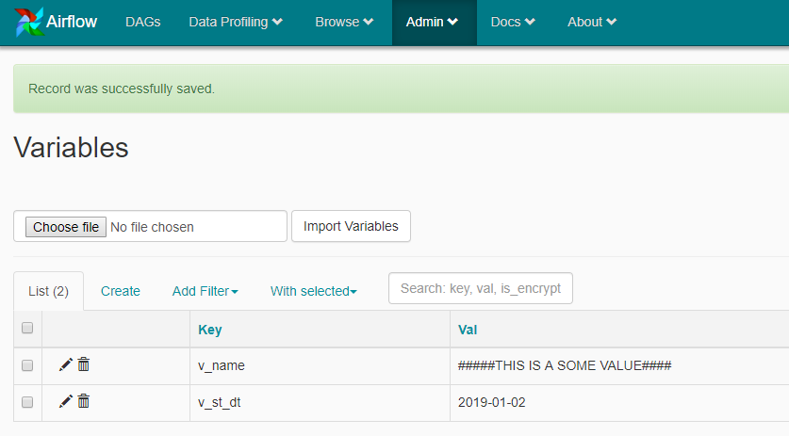](https://www.cloudwalker.io/wp-content/uploads/2019/07/image.png)

Some of the features of Airflow variables are below

* Can be defined as a simple key-value pair
* One variable can hold a list of key-value pairs as well!
* Stored in airflow database which holds the metadata
* Can be used in the Airflow DAG code as jinja variables.

## Define a single key-value variable

Airflow variables can be created using three ways

1. Using Airflow Web UI
2. Airflow CLI
3. File Import

### **Using Airflow Web UI**

To define a variable to hold a single value is done in the following steps

#### Step 1 – Navigate to Airflow UI->Admin->Variables

[](https://www.cloudwalker.io/wp-content/uploads/2019/07/image-1.png)

#### Step 2 – Press Create

[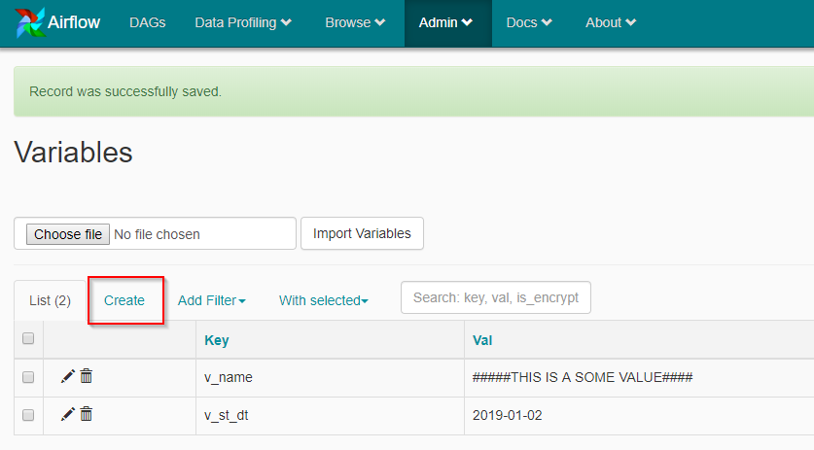](https://www.cloudwalker.io/wp-content/uploads/2019/07/image-2.png)

#### Step 3 – Define the variable

[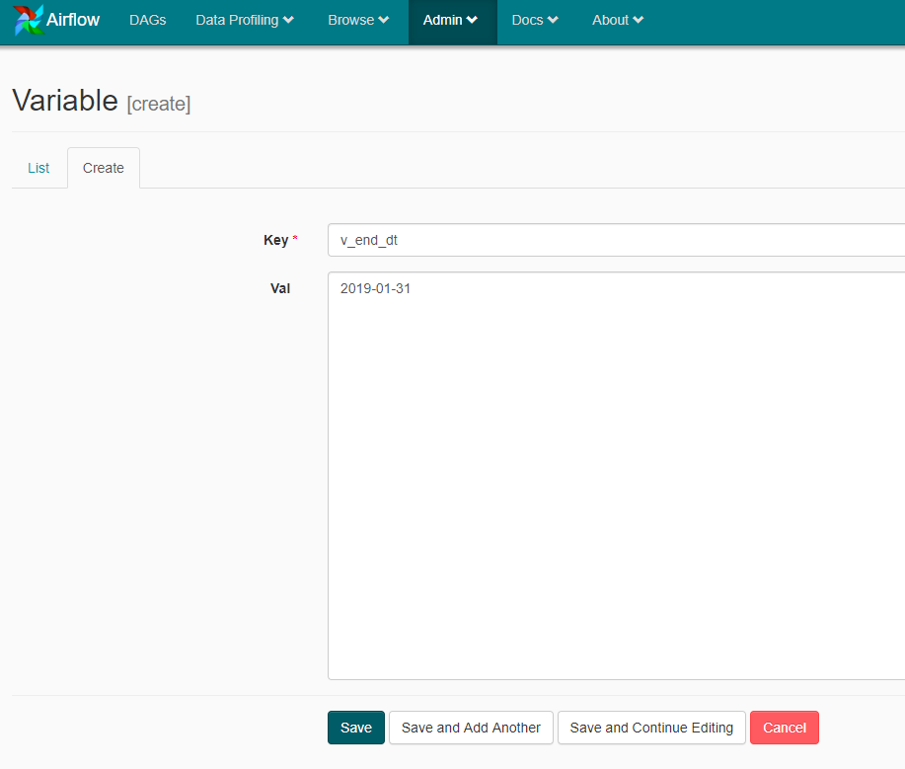](https://www.cloudwalker.io/wp-content/uploads/2019/07/image-3.png)

Press **Save** to create the variable.

[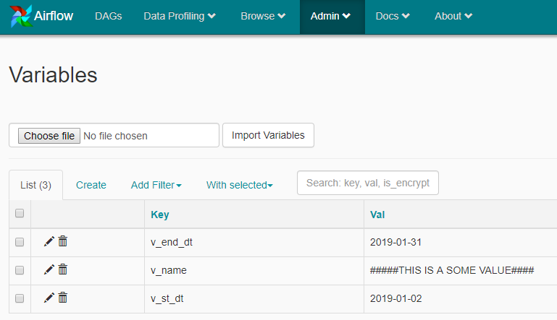](https://www.cloudwalker.io/wp-content/uploads/2019/07/image-5.png)

### **Airflow CLI**

Variables can also be created via Airflow CLI. Use the following command to create variable via CLI

airflow variables --set my_new_var testval

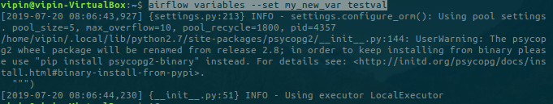

The variable is then also visible in the Airflow Web UI

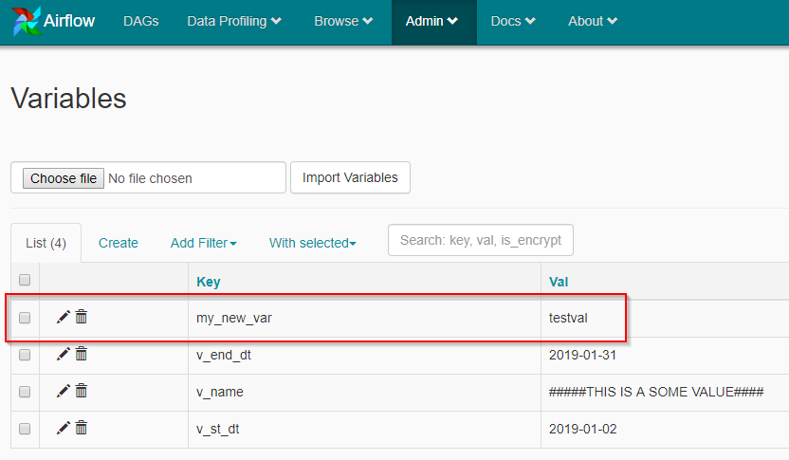

The CLI allows all creation, deletion and import of variables and is quite easy. Here is the documentation [link](https://airflow.apache.org/cli.html#variables)

### **Usage**

Variables can be quite easily be used in the code as jinja variables. Below is an example of a DAG which uses one of the variables we have defined earlier –**v_name**

You can access a variable using the following API

var.value.<variable name>

For example var.value.v_name. See Below

# Filename: hello_world_variables.py  
from airflow import DAG  
from airflow.operators.bash_operator import BashOperator  
from datetime import datetime, timedelta  
  
default_args = {  
  'owner': 'airflow',  
  'depends_on_past': False,  
  'start_date': datetime(2019, 7, 13),  
  'email': ['vipin.chadha@gmail.com'],  
  'email_on_failure': False,  
  'email_on_retry': False,  
  'retries': 1,  
  'retry_delay': timedelta(minutes=5),  
  
}  
  
dag = DAG(  'hello_world_variables',  
        schedule_interval='0 0 * * *' ,  
        default_args=default_args  
    )  
  
# Use of variable in the command  
create_command = 'echo {{var.value.v_name}}'  
  
t1 = BashOperator(  
  task_id='print_date',  
  bash_command='date',  
  dag=dag  
)  
  
t2 = BashOperator(  
  task_id= 'echo_my_variable',  
  bash_command=create_command,  
  dag=dag  
)  
  
t2.set_upstream(t1)

Let’s execute the DAG and see the output

Once the DAG is executed you can see the logs using the following steps

Click on the **DAG**

[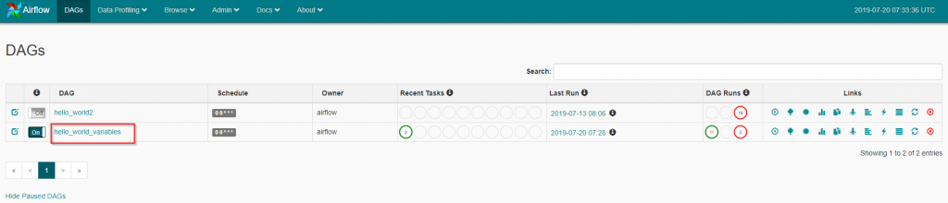](https://www.cloudwalker.io/wp-content/uploads/2019/07/image-9.png)

Click on **Graph View** and then **echo_my_variable**

[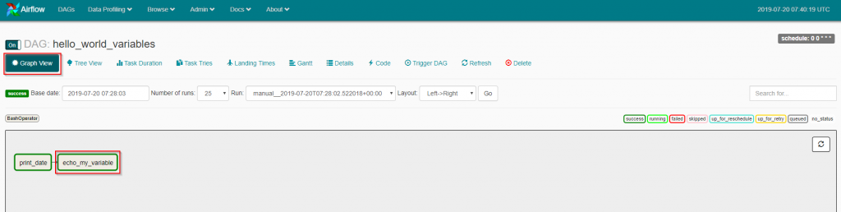](https://www.cloudwalker.io/wp-content/uploads/2019/07/image-11.png)

Click on **View Log**

[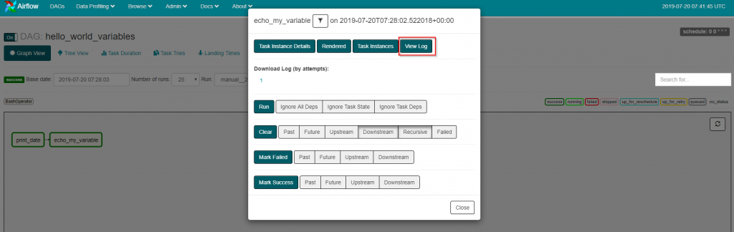](https://www.cloudwalker.io/wp-content/uploads/2019/07/image-12.png)

The log of the task is shown below with the output of our command highlighted

[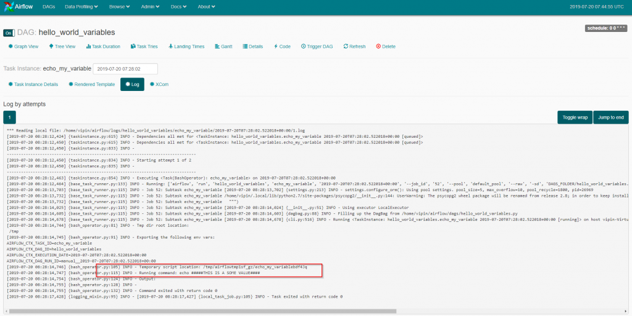](https://www.cloudwalker.io/wp-content/uploads/2019/07/image-13.png)

## Define a variable – list of key-value pairs

If your DAG uses more than one variable then(depending upon the use case) they can be stored as a list of key-value pairs in an airflow variable. The variables can be created via UI and CLI or imported as well.

### **Airflow UI**

Navigate to Airflow Web UI ->Admin -> Variables and create a variable called another_var. Observe how the key-value pairs are added as a JSON. See Below

[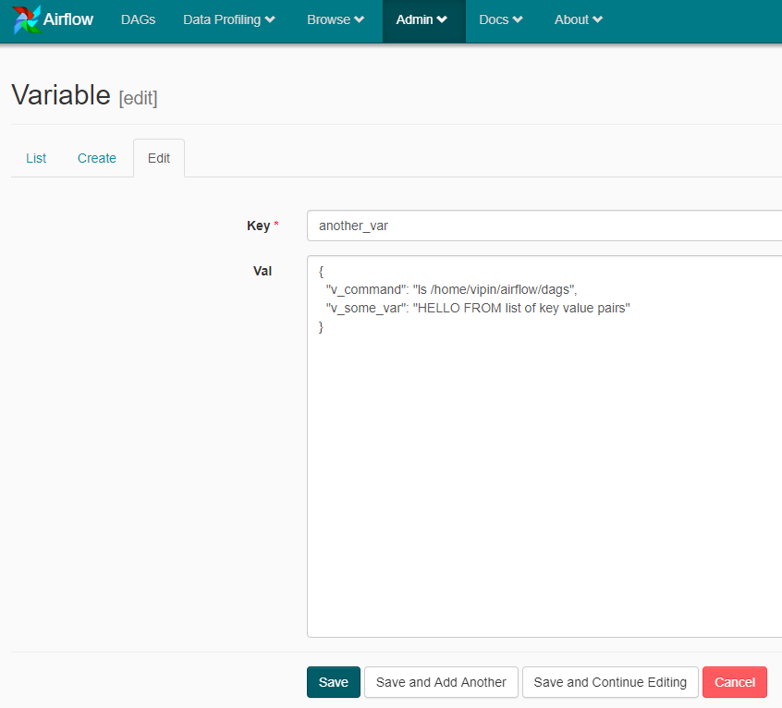](https://www.cloudwalker.io/wp-content/uploads/2019/07/image-14.png)

Save and you have a variable which is a list of key-value pairs

[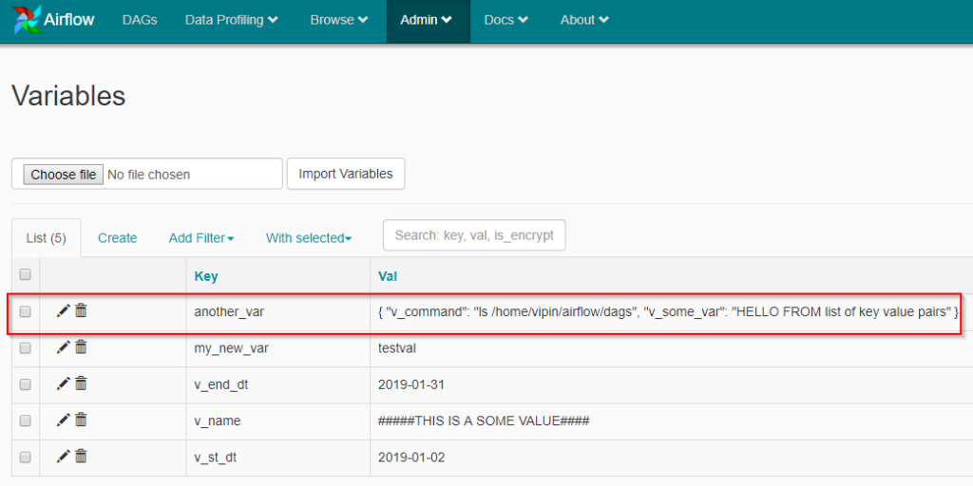](https://www.cloudwalker.io/wp-content/uploads/2019/07/image-15.png)

### **Airflow CLI**

From the command line, the variables with a list of key-value pairs can be created using the following command

airflow variables --set my_new_var1 '{ "v_command": "ls /var/log", "v_some_var": "HELLO FROM CLI" }'

[](https://www.cloudwalker.io/wp-content/uploads/2019/07/image-16.png)(Click on the image)

The variable is now also available in the Airflow Web UI.

[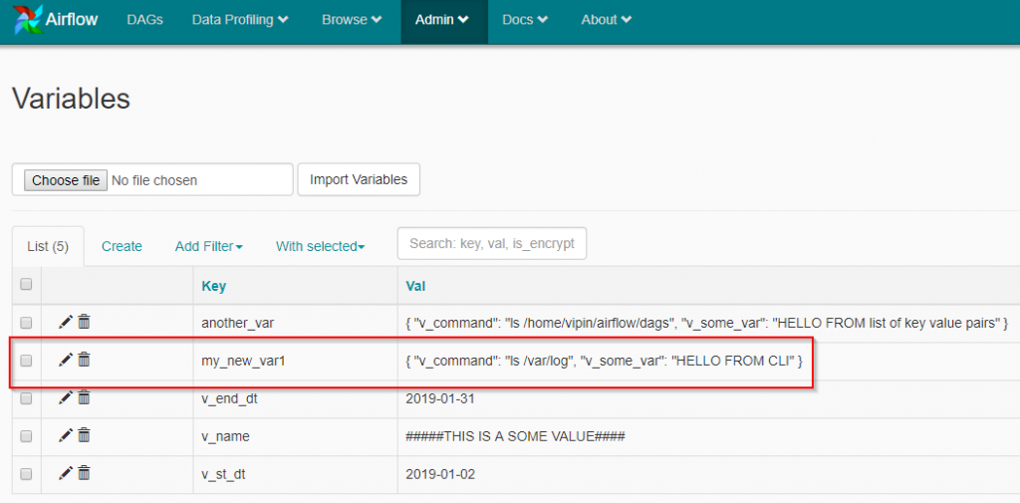](https://www.cloudwalker.io/wp-content/uploads/2019/07/image-17.png)

## Usage

Let’s now see how the variables with a list of key-value pairs are used in the code. The DAG below uses a key-value pair from the variable **another_var**. See Below

# Filename: hello_world_variables_2.py  
from airflow import DAG  
from airflow.operators.bash_operator import BashOperator  
from datetime import datetime, timedelta  
  
default_args = {  
  'owner': 'airflow',  
  'depends_on_past': False,  
  'start_date': datetime(2019, 7, 19),  
  'email': ['vipin.chadha@gmail.com'],  
  'email_on_failure': False,  
  'email_on_retry': False,  
  'retries': 1,  
  'retry_delay': timedelta(minutes=5),  
  
}  
  
dag = DAG(  'hello_world_variables_2',  
        schedule_interval='0 0 * * *' ,  
        default_args=default_args  
    )  
  
  
create_command = '{{var.json.another_var.v_command}}'  
  
t1 = BashOperator(  
  task_id='print_date',  
  bash_command='date',  
  dag=dag  
)  
  
t2 = BashOperator(  
  task_id= 'run_my_command',  
  bash_command=create_command,  
  dag=dag  
)  
  
t2.set_upstream(t1)

Once the DAG is executed you can see the logs using the following steps

Click on **DAG**

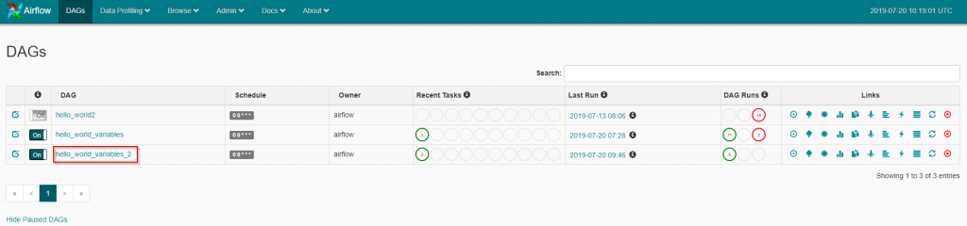

Click on **Graph View** and then **run_my_variable**

[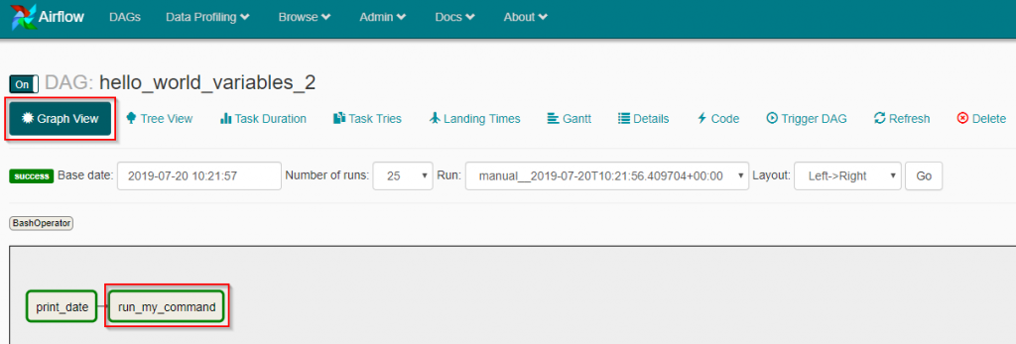](https://www.cloudwalker.io/wp-content/uploads/2019/07/image-19.png)

Click on **Log**

[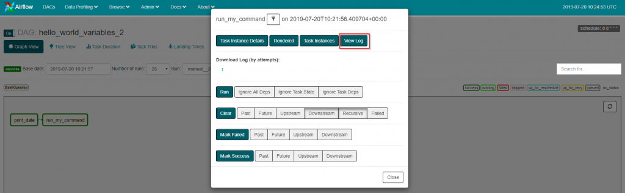](https://www.cloudwalker.io/wp-content/uploads/2019/07/image-20.png)

The log is shown below

[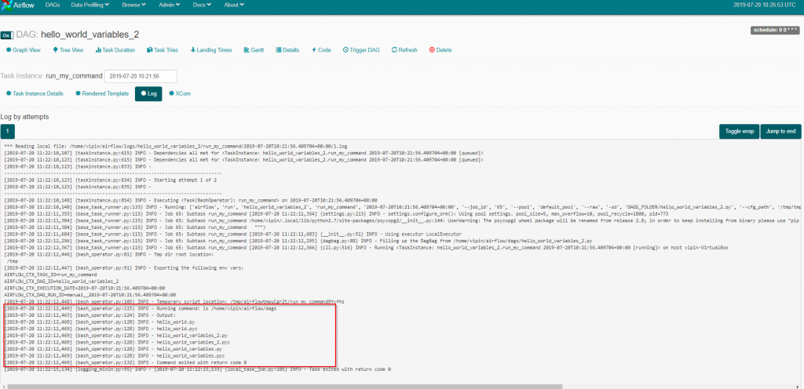](https://www.cloudwalker.io/wp-content/uploads/2019/07/image-21.png)

# **Airflow – Sub-DAGs**

Introduction

Workflows can quickly become quite complicated which makes them difficult to understand. To reduce complexity tasks can be grouped together into smaller DAGs and then called. This makes DAGs easier to manage and maintain.

Creating a sub dag consists of

1. Creating the actual Sub DAG and testing it.
2. Create a DAG which calls the Sub-DAG created in Step1.

For those of you wondering how to call a sub-dag. It is easy using the **SubDagOperator**. In the next example, we would re-use one of our earlier examples as a Sub-DAG and call it from another DAG.

Create a Sub-DAG

Let’s first see the code of the Sub-DAG. You will observe that it is very similar to a DAG from the previous entries except that it is called inside a function. See Below

# Filename: hello_subdag.py  
from airflow import DAG  
from airflow.operators.bash_operator import BashOperator  
from airflow.operators.python_operator import PythonOperator, BranchPythonOperator  
from datetime import datetime, timedelta  
from airflow.models import Variable  
from airflow.utils.trigger_rule import TriggerRule  
  
def my_sub_dag(parent_dag_id):  
    # Step 1 - define the default parameters for the DAG  
    default_args = {  
      'owner': 'airflow',  
      'depends_on_past': False,  
      'start_date': datetime(2019, 7, 28),  
      'email': ['vipin.chadha@gmail.com'],  
      'email_on_failure': False,  
      'email_on_retry': False,  
      'retries': 1,  
      'retry_delay': timedelta(minutes=5),  
  
    }  
     
    p_val=Variable.get('v_val') #Variable passed to registered method  
  
  
    # Step 2 - Create a DAG object  
    my_sub_dag = DAG(dag_id = parent_dag_id+ '.' + 'my_sub_dag',  
            schedule_interval='0 0 * * *' ,  
            default_args=default_args  
        )  
  
    # Step 3 - Define the method to check the condition for branching  
    def my_check_condition(**kwargs):  
      if int(p_val)&gt;=15 :  
        return 'greater_Than_equal_to_15'  
      else:  
        return 'less_Than_15'  
  
    # Step 4 - Create a Branching task to Register the method in step 3 to the branching API  
    checkTask = BranchPythonOperator(  
      task_id='check_task',  
      python_callable=my_check_condition, #Registered method  
      provide_context=True,  
      dag=my_sub_dag  
    )  
  
    # Step 5 - Create tasks  
    greaterThan15 = BashOperator(  
      task_id= 'greater_Than_equal_to_15',  
      bash_command="echo value is greater than or equal to 15",  
      dag=my_sub_dag  
    )  
  
    lessThan15 = BashOperator(  
      task_id= 'less_Than_15',  
      bash_command="echo value is less than 15",  
      dag=my_sub_dag  
    )  
  
    finalTask = BashOperator(  
      task_id= 'join_task',  
      bash_command="echo This is a join",  
      trigger_rule=TriggerRule.ONE_SUCCESS,  
      dag=my_sub_dag  
    )  
  
  
    # Step 6 - Define the sequence of tasks.  
    lessThan15.set_upstream(checkTask)  
    greaterThan15.set_upstream(checkTask)  
    finalTask.set_upstream([lessThan15, greaterThan15])  
  
    # Step 7 - Return the DAG  
    return my_sub_dag

Before moving forward a few important points

* Airflow Sub DAG is in a separate file in the same directory.
* Airflow Sub DAG has been implemented as a function.
* Airflow Sub DAG id needs to be in the following format parent_dag_id.child_dag_id. If not you will get errors. Check out the dag_id in step 2

Call the Sub-DAG

Next, let’s create a DAG which will call our sub dag. See Below

# Filename: hello_main_dag.py  
from airflow import DAG  
from airflow.operators.bash_operator import BashOperator  
from airflow.operators import PythonOperator, SubDagOperator  
from datetime import datetime, timedelta  
from hello_sub_dag import my_sub_dag  
  
# Step 1 - define the default parameters for the DAG  
default_args = {  
  'owner': 'airflow',  
  'depends_on_past': False,  
  'start_date': datetime(2019, 7, 28),  
  'email': ['vipin.chadha@gmail.com'],  
  'email_on_failure': False,  
  'email_on_retry': False,  
  'retries': 1,  
  'retry_delay': timedelta(minutes=5),  
  
}  
  
# Step 2 - Create a DAG object  
dag = DAG(  'hello_main_dag',  
        schedule_interval='0 0 * * *' ,  
        default_args=default_args  
    )  
  
# Step 3 - Create tasks  
some_task = BashOperator(  
  task_id= 'someTask',  
  bash_command="echo I am some task",  
  dag=dag  
)  
  
sub_dag = SubDagOperator(  
    subdag=my_sub_dag('hello_main_dag'),  
    task_id='my_sub_dag',  
    dag=dag  
)  
  
final_task = BashOperator(  
  task_id= 'finalTask',  
  bash_command="echo I am the final task",  
  dag=dag  
)  
  
# Step 4 - Define the sequence of tasks.  
sub_dag.set_upstream(some_task)  
final_task.set_upstream(sub_dag)

DAG Execution

If you go thru the code you will find the following

* Sub DAG python file has been imported as any other file/package.
* Use of SubDagOperator in step 3 which calls the function in sub dag python file.

The above code results in the following DAG

[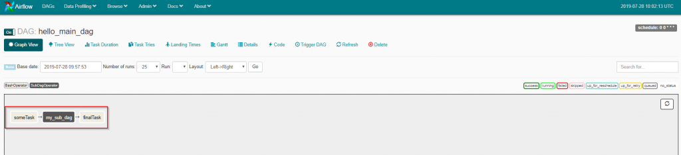](https://www.cloudwalker.io/wp-content/uploads/2019/07/image-31.png)

You can click on the sub-dag which is the box filled with gray color and white text.

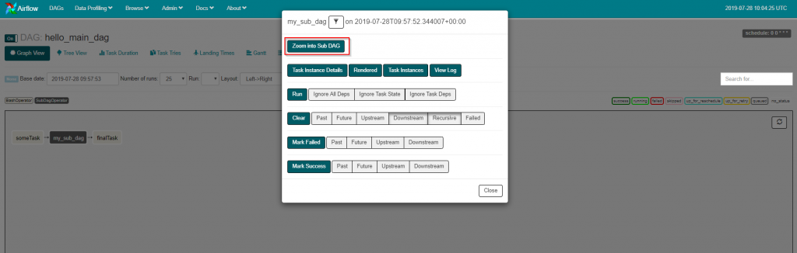

In the above pic if you click on **Zoom into Sub-DAG** it will open the sub dag for us. See Below

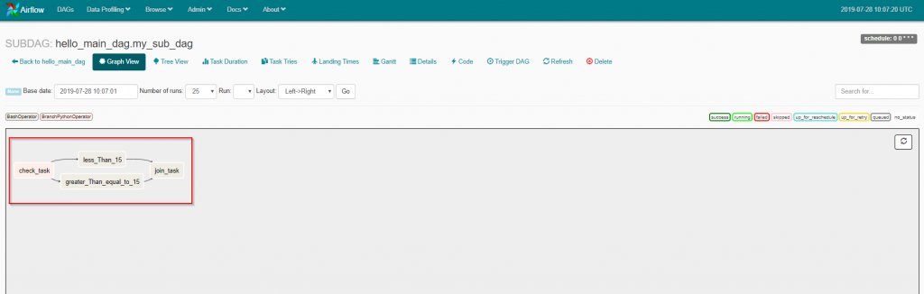

When executed the main DAG executes the sub dag, which then launches the tasks inside the sub dag and the control is passed back to the main dag once the sub-dag finishes.

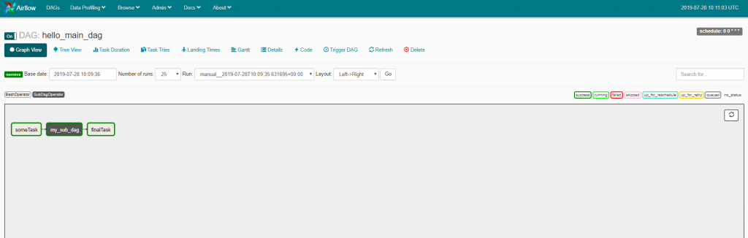

This brings us to the end of this blog entry. Hope you find this blog entry useful.

# **Airflow – Connections**

## Introduction

We understand that airflow is a workflow/job orchestration engine and can execute various tasks by connecting to our environments. There are various ways to connect to an environment. One needs is connection details about that environment to connect to. For example

* Postgres DB – Hostname, Port, Schema
* SSH – Hostname which allows SSH connections.

The list may extend to AWS, Google Cloud or Azure as well. But all of them need to some sort of connection information. Airflow is no different and needs connection information.

One only needs to log in and goto **Admin->Connections** to see the exhaustive list of connections which are possible.

[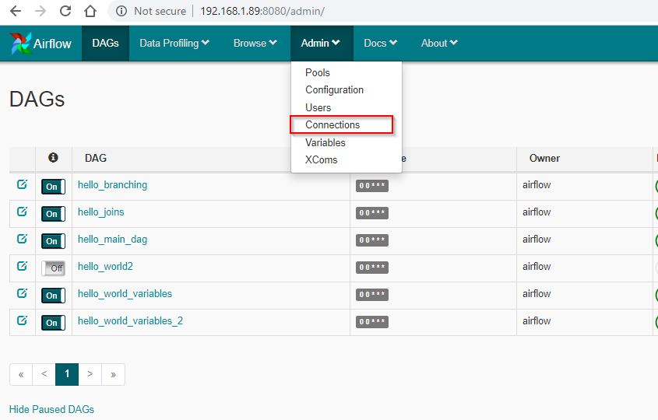](https://www.cloudwalker.io/wp-content/uploads/2019/08/image.png)[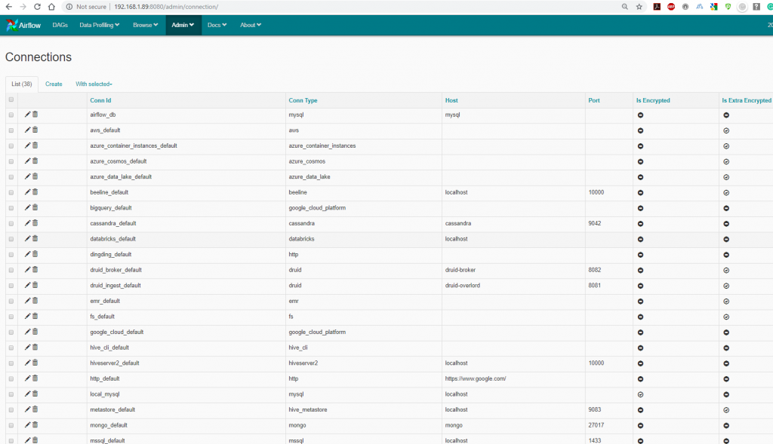](https://www.cloudwalker.io/wp-content/uploads/2019/08/image-1.png)

Airflow allows for various connections and some of the documentation can be found on this [link](https://airflow.apache.org/howto/connection/index.html). You can see the various types of connections which can be made by airflow. This makes connecting to different types of technologies so easy by airflow. Keep in mind you can create your own connections if you do not find one which suits you. Though I doubt it but who knows!

Going into all the different types of connections is really not possible. However, we can look at one of the most often used one – SSH connections. This is one of the most widely used airflow connections and makes it a good example to provide for this blog entry. We will also look at a few more as we go thru the airflow blog series.

## SSH Airflow Connections

The use case for this is pretty simple. There is a requirement to execute a shell script on a remote server. As a part of our airflow workflow orchestration, we need to enable airflow to execute a shell script or Linux command be executed on a remote server. Let’s get started

For this blog entry – I have already created an EC2 instance which has a working shell script. Now airflow should be able to execute this shell script as a part of a DAG.

The shell script is in /home/ec2-user/my_test.sh

echo ******Hello World from AWS EC2 Instance*******  
echo $(hostname -i)

Nothing fancy but should give us a good idea about what airflow connection can do.

The following steps are involved

**Step-1 – Goto Admin->Connections**

[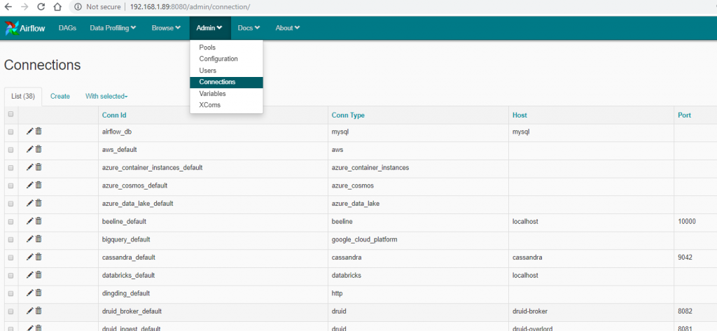](https://www.cloudwalker.io/wp-content/uploads/2019/08/image-2.png)

**Step-2 – Click on Create**

[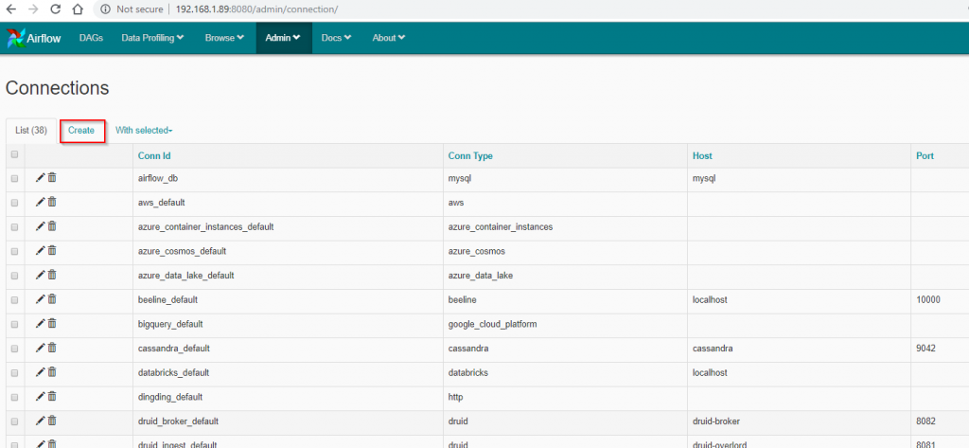](https://www.cloudwalker.io/wp-content/uploads/2019/08/image-3.png)

**Step-3 – Enter the connection details and Save**

[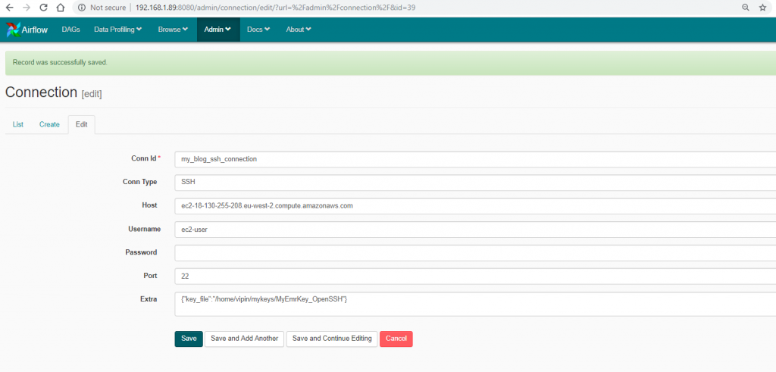](https://www.cloudwalker.io/wp-content/uploads/2019/08/image-4.png)

Note: There are a couple of catches before you jump ahead

1. Make sure you are able to access your Linux box from airflow server before jumping head.
2. Install the following python library and its dependencies
   * ssh_tunnel

List of connections now shows the new ssh connection.

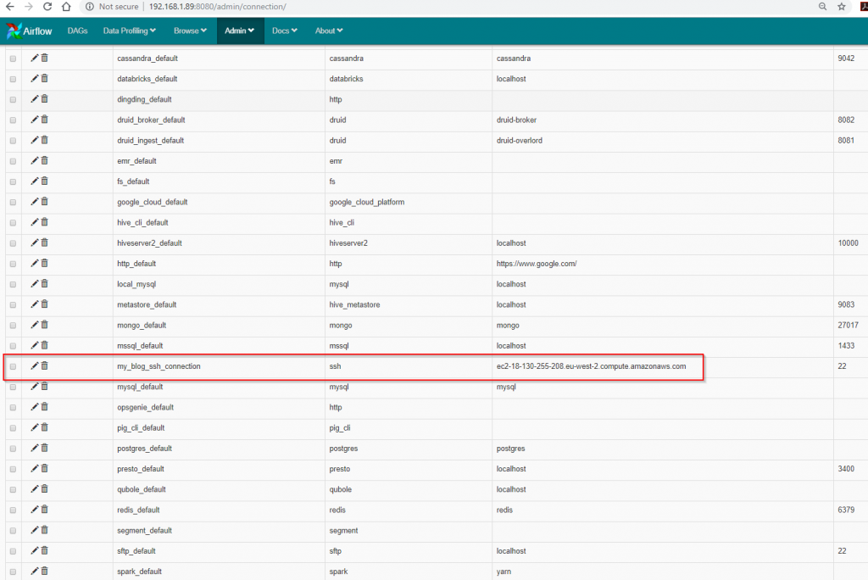

**Step-4 Create a DAG**

Below is the dag used for this blog entry. Add this to the $DAG_HOME as **hello_connections.py**

# Filename: hello_connections1.py  
from airflow import DAG  
from airflow.contrib.operators.ssh_operator import SSHOperator  
from airflow.contrib.hooks import SSHHook  
from datetime import datetime, timedelta  
  
default_args = {  
  'owner': 'airflow',  
  'depends_on_past': False,  
  'start_date': datetime(2019, 8, 31),  
  'email': ['airflow@example.com'],  
  'email_on_failure': False,  
  'email_on_retry': False,  
  'retries': 1,  
  'retry_delay': timedelta(minutes=5),  
# 'queue': 'bash_queue',  
# 'pool': 'backfill',  
# 'priority_weight': 10,  
# 'end_date': datetime(2016, 1, 1),  
}  
  
dag = DAG(  'hello_connections1',  
        schedule_interval='0 0 * * *' ,  
        default_args=default_args  
    )  
  
sshHook = SSHHook('my_blog_ssh_connection')  
linux_command = "sh /home/ec2-user/my_test.sh "  
  
t1 = SSHOperator(  
    ssh_hook=sshHook,  
    task_id='test_remote_script',  
    command=linux_command,  
    dag=dag)

*Note: Observe in the****string****– linux_command. At the end, there is a space. If you do not give the space airflow interprets the string as a jinja template. More of this can be found on this*[*link*](https://cwiki.apache.org/confluence/display/AIRFLOW/Common+Pitfalls)

When the dag is executed the following is the output. The relevant lines are highlighted.

[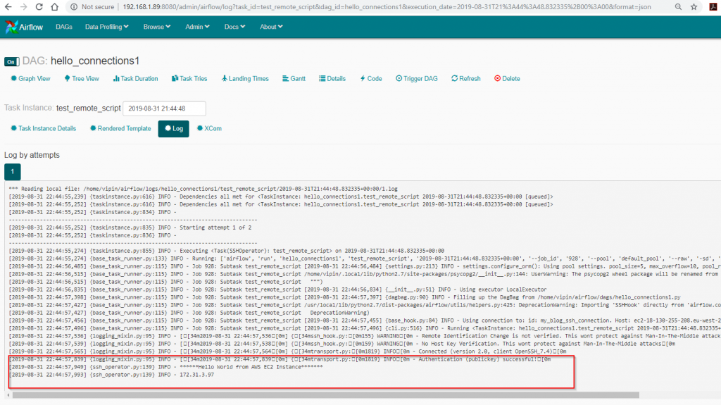](https://www.cloudwalker.io/wp-content/uploads/2019/08/image-6.png)

The airflow server goes to the remote AWS EC2 instance and executes a shell script and outputs the results to airflow log. As you can see now airflow can now connect to different servers and execute commands and complete more complicated workflows.

# **Airflow – Scale out with RabbitMQ and Celery**

## Introduction

Airflow Queues and workers are required if there is a need to make the airflow infrastructure more flexible and resilient. This blog entry describes how to install/setup/configure additional components so that we can use airflow in a more flexible and resilient manner.

Till now we have used a local executor to execute all our jobs. Which works fine if we have a small number of jobs and they are not running when another job is running. However, in the real world, this is always the case. Additionally, we also need to take care of the possibilities of an airflow local executor becoming unavailable.

Airflow queues are like any other queues and use a messaging system – like RabbitMQ, ActiveMQ. Airflow scheduler sends tasks as messages to the queues and hence acts as a publisher. Airflow workers are configured to listen for events(i.e tasks) coming on particular queues and execute those tasks. Pretty cool – Have a look at the diagram below.

[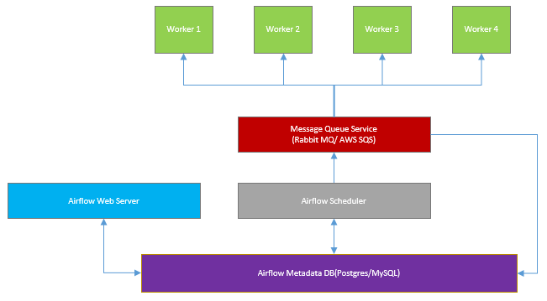](https://www.cloudwalker.io/wp-content/uploads/2019/09/image-25.png)

To create an infrastructure like this we need to do the following steps

1. Install & Configure RabbitMQ on a separate host – 1 server
2. Install & Configure Airflow with RabbitMQ and Celery Executor support – 4 servers
3. Start airflow scheduler & webserver
4. Start airflow workers
5. Start flower UI
6. Run a DAG
7. Watch it all happen!

## Install & Configure RabbitMQ

This step is probably the most tricky part and can be broken into four smaller steps.

***Note****: Only do this step if you donot have a RabbitMQ setup. If you already you can skip this step.*

### **Step-1a – Install RabbitMQ**

We will install RabbitMQ on a separate machine and for the purposes of this blog entry, I have created it on an AWS EC2 instance(**RedHat 8**) on which RabbitMQ is installed.

Download the following

* Download **Erlang rpm** from this [link](https://github.com/rabbitmq/erlang-rpm/releases/download/v20.1.7/erlang-20.1.7-1.el6.x86_64.rpm)onto your EC2 instance
* Download the **RabbitMQ rpm** from this [link](https://dl.bintray.com/rabbitmq/all/rabbitmq-server/3.7.0/rabbitmq-server-3.7.0-1.el6.noarch.rpm) onto your EC2 instance

Execute the following commands

sudo yum install socat  
sudo yum install logrotate  
sudo yum install erlang-20.1.7-1.el6.x86_64.rpm  
sudo yum install rabbitmq-server-3.7.0-1.el6.noarch.rpm

[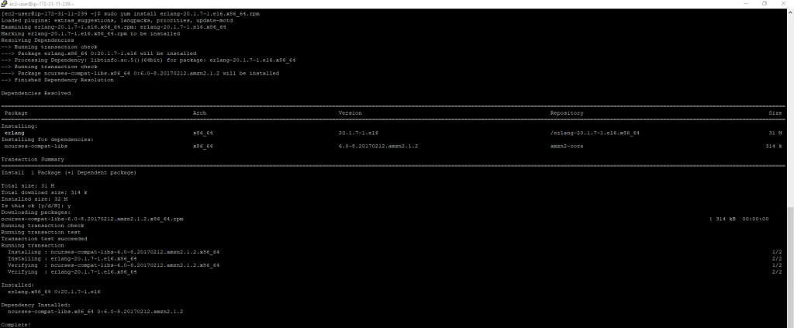](https://www.cloudwalker.io/wp-content/uploads/2019/09/image.png)[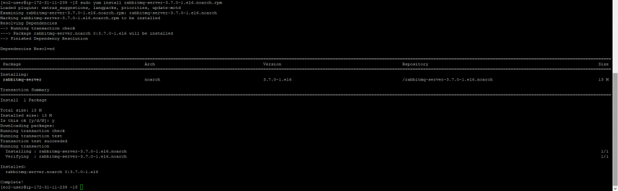](https://www.cloudwalker.io/wp-content/uploads/2019/09/image-1.png)

### **Step-1b – Enable and Start RabbitMQ**

Use the following commands to enable and start RabbitMQ server

sudo chkconfig rabbitmq-server on  
sudo systemctl start rabbitmq-server

[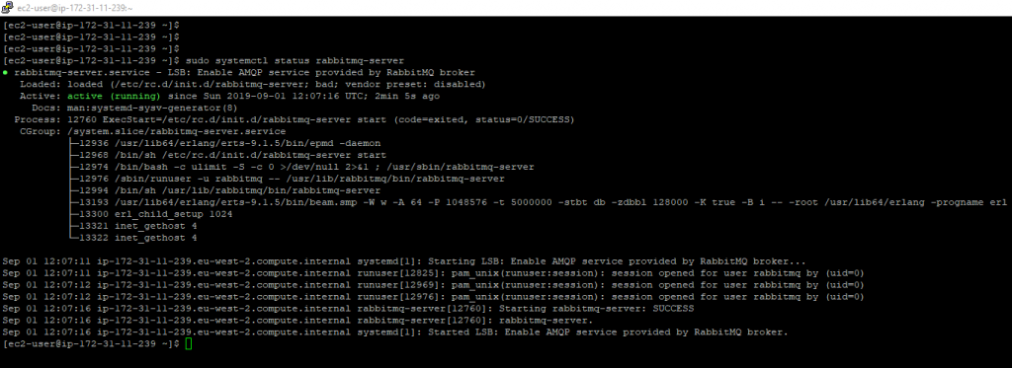](https://www.cloudwalker.io/wp-content/uploads/2019/09/image-2.png)

### **Step-1c – Configure RabbitMQ**

There are 4 commands to complete our config

* Create a user – rabbitmqctl <username> <password>
* Create a vHost –
* Add user tags
* Set privileges

sudo rabbitmqctl add_user airflow_mq airflow_mq  
sudo rabbitmqctl add_vhost airflow_mq_host  
sudo rabbitmqctl set_user_tags airflow_mq administrator  
sudo rabbitmqctl set_permissions -p airflow_mq_host airflow_mq ".*" ".*" ".*"

[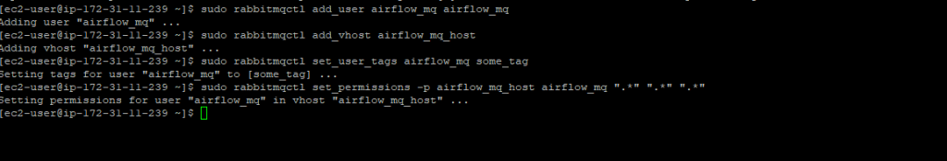](https://www.cloudwalker.io/wp-content/uploads/2019/09/image-4.png)

### **Step-1d Enable RabbitMQ management UI**

Even though we have enabled RabbitMQ we need something to see how it looks and sure enough, there is a management plugin we can enable.

Use the following commands

cd /usr/lib/rabbitmq/bin  
sudo rabbitmq-plugins enable rabbitmq_management

[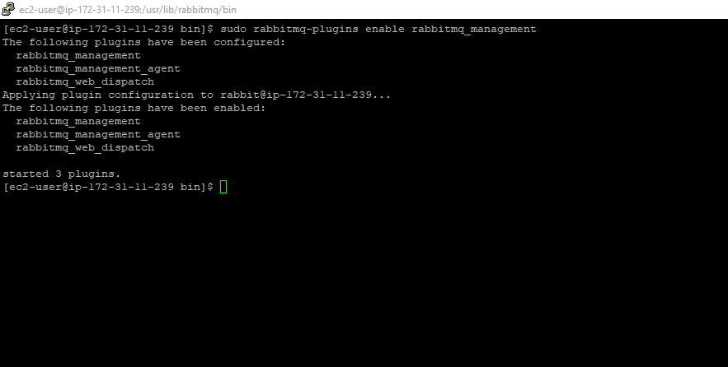](https://www.cloudwalker.io/8807dde1-7f51-4412-8b41-6671cbd09fbc)

Navigate to /etc/rabbitmq and create a file **rabbitmq.config**

[{rabbit, [{tcp_listeners, [{"", 5672}]},{loopback_users, []}]}].

Now you can open the management interface with the following

**http://<<server-name>>:15672** and use **airflow_mq**for username and password.

[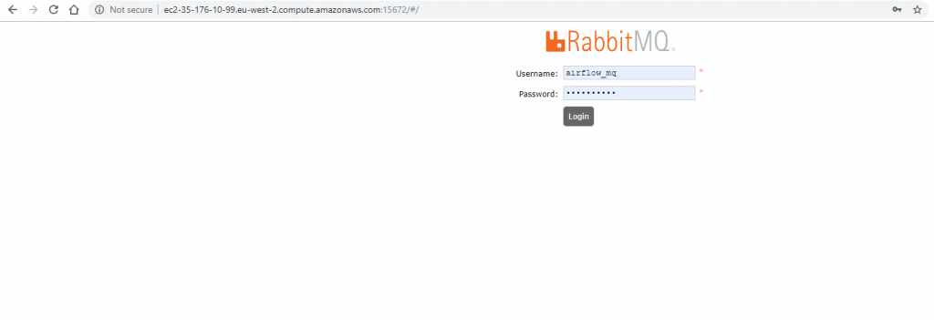](https://www.cloudwalker.io/wp-content/uploads/2019/09/image-6.png)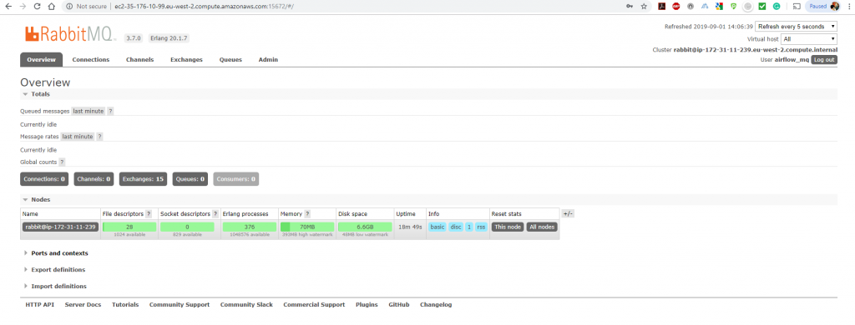

## Install & Configure Airflow with RabbitMQ and Celery Executor

This part needs to be performed for all the Airflow servers exactly the same way. So have as many airflow servers just make sure all of them have the same airflow.cfg! All the airflow configuration for all the components is stored in the same airflow.cfg.

### **Step-2a – Install Airflow with RabbitMQ and Celery Support**

Execute the following on your EC2 Instance

sudo pip install apache-airflow[celery,rabbitmq,s3,postgres,crypto,jdbc]  
sudo pip install psycopg2

**Note:** Airflow(1.10.x) applies certain [libraries](http://docs.celeryproject.org/en/latest/userguide/optimizing.html#librabbitmq)as part of celery optimisations for RabbitMQ but they usually get in way of airflow normal working. So uninstall those optimisations(for now) these may be fixed in the subsequent airflow versions.

sudo pip uninstall librabbitmq

Additionally, you also need to downgrade sqlalchemy if you are using 1.10.5+. It is sad that the dependencies of airflow are a bit all over the place but is all.

sudo pip uninstall marshmallow-sqlalchemy  
sudo pip install marshmallow-sqlalchemy==0.17.1

### **Step-2b – Configure Airflow – Set Executor**

Set the executor in airflow.cfg to CeleryExecutor

[](https://www.cloudwalker.io/wp-content/uploads/2019/09/image-9.png)

### **Step-2c – Configure Airflow – Metadata DB**

The hard part is now out of the way and all the configuration is now done in **airflow.cfg**. Provide database details – see an example below

[](https://www.cloudwalker.io/wp-content/uploads/2019/09/image-13.png)

### **Step-2d – Configure Airflow – Celery configuration**

Scroll down the **airflow.cfg** and there is a section called **celery** do the following modifications

Set the **Celery broker URL** to point to RabbitMQ server as below

[](https://www.cloudwalker.io/wp-content/uploads/2019/09/image-12.png)

Set the **Celery Result Backend DB** – this is the same database which airflow uses. Celery sends updates on airflow tasks. Note the way database is configured – slightly different from the way mentioned earlier in step2c

[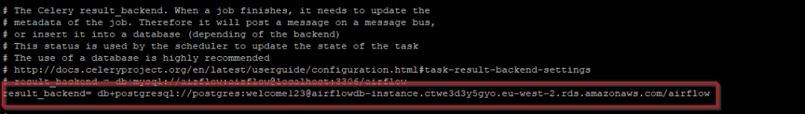](https://www.cloudwalker.io/wp-content/uploads/2019/09/image-11.png)

All done with the configuration! – Phew

### **Step-3 – Start Airflow Scheduler & Webserver**

These can be started as below

airflow webserver

Observe the webserver detects that it is using CeleryExecutor

[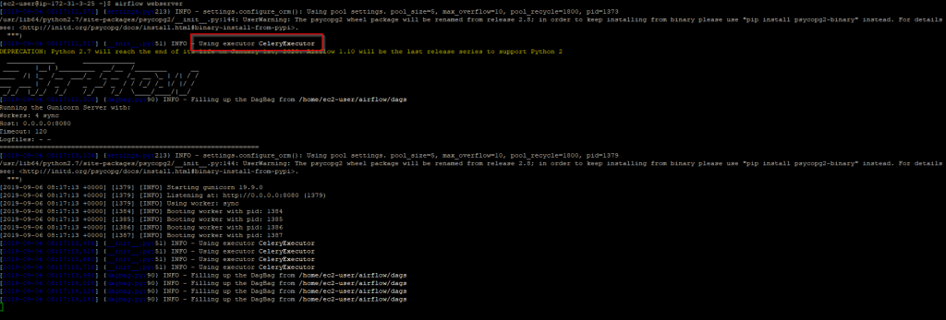](https://www.cloudwalker.io/wp-content/uploads/2019/09/image-14.png)

While starting the scheduler for use with celery an additional [startup parameter](https://airflow.apache.org/cli.html#scheduler) is added to the startup command. See below

airflow scheduler -p

[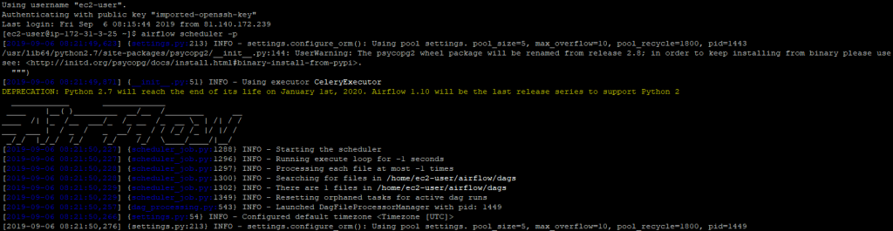](https://www.cloudwalker.io/wp-content/uploads/2019/09/image-15.png)

### **Step-4 – Start Airflow Worker(s)**

The idea here is that the airflow worker should be executing tasks sent to it by the airflow scheduler. Also each worker is associated with a queue. The name of the queue is given when the worker is started. See below

airflow worker -q cloudwalker_q1

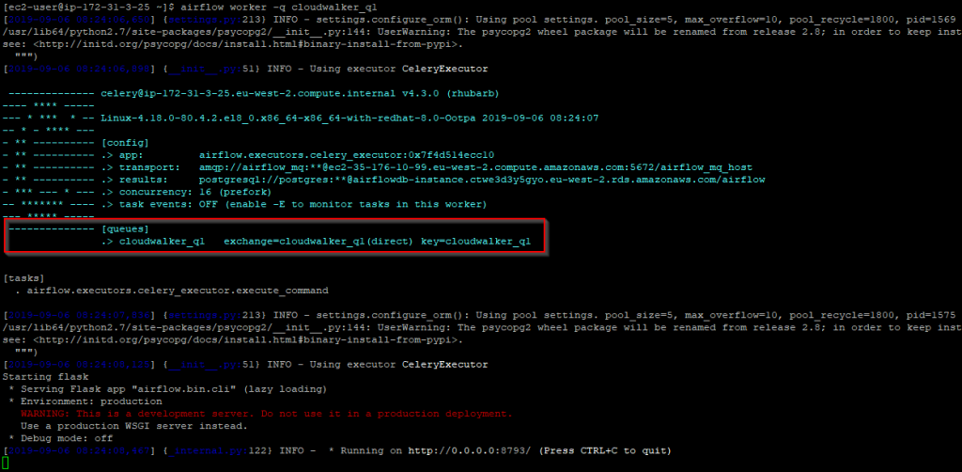

We are in business our environment is up and running and now we can start are remaining worker nodes. Start the remaining two worker nodes with the following command. Essentially we want to have two worker nodes servicing the queue **cloudwalker_q2** so that just in case one worker node goes down airflow will still be able to service the queue.

airflow worker -q cloudwalker_q2

**IMPORTANT**: It is possible to server a single queue with multiple workers. This introduces **resilience in workflow orchestration**. If one of the airflow workers becomes unavailable the tasks are then executed by the other workers servicing the queue

### **Step-5 Start Flower UI**

airflow flower

[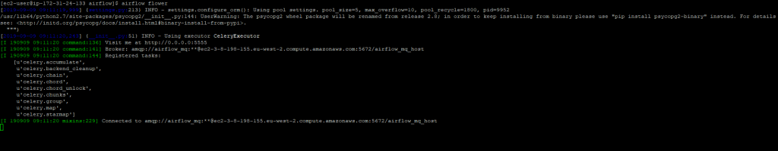](https://www.cloudwalker.io/wp-content/uploads/2019/09/image-19.png)

This will start the flower UI for monitoring all the tasks. You can access the flower UI using the following URL – **http://<server-name>:5555**

[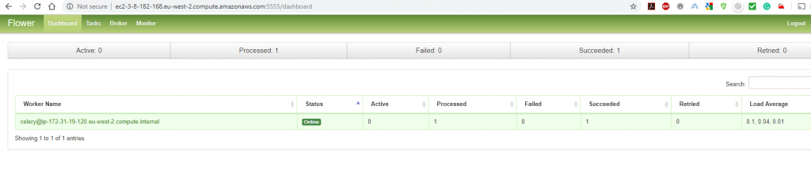](https://www.cloudwalker.io/wp-content/uploads/2019/09/image-18.png)

### **Step-6 Start a DAG**

Now let’s execute a DAG. Because we are now using workers and queues. In code for DAGs additional information needs to be added for queues. This is done on the task level. See Below

# Filename: hello_world2.py  
from airflow import DAG  
from airflow.operators.bash_operator import BashOperator  
from datetime import datetime, timedelta  
  
default_args = {  
  'owner': 'airflow',  
  'depends_on_past': False,  
  'start_date': datetime(2019, 9, 9),  
  'email': ['airflow@example.com'],  
  'email_on_failure': False,  
  'email_on_retry': False,  
  'retries': 1,  
  'retry_delay': timedelta(minutes=5),  
# 'queue': 'bash_queue',  
# 'pool': 'backfill',  
# 'priority_weight': 10,  
# 'end_date': datetime(2016, 1, 1),  
}  
  
dag = DAG(  'hello_world2',  
        schedule_interval='0 0 * * *' ,  
                catchup=False,  
        default_args=default_args  
    )  
create_command = 'echo *************************************$(hostname)*************************************'  
  
t1 = BashOperator(  
  task_id='task_for_q1',  
  bash_command=create_command,  
  queue='cloudwalker_q1',  
  dag=dag  
)  
  
t2 = BashOperator(  
  task_id= 'task_for_q2',  
  bash_command=create_command,  
  queue='cloudwalker_q2',  
  dag=dag  
)  
  
t2.set_upstream(t1)

Observe that in the code we have added an additional parameter called **queue** when calling the BashOperator.

### **Step-7 Watch it happen!**

#### Step-7a Goto the Airflow UI & Execute the task

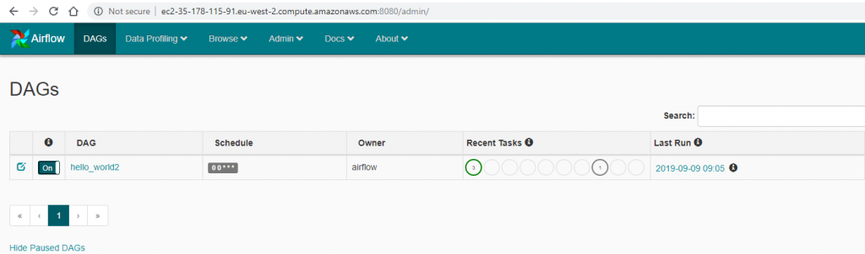

#### Step-7b Check the Dag

[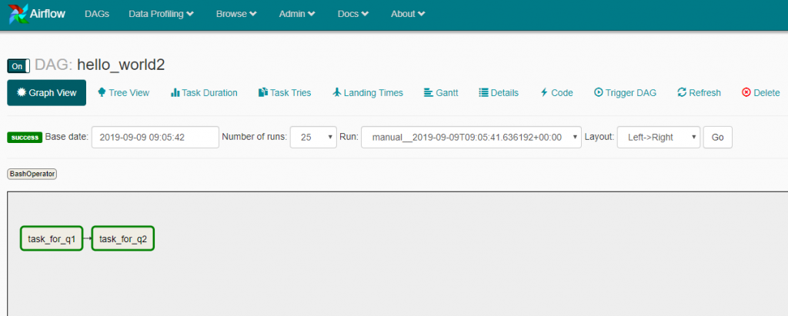](https://www.cloudwalker.io/wp-content/uploads/2019/09/image-23.png)

#### Step-7c Check the logs – task_for_q1

[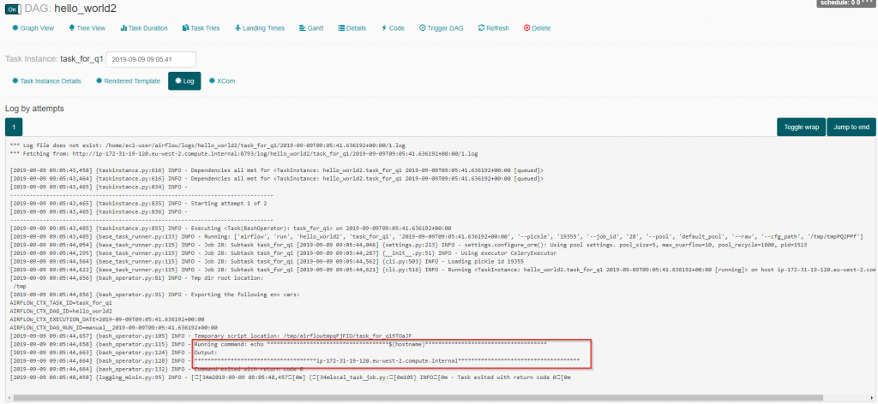](https://www.cloudwalker.io/wp-content/uploads/2019/09/image-21.png)

#### Step-7d Check the logs – task_for_q2

[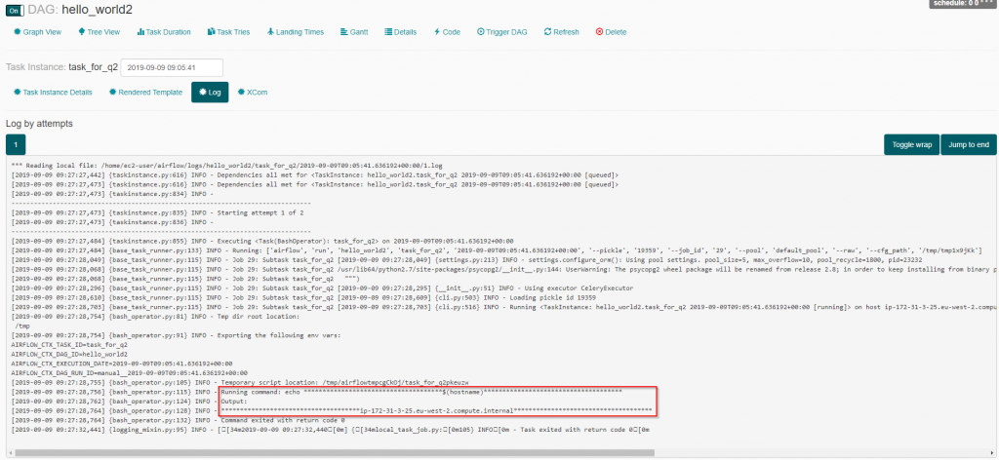](https://www.cloudwalker.io/wp-content/uploads/2019/09/image-22.png)

We have now come to the end of this blog. If you have made it till here – well done!. Hope this blog entry is useful

# **Airflow – Scale-out with Redis and Celery**

## Introduction

This post uses Redis and celery to scale-out airflow. [Redis](https://redis.io/)is a simple caching server and scales out quite well. It can be made resilient by deploying it as a cluster.

In my previous [post](https://www.cloudwalker.io/2019/09/09/airflow-using-rabbitmq-and-celery/), the airflow scale-out was done using celery with rabbitmq as the message broker. On the whole, I found the idea of maintaining a rabbitmq a bit fiddly unless you happen to be an expert in rabbitmq.

Redis seems to be a better solution when compared to rabbitmq. On the whole, it is a lot easier to deploy and maintain when compared with the various steps taken to deploy a RabbitMQ broker. In a nutshell, I like it more than RabbitMQ!

To create an infrastructure like this we need to do the following steps

1. Install & Configure Redis server on a separate host – 1 server
2. Install & Configure Airflow with Redis and Celery Executor support – 4 servers
3. Start airflow scheduler & webserver
4. Start airflow workers
5. Start flower UI
6. Run a DAG
7. Watch it all happen!

## Install & Configure Redis Server

We will install Redis-server on a separate machine and for the purposes of this blog entry, I have created it on an AWS EC2 instance(**RedHat 8**) on which Redis is installed.

***Note****: For production – It is recommended you set up a redis in a cluster just to make things redundant and eliminate single points of failure.*

Download the source code from the following [link](http://download.redis.io/redis-stable.tar.gz)

Execute the following command to install the required utilities to build the source code

sudo yum install make tcl-devel gcc

Extract the redis source code using the following command

tar -xvf redis-stable.tar.gz

Navigate to the redis folder

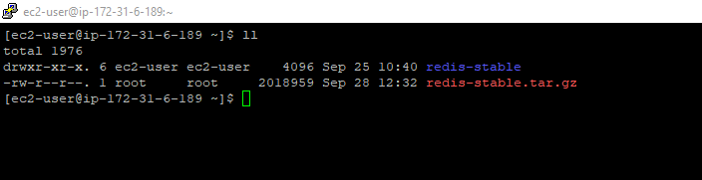

Navigate to **redis-stable**directory. Execute the following commands one by one

make  
sudo make install

Job done! – Redis is now ready to be run. Execute the following command

redis-server

[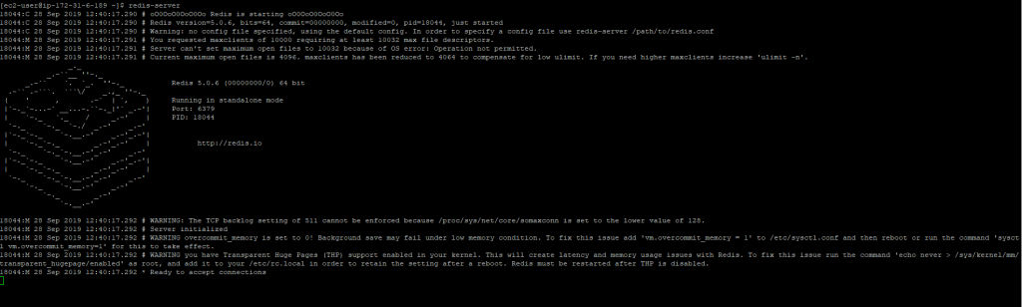](https://www.cloudwalker.io/wp-content/uploads/2019/09/image-27.png)

## Install & Configure Airflow with Redis and Celery Executor

This part needs to be performed for all the Airflow servers exactly the same way. So have as many airflow servers just make sure all of them have the same airflow.cfg! All the airflow configuration for all the components is stored in the same airflow.cfg.

### **Step-2a – Install Airflow with Redis and Celery Support**

Execute the following on your EC2 Instance

sudo yum install gcc python2-devel  
sudo pip install setuptools -U  
sudo pip install apache-airflow[celery,redis,s3,postgres,crypto,jdbc]==1.10.4  
sudo pip install psycopg2  
sudo pip install kombu==4.5.0  
sudo pip uninstall marshmallow-sqlalchemy  
sudo pip install marshmallow-sqlalchemy==0.17.1

### **Step-2b – Configure Airflow – Set Executor**

Set the executor in airflow.cfg to CeleryExecutor

[](https://www.cloudwalker.io/wp-content/uploads/2019/09/image-9.png)

### **Step-2c – Configure Airflow – Metadata DB**

The hard part is now out of the way and all the configuration is now done in **airflow.cfg**. Provide database details – see an example below

[](https://www.cloudwalker.io/wp-content/uploads/2019/09/image-13.png)

### **Step-2d – Configure Airflow – Celery configuration**

Scroll down the **airflow.cfg** and there is a section called **celery** do the following modifications

Set the **Celery broker URL** to point to redis-server as below

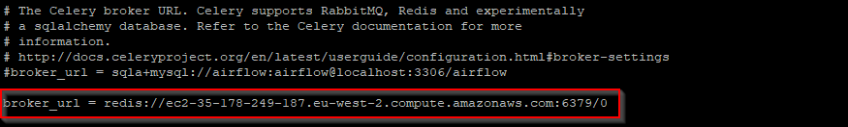

Set the **Celery Result Backend DB** – this is the same database which airflow uses. Celery sends updates on airflow tasks. Note the way database is configured – slightly different from the way mentioned earlier in step2c

[](https://www.cloudwalker.io/wp-content/uploads/2019/09/image-11.png)

The hard part is now out of the way and all the configuration is now done in **airflow.cfg**.

## Start airflow scheduler & webserver

Start airflow webserver using the following command

airflow webserver

[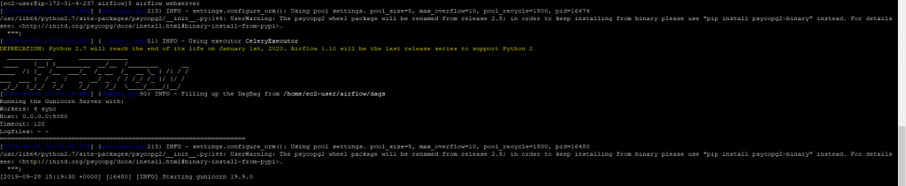](https://www.cloudwalker.io/wp-content/uploads/2019/09/image-30-1024x211.png)

Start the airflow scheduler using the following command

airflow scheduler -p

[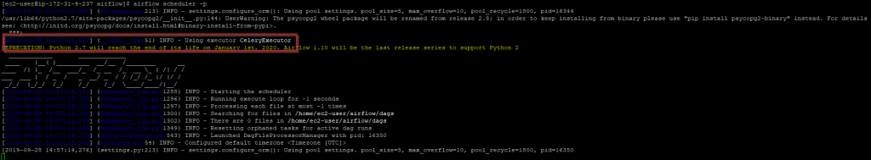](https://www.cloudwalker.io/wp-content/uploads/2019/09/image-28.png)

## Start airflow workers

The idea here is that the airflow worker should be executing tasks sent to it by the airflow scheduler. Also, each worker is associated with a queue. The name of the queue is given when the worker is started. See below

airflow worker -q cloudwalker_q1

[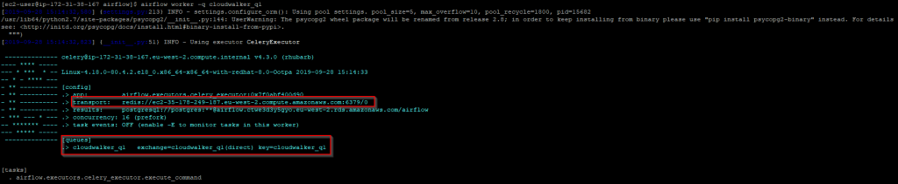](https://www.cloudwalker.io/wp-content/uploads/2019/09/image-31.png)

We are in business our environment is up and running and now we can start are remaining worker nodes. Start the remaining two worker nodes with the following command. Essentially we want to have two worker nodes servicing the queue **cloudwalker_q2** so that just in case one worker node goes down airflow will still be able to service the queue.airflow worker -q **cloudwalker_q2**

**IMPORTANT**: It is possible to serve a single queue with multiple workers. This introduces **resilience in workflow orchestration**. If one of the airflow workers becomes unavailable the tasks are then executed by the other workers servicing the queue

### **Start Flower UI**

airflow flower

[](https://www.cloudwalker.io/wp-content/uploads/2019/09/image-19.png)

This will start the flower UI for monitoring all the tasks. You can access the flower UI using the following URL – **http://<server-name>:5555**

[](https://www.cloudwalker.io/wp-content/uploads/2019/09/image-18.png)

### **Start a DAG**

Now let’s execute a DAG. Because we are now using workers and queues. In code for DAGs additional information needs to be added for queues. This is done on the task level. See Below

# Filename: hello_world2.py  
from airflow import DAG  
from airflow.operators.bash_operator import BashOperator  
from datetime import datetime, timedelta  
  
default_args = {  
  'owner': 'airflow',  
  'depends_on_past': False,  
  'start_date': datetime(2019, 9, 28),  
  'email': ['airflow@example.com'],  
  'email_on_failure': False,  
  'email_on_retry': False,  
  'retries': 1,  
  'retry_delay': timedelta(minutes=5),  
# 'queue': 'bash_queue',  
# 'pool': 'backfill',  
# 'priority_weight': 10,  
# 'end_date': datetime(2016, 1, 1),  
}  
  
dag = DAG(  'hello_world2',  
        schedule_interval='0 0 * * *' ,  
                catchup=False,  
        default_args=default_args  
    )  
create_command = 'echo *************************************$(hostname)*************************************'  
  
t1 = BashOperator(  
  task_id='task_for_q1',  
  bash_command=create_command,  
  queue='cloudwalker_q1',  
  dag=dag  
)  
  
t2 = BashOperator(  
  task_id= 'task_for_q2',  
  bash_command=create_command,  
  queue='cloudwalker_q2',  
  dag=dag  
)  
  
t2.set_upstream(t1)

Observe that in the code we have added an additional parameter called **queue** when calling the BashOperator.

## Watch it happen!

### **Step-7a Goto the Airflow UI & Execute the task**

[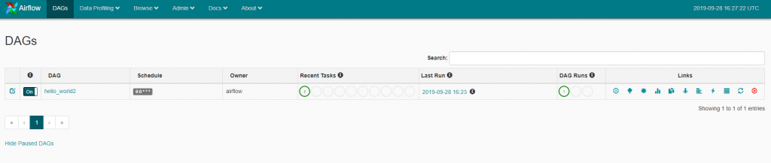](https://www.cloudwalker.io/wp-content/uploads/2019/09/image-32.png)

### **Step-7b Check the Dag**

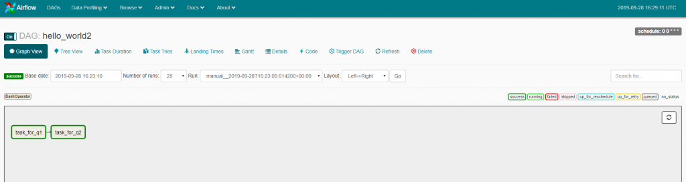

### **Step-7c Check the logs – task_for_q1**

[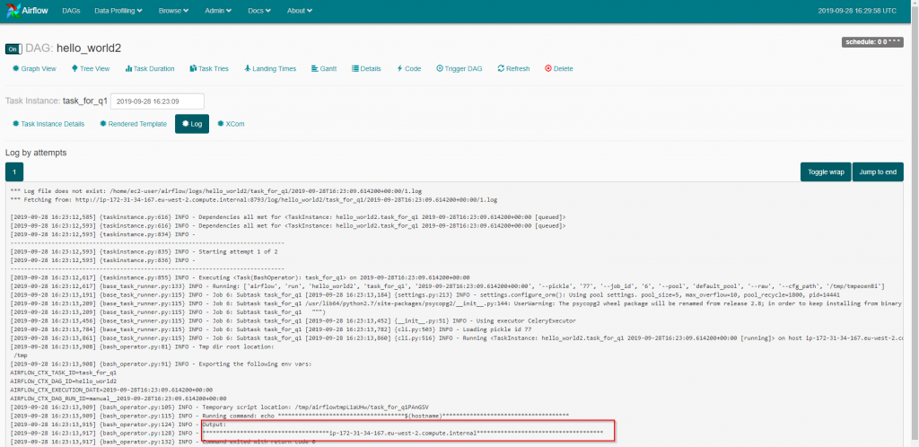](https://www.cloudwalker.io/wp-content/uploads/2019/09/image-35.png)

### **Step-7c Check the logs – task_for_q2**

[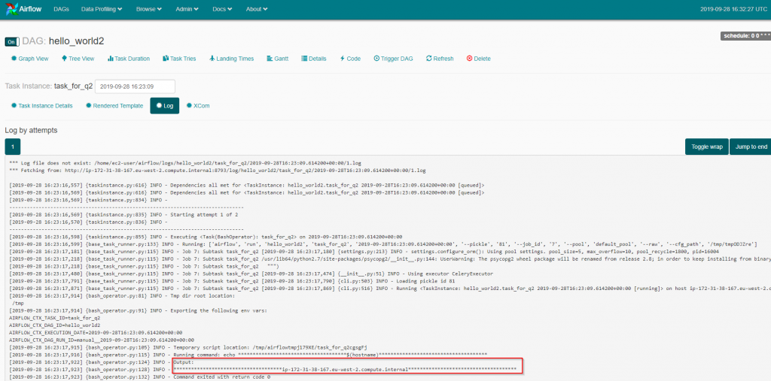](https://www.cloudwalker.io/wp-content/uploads/2019/09/image-36.png)

You now have a working airflow which is scaled out with celery and redis.

# **Airflow – Dynamic DAGs**

## Introduction

Over the last couple of months got lots of queries around dynamic dags. So here is a post on dynamic dags in an airflow. Dynamic tasks is probably one of the best features of [airflow](https://airflow.apache.org/). It allows you to launch airflow tasks dynamically inside an airflow DAG. A simple use case can be if you want to launch a shell script with different parameters in a list all at the same time. To make things more fun is that the list size changes all the time. This is where airflow really shines. Let’s see how

If you are new to airflow – before you jump into reading this post read these posts for a getting some background

* [Airflow getting started](https://www.cloudwalker.io/2018/06/05/apache-airflow/)
* [How to write a DAG](https://www.cloudwalker.io/2018/06/06/apache-airflow-first-dag/)
* [Airflow Variables](https://www.cloudwalker.io/2019/07/22/airflow-variables/)

### **Table of Contents**

* [Introduction](https://www.cloudwalker.io/2020/12/21/airflow-dynamic-tasks/#h-introduction)
* [Airflow DAG – Dynamic Tasks – Example-1](https://www.cloudwalker.io/2020/12/21/airflow-dynamic-tasks/#h-airflow-dag-dynamic-tasks-example-1)
  + [Airflow DAG](https://www.cloudwalker.io/2020/12/21/airflow-dynamic-tasks/#h-airflow-dag)
  + [Analyse Airflow DAG](https://www.cloudwalker.io/2020/12/21/airflow-dynamic-tasks/#h-analyse-airflow-dag)
  + [DAG execution](https://www.cloudwalker.io/2020/12/21/airflow-dynamic-tasks/#h-dag-execution)
* [Airflow DAG – Dynamic Tasks – Example-2](https://www.cloudwalker.io/2020/12/21/airflow-dynamic-tasks/#h-airflow-dag-dynamic-tasks-example-2)
  + [Airflow Variable](https://www.cloudwalker.io/2020/12/21/airflow-dynamic-tasks/#h-airflow-variable)
  + [Airflow DAG](https://www.cloudwalker.io/2020/12/21/airflow-dynamic-tasks/#h-airflow-dag-1)
  + [Analyse Airflow DAG](https://www.cloudwalker.io/2020/12/21/airflow-dynamic-tasks/#h-analyse-airflow-dag-1)
  + [DAG Execution](https://www.cloudwalker.io/2020/12/21/airflow-dynamic-tasks/#h-dag-execution-1)
    - [DAG Execution – 1](https://www.cloudwalker.io/2020/12/21/airflow-dynamic-tasks/#h-dag-execution-1-1)
    - [DAG Execution – 2](https://www.cloudwalker.io/2020/12/21/airflow-dynamic-tasks/#h-dag-execution-2)

## Airflow DAG – Dynamic Tasks – Example-1

Creating dynamic tasks in a DAG is pretty simple. For the purpose of this section, we will create dynamic tasks based on a range of numbers. Just to illustrate our point. Let’s take look at the DAG below

### **Airflow DAG**

# Filename: hello_dynamic_tasks_eg1.py  
from airflow import DAG  
from airflow.operators.bash_operator import BashOperator  
from airflow.operators.dummy_operator import DummyOperator  
from datetime import datetime, timedelta  
  
# Step 1 - Define the default arguments for DAG  
default_args = {  
    'owner': 'airflow',  
    'depends_on_past': False,  
    'start_date': datetime(2020, 12, 18),  
    'email': ['vipin.chadha@gmail.com'],  
    'email_on_failure': False,  
    'email_on_retry': False,  
    'retries': 1,  
    'retry_delay': timedelta(minutes=5)  
}  
  
# Step 2 - Declare a DAG with default arguments  
dag = DAG('hello_dynamic_tasks_eg1',  
          schedule_interval='0 8 * * *',  
          default_args=default_args,  
          catchup=False  
          )  
  
# Step 3 - Declare dummy start and stop tasks  
start_task = DummyOperator(task_id='start', dag=dag)  
end_task = DummyOperator(task_id='end', dag=dag)  
  
# Steo 4 - Create dynamic tasks for a range of numbers  
for i in range(1, 4):  
    # Step 4a - Declare the task  
    t1 = BashOperator(  
        task_id='task_t' + str(i),  
        bash_command='echo hello from task:'+str(i),  
        dag=dag  
    )  
    # Step 4b - Define the sequence of execution of tasks  
    start_task >> t1  >> end_task

### **Analyse Airflow DAG**

Let’s analyse the code quickly

* Step 1 – Declare a dictionary of default arguments for DAG
* Step 2 – Create a DAG with the default arguments
* Step 3 – Create two dummy tasks
  + A dummy task for beginning the DAG
  + A dummy task for the end of DAG
* Step 4 – Creates dynamic tasks
  + Step 4a – Create the task using BashOperator
  + Step 4b – Define which is the preceding task and which is the next task
    - The logic defined here can be changed as per your requirements.

### **DAG execution**

This results in a DAG which looks like this

[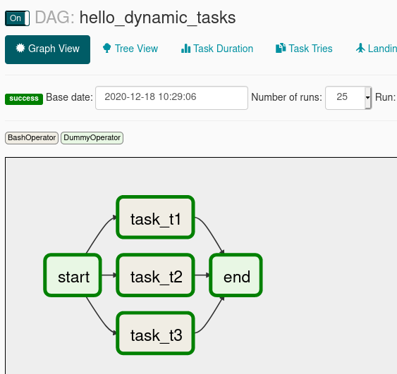](https://www.cloudwalker.io/wp-content/uploads/2020/12/image-16.png)

## Airflow DAG – Dynamic Tasks – Example-2

Let’s take a slightly more complicated example. Assume that there is an airflow variable which stores a list of elements. The airflow DAG will create a task for every element of the list. If you are unfamiliar with how to create airflow variables please refer to this [blog entry](https://www.cloudwalker.io/2019/07/22/airflow-variables/).

### **Airflow Variable**

Below is the airflow variable created

[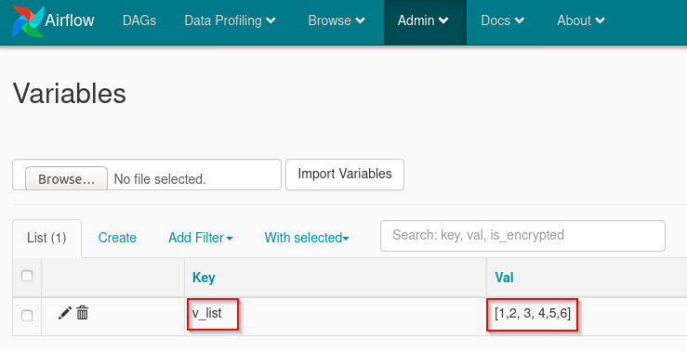](https://www.cloudwalker.io/wp-content/uploads/2020/12/image-21.png)

### **Airflow DAG**

Below is the airflow DAG which utilizes the above variable and creates dynamic tasks for all the elements in the list.

# Filename: hello_dynamic_tasks_eg1.py  
from airflow import DAG  
from airflow.models import Variable  
from airflow.operators.bash_operator import BashOperator  
from airflow.operators.dummy_operator import DummyOperator  
from datetime import datetime, timedelta  
  
# Step 1 - Define the default arguments for DAG  
default_args = {  
    'owner': 'airflow',  
    'depends_on_past': False,  
    'start_date': datetime(2020, 12, 18),  
    'email': ['vipin.chadha@gmail.com'],  
    'email_on_failure': False,  
    'email_on_retry': False,  
    'retries': 1,  
    'retry_delay': timedelta(minutes=5)  
}  
  
# Step 2 - Declare a DAG with default arguments  
dag = DAG('hello_dynamic_tasks_eg2',  
          schedule_interval='0 8 * * *',  
          default_args=default_args,  
          catchup=False  
          )  
  
# Step 3 - Declare dummy start and stop tasks  
start_task = DummyOperator(task_id='start', dag=dag)  
end_task = DummyOperator(task_id='end', dag=dag)  
  
# Step 4 - Read the list of elements from the airflow variable  
v_list = Variable.get("v_list", deserialize_json=True)  
  
# Step 5 - Create dynamic tasks for each element of the list  
for element in v_list:  
    # Step 5a - Declare the task  
    t1 = BashOperator(  
        task_id='task_t' + str(element),  
        bash_command='echo hello from task:' + str(element),  
        dag=dag  
    )  
    # Step 5b - Define the sequence of execution of task  
    start_task >> t1 >> end_task

### **Analyse Airflow DAG**

Let’s analyse the code quickly

* Step 1 – Declare a dictionary of default arguments for DAG
* Step 2 – Create a DAG with the default arguments
* Step 3 – Create two dummy tasks
  + A dummy task for beginning the DAG
  + A dummy task for the end of DAG
* Step 4 – Read the airflow variable which stores the list
* Step 5 – Creates dynamic tasks
  + Step 4a – Create the task using BashOperator
  + Step 4b – Define which is the preceding task and which is the next task
    - The logic defined here can be changed as per your requirements.

### **DAG Execution**

This DAG is executed twice to show the dynamic nature of the DAG. Each time with a different number of list elements by modifying the airflow variable.

1. Airflow variable consists of a list of 6 elements as shown above.
2. List of 4 elements

#### DAG Execution – 1

When the DAG is manually triggered. It creates the following graph

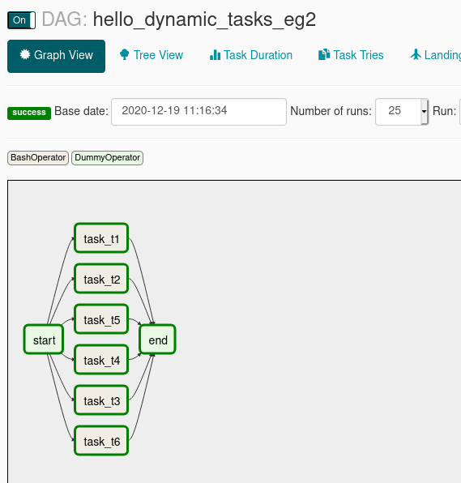Six elements in the airflow variable list

#### DAG Execution – 2

When the list is changed to 4 elements

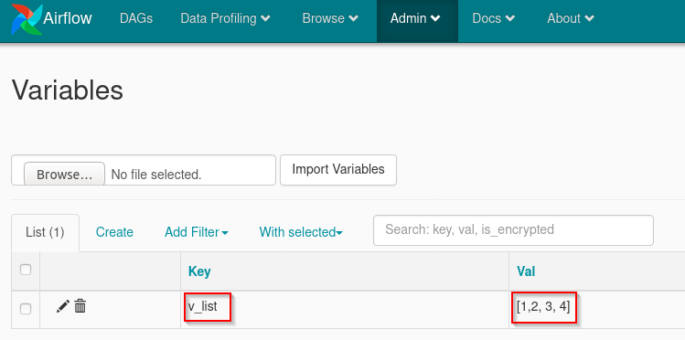

The following DAG is generated

[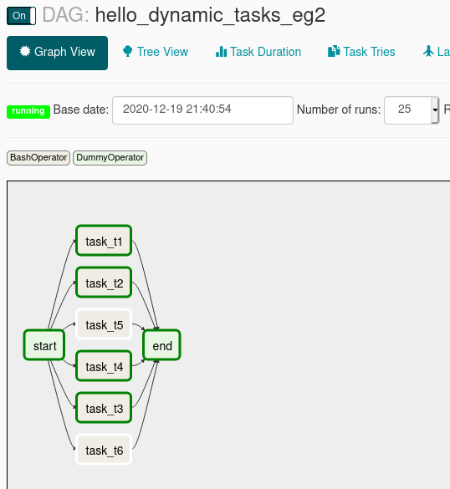](https://www.cloudwalker.io/wp-content/uploads/2020/12/image-23.png)Four elements in the airflow variable list

As you can see in the screenshot only 4 tasks are generated and executed instead of 6.

As you can see you can apply programmatic logic to dynamically create tasks and DAG logic. DAG logic is independent of business/functional logic, which allows for the various tasks to be moved around with substantial ease reducing turnaround time. This brings us to the end of this post on dynamic tasks. I hope you find this post useful. If you like it please do share it!

# **Airflow & SLA Management**

## Introduction

Came across this interesting feature of managing SLA’s natively in airflow. Failures can happen not just by an actual failure of a task/pipeline but may a slow running task/pipeline. A slow running task/pipeline may cause downstream tasks or DAGs which depend upon it to fail. This thought got me searching and I decided to write a post about Airflow and SLAs Management. What I found was a simple solution which can help manage failures and delays.

Before you jump into understanding how to manage [SLAs in airflow](https://airflow.apache.org/docs/apache-airflow/stable/concepts.html#slas)make sure you are familiar with how to [create airflow DAGs](https://www.cloudwalker.io/2018/06/06/apache-airflow-first-dag/).

This post is divided into the following parts

### **Table of Contents**

* [Introduction](https://www.cloudwalker.io/2020/12/15/airflow-sla-management/#h-introduction)
* [Define a callback method](https://www.cloudwalker.io/2020/12/15/airflow-sla-management/#h-define-a-callback-method)
* [Pass the callback method to DAG object](https://www.cloudwalker.io/2020/12/15/airflow-sla-management/#h-pass-the-callback-method-to-dag-object)
* [Define SLA on task(s)](https://www.cloudwalker.io/2020/12/15/airflow-sla-management/#h-define-sla-on-task-s)
* [Define SLA on DAG level](https://www.cloudwalker.io/2020/12/15/airflow-sla-management/#h-define-sla-on-dag-level)
* [Airflow UI – SLA Misses](https://www.cloudwalker.io/2020/12/15/airflow-sla-management/#h-airflow-ui-sla-misses)
* [Conclusion](https://www.cloudwalker.io/2020/12/15/airflow-sla-management/#h-conclusion)

Time duration is defined on a task. Airflow will monitor the performance of task/DAG when SLAs are enabled. When SLAs are breached airflow can trigger the following

* An email notification
* An action via a callback function call

**Note 1**: SLAs checks occur only for scheduled tasks only!!! Strange!

**Note 2**: SLAs monitoring is started from the scheduled time when the DAG is to be triggered!

**Note 3**: There can be only one callback function for tasks and/or DAG level

Defining SLAs is done in three simple steps in defining SLAs in Airflow

* Step 1 – Define a callback method
* Step 2 – Pass the callback method to DAG
* Step 3 – Define the SLA duration on task(s)

## Define a callback method

Here is an example below of a simple callback function. Keep in mind to keep the same arguments as show.

def cw_sla_missed_take_action(*args, **kwargs):  
    # Logs to scheduler logs. Not in the scheduler UI.  
    # Location $AIRFLOW_HOME/logs/scheduler/  
    logger.info("************************************* SLA missed! ***************************************")  
    logger.info(args)

Function which prints out a log to the scheduler log. But your method may do a lot more like logging a ticket with ServiceNow or sending a slack notification or something much more complex.

## Pass the callback method to DAG object

Here is an example

dag = DAG('hello_sla',  
          schedule_interval='* * * * *',  
          default_args=default_args,  
          catchup=False,  
          sla_miss_callback=dag_sla_missed_take_action  # callback function  
          )

**Line 5 –**The last line is where the reference to the callback method is passed to the DAG object. Nothing fancy at all till now!!

## Define SLA on task(s)

Finally, we come to a point where you would like to define the SLA for a task. Keep in mind defining SLAs is optional for a task. So in a DAG with multiple tasks, there may be some tasks with SLAs and some without any SLAs. See the complete DAG definition below

# Filename: hello_SLA_tasks.py  
from airflow import DAG  
from airflow.operators.bash_operator import BashOperator  
from datetime import datetime, timedelta  
import logging  
  
logger = logging.getLogger(__name__)  
  
  
def cw_sla_missed_take_action(*args, **kwargs):  
    # Logs to scheduler logs. Not in the scheduler UI.  
    # Location $AIRFLOW_HOME/logs/scheduler/  
    logger.info("************************************* SLA missed! ***************************************")  
    logger.info(args)  
  
  
default_args = {  
    'owner': 'airflow',  
    'depends_on_past': False,  
    'start_date': datetime(2020, 12, 14),  
    'email': ['vipin.chadha@gmail.com'],  
    'email_on_failure': False,  
    'email_on_retry': False,  
    'retries': 1,  
    'retry_delay': timedelta(minutes=5),  
}  
  
dag = DAG('hello_sla_tasks',  
          schedule_interval='* * * * *',  
          default_args=default_args,  
          catchup=False,  
          sla_miss_callback=cw_sla_missed_take_action  # callback function  
          )  
  
next_command = 'echo   Awake now!'  
  
t1 = BashOperator(  
    task_id='sleep_for_10s',  # Cause the task to miss the SLA  
    bash_command='sleep 10',  
    sla=timedelta(seconds=5),  # SLA for the task  
    dag=dag  
)  
  
t2 = BashOperator(  
    task_id='next_task',  
    bash_command=next_command,  
    dag=dag  
)  
  
t2.set_upstream(t1)

The first task has a SLA defined but not the next tasks.

When this DAG runs as a scheduled DAG, we will see that the task **t1** will be delayed and miss the SLA. It will cause the entry to be created in the scheduler log. Also will generate an email notification to the DAG owner. See below

[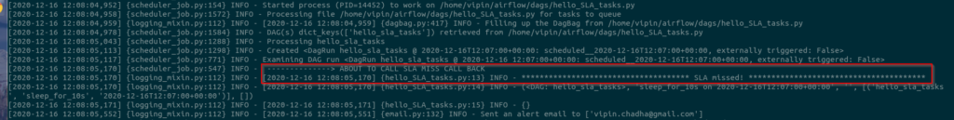](https://www.cloudwalker.io/wp-content/uploads/2020/12/image-11.png)Screenshot – scheduler logs

Additionally, I also got an email notification as I had setup my smtp in airflow.cfg.

[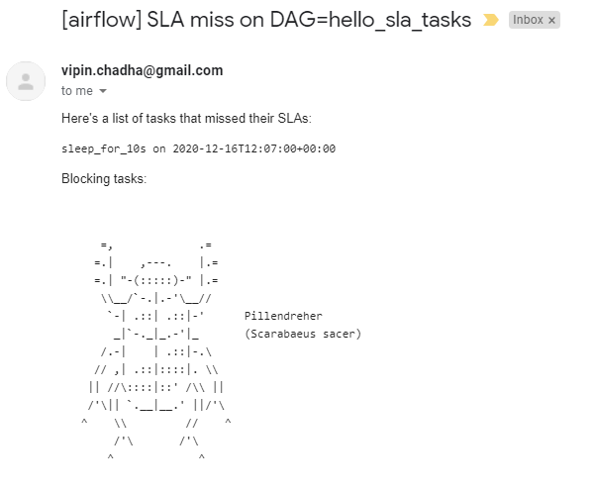](https://www.cloudwalker.io/wp-content/uploads/2020/12/image-12.png)Screenshot of automatic email notification

## Define SLA on DAG level

SLAs on DAG are equally simple to define. They can be attached to a DAG as a part of default arguments. See the DAG below and checkout line 26, last line of **default_args**. SLA has now been defined on the entire DAG

# Filename: hello_SLA_dag.py  
from airflow import DAG  
from airflow.operators.bash_operator import BashOperator  
from datetime import datetime, timedelta  
import logging  
  
logger = logging.getLogger(__name__)  
  
  
def cw_sla_missed_take_action(*args, **kwargs):  
    # Logs to scheduler logs. Not in the scheduler UI.  
    # Location $AIRFLOW_HOME/logs/scheduler/  
    logger.info("************************************* SLA missed! ***************************************")  
    logger.info(args)  
  
  
default_args = {  
    'owner': 'airflow',  
    'depends_on_past': False,  
    'start_date': datetime(2020, 12, 14),  
    'email': ['vipin.chadha@gmail.com'],  
    'email_on_failure': False,  
    'email_on_retry': False,  
    'retries': 1,  
    'retry_delay': timedelta(minutes=5),  
    'sla': timedelta(seconds=5)  
}  
  
dag = DAG('hello_sla_dag',  
          schedule_interval='* * * * *',  
          default_args=default_args,  
          catchup=False,  
          sla_miss_callback=cw_sla_missed_take_action  # callback function  
          )  
next_command = 'echo   Awake now!'  
  
t1 = BashOperator(  
    task_id='sleep_for_10s',  # Cause the task to miss the SLA  
    bash_command='sleep 10',  
    dag=dag  
)  
  
t2 = BashOperator(  
    task_id='next_task',  
    bash_command=next_command,  
    dag=dag  
)  
  
t2.set_upstream(t1)

Below is the screenshot of the scheduler log which is generated by the callback function.

[](https://www.cloudwalker.io/wp-content/uploads/2020/12/image-13.png)Screenshot of scheduler log

Finally, let’s also look at the notification email which you would see lists the tasks which missed the SLAs.

[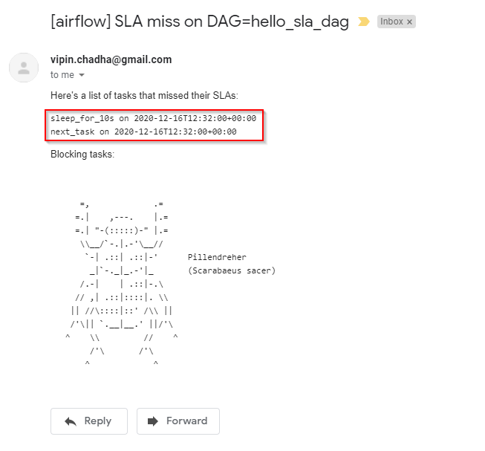](https://www.cloudwalker.io/wp-content/uploads/2020/12/image-14.png)

## Airflow UI – SLA Misses

You can also monitor SLA miss events which have happened on the airflow UI by going to Admin->SLA Misses

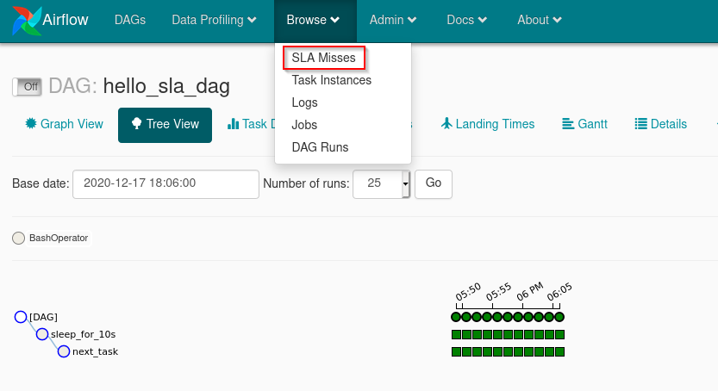Navigate to Browse->SLA Misses

It will take you to this screen

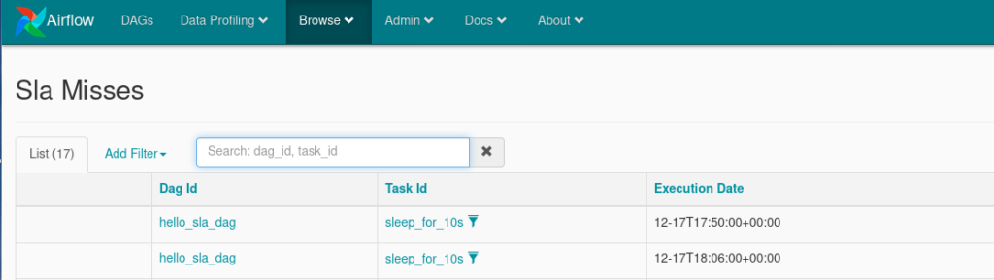SLA Misses

## Conclusion

As you can see from above post it is not really difficult to setup SLA in airflow. It can make your failure management by either failures or delayed jobs a lot more streamlined. If you like this post please do share it and spread the knowledge!

# Use LatestOnlyOperator to skip some tasks while running a backfill in Airflow

Occasionally, when we use Airflow, we have a DAG which always works on the most recent snapshot of data even if we run a backfill for days in the past. It happens when at least one of the tasks downloads a snapshot of the current state from an external API, uploads data into another service (using an API, FTP upload, sending events to a message queue, or anything else), or pushes some information to users.

The last case is the worst. Certainly, we don’t want to send old versions of newsletters to all of the subscribers just because we had to backfill some values in a report.

How do we make sure that such time-sensitive tasks are executed only in the most recent DAG run and don’t start when we run a backfill? We can do that by using the LatestOnlyOperator in Airflow!

It is simple to use it. All we need to do is importing the operator, creating a new instance, and adding it to the DAG:

|  |  |
| --- | --- |
| 1  2  3  4  5 | from airflow.operators.latest_only_operator import LatestOnlyOperator  is_this_latest_dag_run **=** LatestOnlyOperator(task_id**=**"dont_send_newsletters_during_backfills", dag**=**dag)  upstream_task **>>** is_this_latest_dag_run **>>** send_newsletters **>>** other_downstream_task |

When the operator runs, it checks whether the current time is between the most recent execution time and the next scheduled execution time. If yes, it lets the downstream tasks run. If no, it means that we are running a backfill, and the downstream tasks get skipped.

# Data Profiling

Part of being productive with data is having the right weapons to profile the data you are working with. Airflow provides a simple query interface to write SQL and get results quickly, and a charting application letting you visualize data.

## Adhoc Queries

The adhoc query UI allows for simple SQL interactions with the database connections registered in Airflow.

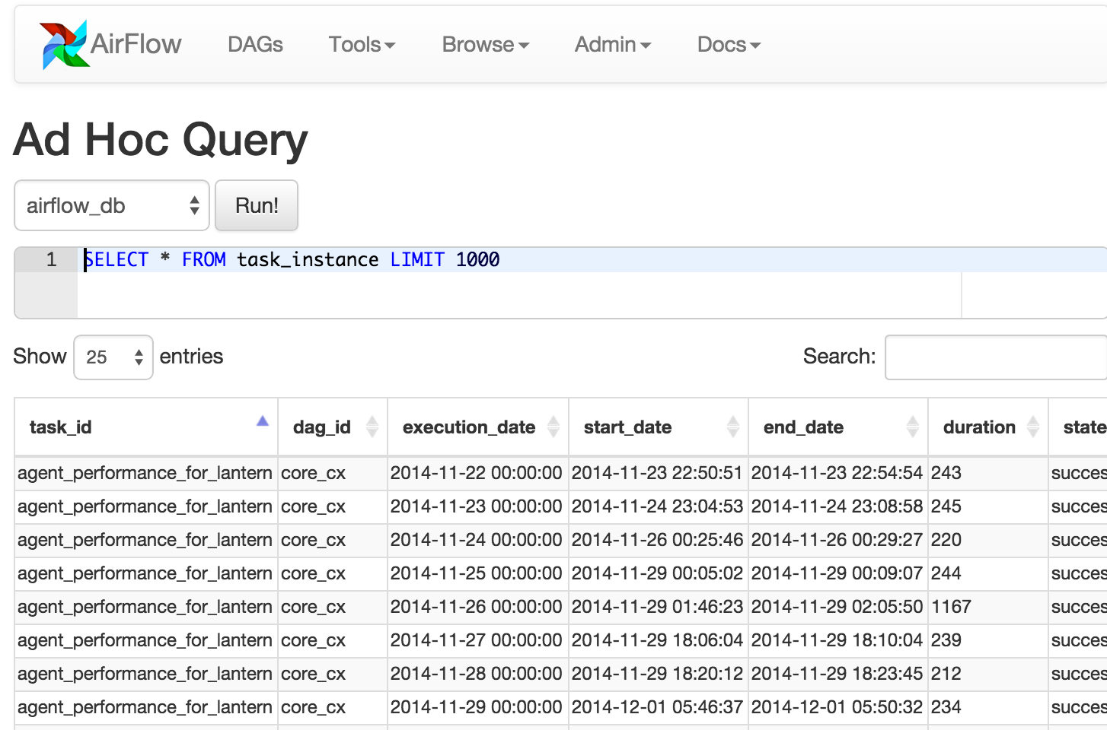

## Charts

A simple UI built on top of flask-admin and highcharts allows building data visualizations and charts easily. Fill in a form with a label, SQL, chart type, pick a source database from your environment’s connections, select a few other options, and save it for later use.

You can even use the same templating and macros available when writing airflow pipelines, parameterizing your queries and modifying parameters directly in the URL.

These charts are basic, but they’re easy to create, modify and share.

### Chart Screenshot

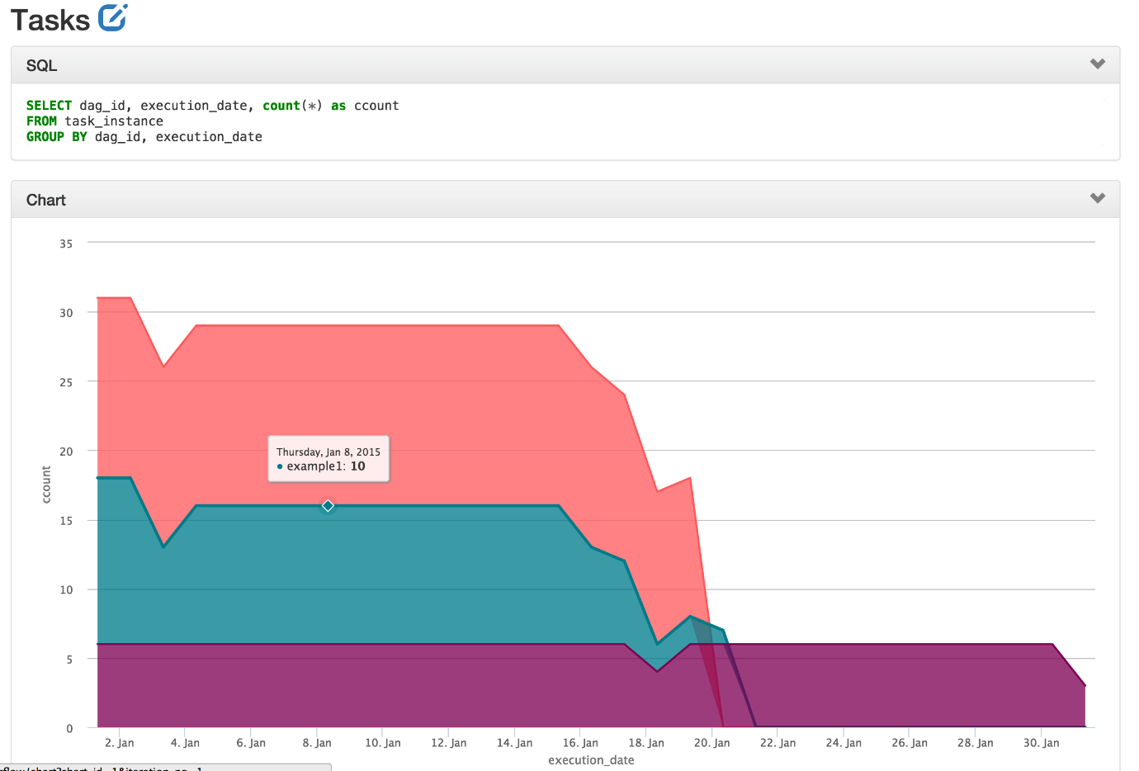

### Chart Form Screenshot

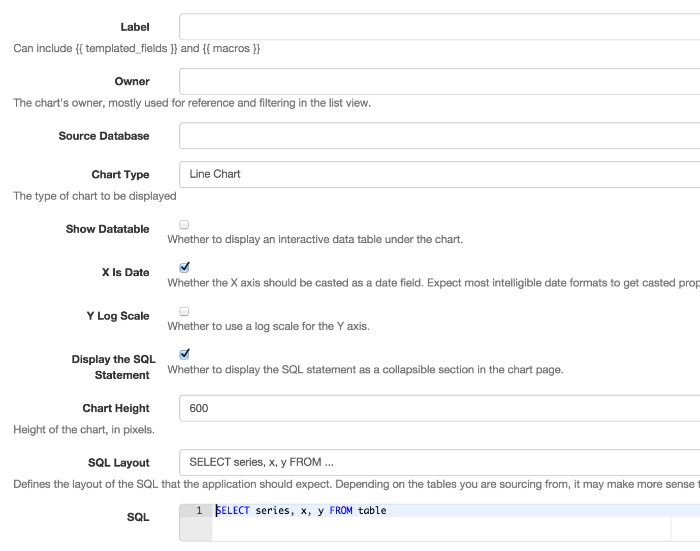

## Managing Dependencies

The logic between tasks

Each DAG object contains a set of tasks that are related by dependencies - the "directed" in directed acyclic graph.

Dependencies are one of Airflow's most powerful and popular features - they allow for previously long, brittle jobs to be broken down into granular parts that are safer, more modular, and reusable.

### Simple Dependencies

Dependencies can be set syntactically or through bitshift operators.

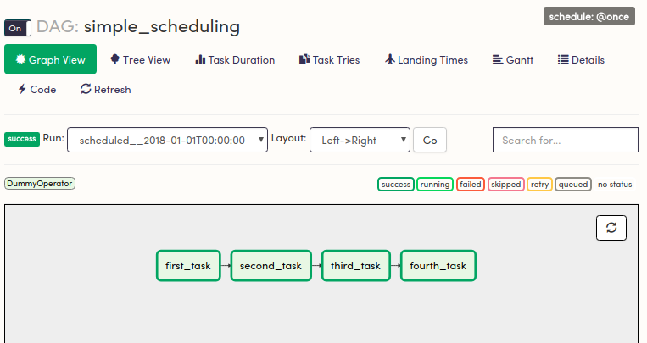

This logic can be set three ways:

* d1.set_downstream(d2)  
  d2.set_downstream(d3)  
  d3.set_downstream(d4)
* d4.set_upstream(d3)  
  d3.set_upstream(d2)  
  d2.set_upstream(d1)
* d1 >> d2 >> d3 >> d4
* d4 << d3 << d2 << d1

To set groups of dependencies, you can use lists or tuples as well.

d1 >> d2 >> (d3, d4)

d1 >> d2 >> [d3, d4]

Both of these are equivalent, and set d3 and d4 downstream of d2.

All three are in line with best practice as long as it is written consistently - do **not** do:

* d1.set_downstream(d2)  
  d2 >>d3  
  d4.set_upstream(d3)

### Dynamically Setting Dependencies

For a large number of tasks, dependencies can be set in loops:

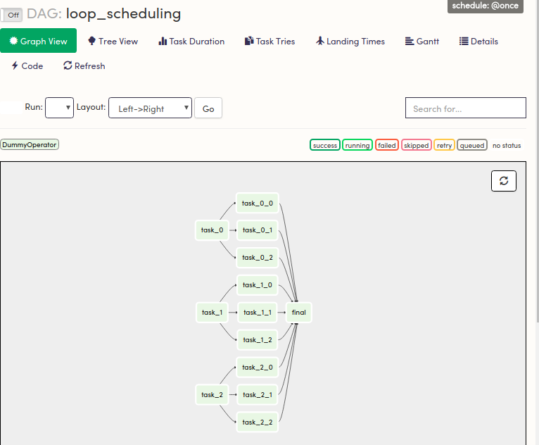

Recall that tasks are identified by their task_id and associated DAG object - not by the type of operator. Consider this:

with dag:

final_task = DummyOperator(task_id='final')

for i in range(0, 3):

d1 = DummyOperator(task_id='task_{0}'.format(i))

for j in range(0, 3):

d2 = PythonOperator(task_id='task_{0}'.format(i),

python_callable=test_callable,

provide_context=True)

d1 >> d2 >> final_task

_ What happens here?_

### Trigger Rules

Complex Dependencies

By default, workflows are triggered when upstream tasks have succeeded. However, more complex trigger rules can be implemented.

Operators have a [trigger_rule](https://airflow.apache.org/concepts.html#trigger-rules) that defines how the task gets triggered. The default all_success rule dictates that the task should be triggered when all upstream dependent tasks have reached the success state.

Each trigger rule can have specific use cases:  
  
**all_success:** (default) all parents have succeeded  
**all_failed:** all parents are in a failed or upstreamfailed state**alldone:** all parents are done with their execution  
**one_failed:** fires as soon as at least one parent has failed, it does not wait for all parents to be done  
**one_success:** fires as soon as at least one parent succeeds, it does not wait for all parents to be done  
**dummy:** dependencies are just for show, trigger at will

TriggerRules are defined as Airflow Utils:

### Different Use Cases

Extendability vs Safety

#### **The one_failed rule**

When you have a critically important but brittle task in a workflow (i.e. a large machine learning job, some reporting task, etc.), a good safety check would be adding a task that handles the failure logic. This logic can be implemented dynamically based on how the DAG is being generated.

# Define the tasks that are "brittle."

# Generally advisable when working with data drops from vendors/FTPs

job_info = [

{

'job_name': 'train_model',

'brittle': True

},

{

'job_name': 'execute_query',

'brittle': False

}]

# Define some failure handling

def fail_logic(**kwargs):

# Implement fail_logic here.

return

with dag:

for job in job_info:

d1 = DummyOperator(task_id=job['job_name'])

# Generate a task based on a condition

if job['brittle']:

d2 = PythonOperator(task_id='{0}_{1}'.format(job['job_name'],

'fail_logic',),

python_callable=fail_logic,

provide_context=True,

trigger_rule=TriggerRule.ONE_FAILED)

d1 >> d2

for i in range(0, 5):

downstream = DummyOperator(

task_id='{0}_{1}'.format(job['job_name'], i))

d1 >> downstream

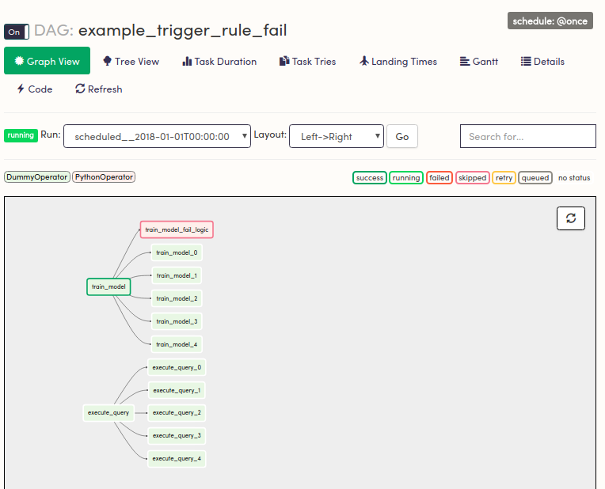

**Note:** Similar logic can be implemented by specifying an on_failure_callback if using a [PythonOperator](https://registry.astronomer.io/providers/apache-airflow/modules/pythonoperator). The trigger_rule is better used when triggering a custom operator.

Though trigger rules can be convenient, they can also be unsafe and the same logic can usually be implemented using safer features.

A common use case of exotic trigger rules is a task downstream of all other tasks that kicks off the necessary logic.

#### **The one_success rule**

This rule is particularly helpful when setting up a "safety check" DAG - a DAG that runs as a safety check to all your data. If one of the "disaster checks" come back as True, the downstream disaster task can run the necessary logic.

**Note:** The same logic can be implemented with the one_failed rule.

#### **The all_failed rule**

all_failed tells a task to run when all upstream tasks have failed and can be used to execute a fail condition for a workflow.

The workflow may look something like this: 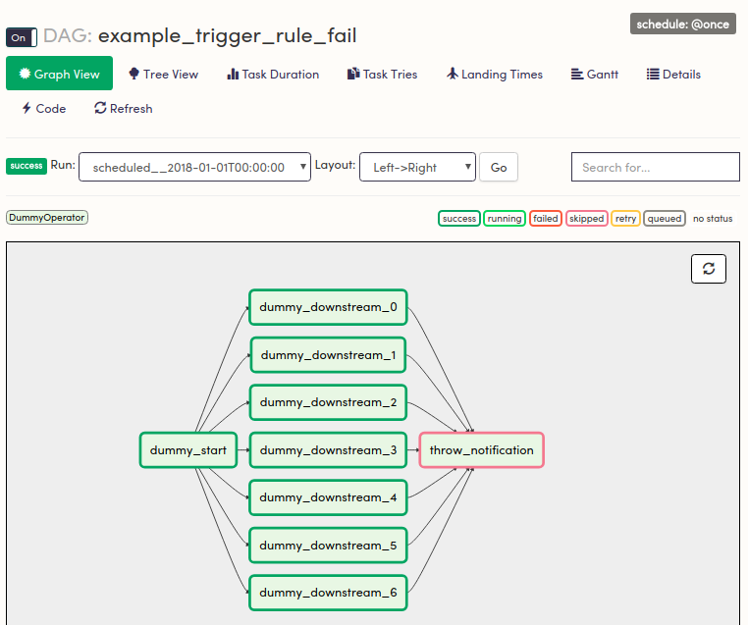

**Note:** The final task was set to skipped

Once again, the same functionality can be achieved by using the [BranchPythonOperator](https://registry.astronomer.io/providers/apache-airflow/modules/branchpythonoperator), a [TriggerDagRunOperator](https://registry.astronomer.io/providers/apache-airflow/modules/triggerdagrunoperator), or just configuring reporting in more specific way.

### Triggers with LatestOnlyOperator

When scheduling tasks with complex trigger rules with dates in the past, there may be instances where certain tasks can run independently of time and others shouldn't. The [LatestOnlyOperator](https://registry.astronomer.io/providers/apache-airflow/modules/latestonlyoperator) handles this scenario.

The parameters can also be set in the DAG configuration as above - the scheduling may get a bit messy, but it can save computing resources and add a layer of safety.

job_info = [

{

'job_name': 'train_model',

'brittle': True,

'latest_only': True

},

{

'job_name': 'execute_query',

'brittle': False,

'latest_only': False

}]

with dag:

start = DummyOperator(task_id='kick_off_dag')

for job in job_info:

d1 = DummyOperator(task_id=job['job_name'])

# Generate a task based on a condition

if job['brittle']:

d2 = PythonOperator(task_id='{0}_{1}'.format(job['job_name'],

'fail_logic',),

python_callable=fail_logic,

provide_context=True,

trigger_rule=TriggerRule.ONE_FAILED)

d1 >> d2

start >> d1

if job['latest_only']:

latest_only = LatestOnlyOperator(task_id='latest_only_{0}'

.format(job['job_name']))

d1 >> latest_only

for i in range(0, 5):

downstream = DummyOperator(

task_id='{0}_{1}'.format(job['job_name'], i))

if job['latest_only']:

latest_only >> downstream

else:

d1 >> downstream

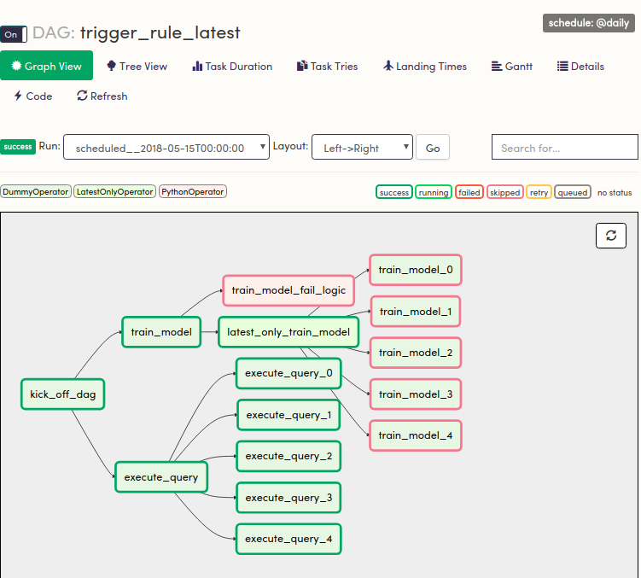  
Computing resources would be saved on past DAG runs.

